1. Describe the distribution of *k_pct* based on this histogram.

Strikeout percentage is left skewed, meaning that is more common for umpires to call a high number of strikeouts.

1. What is the mean *k_pct* for all umpires?

```{r}

mean(umpires_df$k_pct)

```

The mean strike out percentage for all umpires is 20.8%

1. What is the standard deviation of *k_pct* for all umpires?

```{r}

sd(umpires_df$k_pct)

```

The standard deviation of strike out percentage for all umpires is 2.03.

1. Calculate the IQR for *k_pct* using the summary statistics provided below.

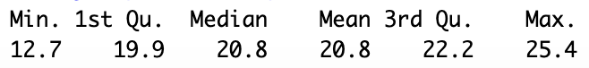

IQR = Q3-Q1 = 22.2 - 19.9 = **2.3**

The IQR for strike out percentage is 2.3.

1. The below table shows the 25 umpires with the lowest strikeout percentages in the dataset. Use the IQR method to determine if there are any outliers.

1.5*IQR = 1.5*2.3 = 3.45

Q1 – 1.5*IQR = 22.2-3.45 = 18.75

All of the umpires in this list except for the top 11 are outliers as they are all less than *Q1-1.5IQR*.

1. Describe the distribution of *bb_pct* based on this histogram.

Walk percentage is right skewed, meaning that is more common for umpires to call a low number of walks.

1. What is the mean *bb_pct* for all umpires?

```{r}

mean(umpires_df$bb_pct)

```

The mean walk percentage for all umpires is 8.48%.

1. What is the standard deviation of *bb_pct* for all umpires?

```{r}

sd(umpires_df$bb_pct)

```

The standard deviation of walk percentage for all umpires is 0.68.

1. Calculate the IQR for *bb_pct* using the summary statistics provided below.

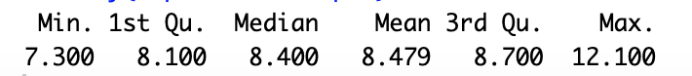

IQR = Q3-Q1 = 8.7 - 8.1 = **0.6**

The IQR for walk percentage is 0.6.

1. The below table shows the 10 umpires with the highest walk percentages in the dataset. Use the IQR method to determine if there are any outliers.

1.5*IQR = 1.5*0.6 = 0.9

Q3 + 1.5*IQR = 8.7+0.9 = 9.6

All of the umpires in this list except for Chris Tiller are outliers as they are all more than *Q3+1.5IQR*.