1. 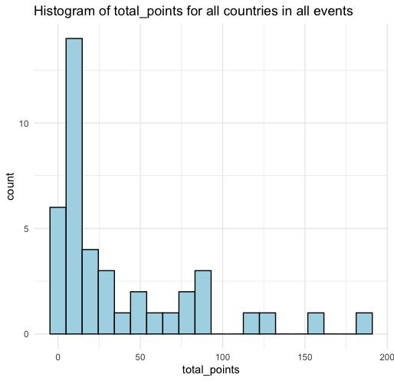The below graphic is a histogram of total\_points for all countries. Describe the distribution of total\_points. Is there a skew, if so, what is it and what does it mean?

The data is right-skewed meaning that the values are clustered around the smaller values for total\_points, so it is more common for nations to do poorly in Olympic rowing than well.

1. Using <rowing_medals.csv>, obtain the summary statistics for total\_points and fill them in below.

**Minimum**: 1.00 **Lower Quartile:** 6.00 **Median**: 15.00 **Mean**: 38.15

**Upper Quartile**: 57.00 **Maximum:** 187.00

1. The UK has 154 total\_points in the dataset, determine whether or not that is an outlier. Use calculations to justify your answer.

An outlier

IQR = Q3-Q1 = 57-6 = 51

1.5\*IQR = 1.5\*51 = 76.5

Q3 +1.5\* IQR = 57 + 76.5 = 133.5

154> 133.5

1. The below table shows the top 5 nations ranked by total\_points, using the same method as in question 3, determine if there are any other outliers.

Only USA is an outlier.

187>133.5

131<133

121<133

87<133

1. Using your answers to questions 2-4 draw a boxplot of total\_points.

1. The below plot shows total\_medals ranked by NOC. Based on the distribution of this plot would it be fair to assume that economic welfare is a confounding variable in predicting nations’ performance in Olympic rowing? Explain why or why not.

Based on this graph it would not be fair to assume that economic welfare is a confounding variable in predicting nations’ performance in Olympic rowing. If there was a GDP variable it may be easier to assess this.

1. What could be a reason for the distribution of medals and points being so heavily skewed towards certain nations winning more than others?

Rowing shells (boats) are expensive, meaning rowing is a sport that requires a great deal of funding. Some nations make funding rowing a priority while others do not. This can also ultimately come down to which countries are wealthier in general than others.

1. There is a lot of debate about how to best weigh the points for the different types of medals. Read [this link](https://www.topendsports.com/events/summer/medal-tally/rankings-weighted.htm) about different medal point weighing and decide on a method you think would be best. How would the new method alter the data?

Open ended, no right or wrong answer, credit for answering.