foiThe Summer Olympic Games are an international athletics event held every four years and hosted in different countries around the world. Rowing was added to the Olympics in 1896 and has been in every Summer Olympics since. Rowing races in the Olympic context are typically regatta style, meaning that there are multiple boats racing head-to-head against each other in multiple lanes. Since 1912, the standard distance for Olympic regattas has been 2000m, but until then there had been a range in distances. The boat that is first to cross the finish line is awarded a gold medal, the second a silver medal, and the third a bronze. Over the course of its time as an Olympic sport there have been 25 different event entries. These events range with the number of rowers in the boat (1, 2, 4, 6, 8, 17), the rigging (inrigged, outrigged), sculling, sweeping, and whether or not they are coxed. An inrigged shell means the riggers (where the oar is attached to the boat) are on the inside of the boat, outrigged shells mean the riggers are on the outside. Sculling is where the rowers have an oar on each side and sweeping is when each rower only has one oar on one side. The coxswain steers the boat and guides the rowers, some events have coxed boats whereas some others do not. In looking at the total medals and total points for each nation, it is interesting to see which nations dominate in Olympic rowing. Additionally, looking at the overall distribution of the medals for all countries provides insight on just how lob-sided medaling can be in rowing at the Olympic level.

1. The below graphic is a histogram of total_medals for all countries in all events. Describe the distribution of total_medals for all countries in all events. Is there a skew, if so, what is it and what does it mean?

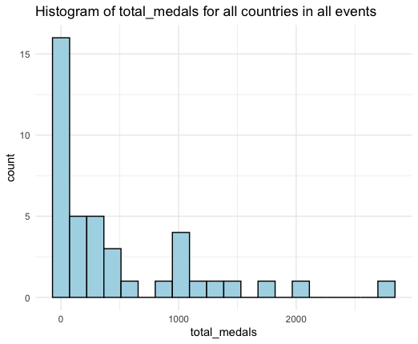

1. Using <medals.csv>, obtain the summary statistics for total_points for all countries in all events and fill them in below.

**Minimum**: **Lower Quartile:**  **Median**: **Mean**:

**Upper Quartile**: **Maximum:**

1. The USA has 94.2 points in the women's coxed eight event, determine whether or not that is an outlier. Use calculations to justify your answer.
2. The below barplot shows total_medals ranked by NOC. Based on the distribution of the plot, would it be fair to assume economic welfare is a confounding variable in predicting a nation’s performance in rowing? Explain why or why not.

