1. The below graphic is a histogram of total_medals for all countries in all events. Describe the distribution of total_medals for all countries in all events. Is there a skew, if so, what is it and what does it mean?

The data is right or negatively skewed, this means that the majority of the values are at the smaller end of the x-axis around 0.

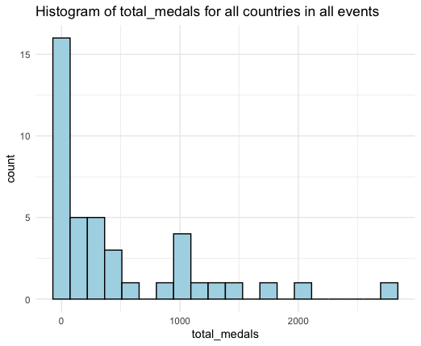

1. Using <medals.csv>, obtain the summary statistics for total_points for all countries in all events and fill them in below.

**Minimum**: 0 **Lower Quartile:** 0.8 **Median**: 12.33 **Mean**: 54.62

**Upper Quartile**: 67.44 **Maximum:** 848

1. The USA has 94.2 points in the women's coxed eight event, determine whether or not that is an outlier. Use calculations to justify your answer.

Not an outlier.

IQR = 67.44-0.8 = 66.64

1.5*66.64 = 99.96

94.2<99.96

1. The below barplot shows total_medals ranked by NOC. Based on the distribution of the plot, would it be fair to assume economic welfare is a confounding variable in predicting a nation’s performance in rowing? Explain why or why not.

Based on this graph it would not be fair to assume that economic welfare is a confounding variable in predicting the performance of nations in Olympic rowing. If there was a variable with GDP it may be easier to assess this.