**Visualizing Professional Woman’s Hockey Data**

The Professional Woman’s Hockey League (PWHL) began its inaugural season in 2023-24. The league has players from 11 different countries. The league looks to expand its exposure and gain new fans for the future of the sport.

We will be investigating the player statistics from the league’s inaugural season. Our focus will be on all players including goalies which includes 147 athletes. Also, to discover which age groups and positions have the most impact on the number of goals scored per game by each player.

In general, the main goal of the forwards is to stay in three different lanes across the ice, moving the puck between them to make the goalie move and open scoring opportunities. The defense players compliment the forwards by positioning themselves along the boundary of the offensive zone to prevent the opposing team from moving the puck away from the zone and provide more opportunities for the forwards to score. The goalie’s focus is to guard their team’s goal by positioning themselves in front of it to prevent the opposing team from scoring.

The different age groups represent a blend of experience and athleticism at a point in the player’s career. More experience should help the player score more goals because they would have more knowledge of the game and ideas on how to score. However, more experience comes with more aging and players with more experience may be past their years of peak athleticism. That is why our goal is to find if there is a perfect blend between the two (i.e. an ideal age group).

**Data Description**

**PWHL_Final** - Name of the data set

**G_Per_GP** -Number of goals scored by the player per game played

**P** - Number of points scored

**Pos** – Position of the player (either Defense (D), Forward (F), or Goalie (G))

**Age** – Age of the player in years

The density plot below displays the distribution of goals per game played for each position. Pay attention to why each curve is different. Use it to answer the following two questions.

1. What would you need to add to the R code below to add a title and change the x-axis label to "Goals Per Game Played"?

```{r}

ggplot(data = PWHL_Final) +

geom_density(aes(G_Per_GP, color = Pos, fill = Pos), alpha = 0.25) +

theme_minimal()

```

1. Describe the distribution of the Forward and Defense positions in the density plot above. Make sure to mention shape and skew. Give a possible reason why the Goalie’s curve is flat in this visual.

Use the graphs below to answer the following question.

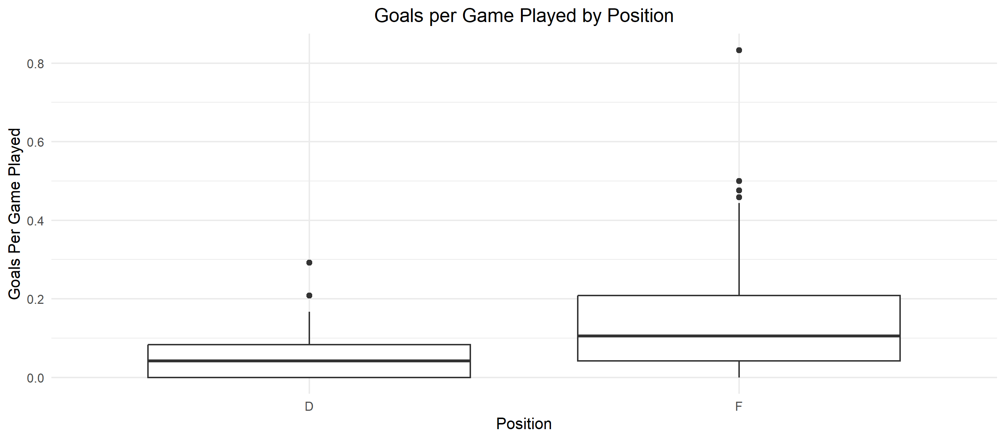

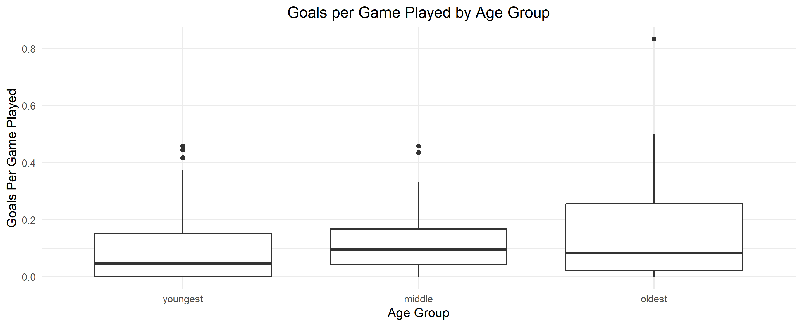

1. Brainstorm some ideas on which combinations of age and positions would be ideal for a player to be to maximize their number of goals per game played.
2. First create three different age groups “youngest” (22-25), “middle” (26-30), and “oldest” (31-36). Then, create side-by-side boxplots that display the range of goals per game for each group. Only include Forward and Defense positions. Make sure to add a theme, flip the axis, and change the x and y axis labels. Refer to the data description on the first page.
3. What trends, if any, do you see in your graphic? Does it confirm your original thoughts in question 3?
4. What are some possible limitations to this dataset?