**Analyzing Olympic Swim Times**

The Summer Olympics are traditionally held every four years, with an extensive history that goes back to 1896. Since then, swimming has been an integral part of the events. The sport has attracted thousands of athletes from over 150 countries around the world. The Olympics allows nations to put aside their differences and come together to provide a sense of unity to millions of fans.

We will be investigating the results of the 50 and 100 meter men and women races from 1924 to 2020. The dataset includes 750 swimmers and 9 variables.

The side-by-side boxplots below display race times for different strokes in the 100-meter event. Use it to answer the questions below.

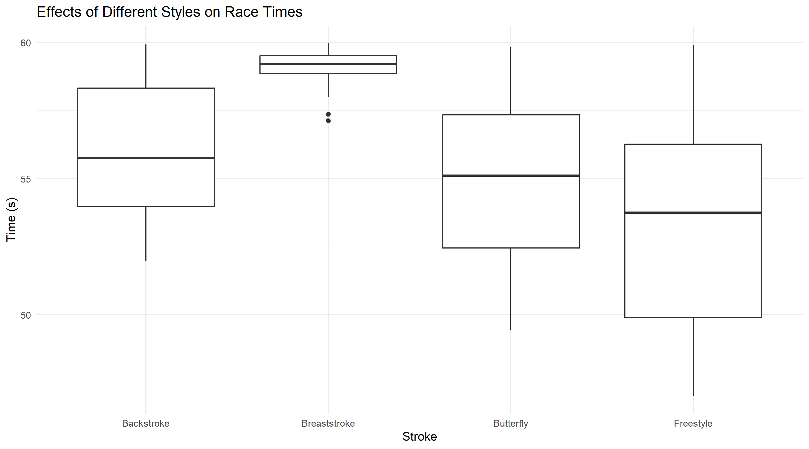

1. Interpret the side-by-side boxplots above. Be sure to compare medians and note any skew and outliers.

All four of the boxplots have approximately no skew. There are two upper (lower times) outliers under the breaststroke category. The freestyle has the highest median of the four styles, with butterfly, backstroke, and breaststroke following. Freestyle has the highest range and IQR, while breaststroke has the lowest range and IQR.

1. Give an approximate 5 number summary of the Butterfly Stroke.

Minimum: ~ 59.5, Q1: ~ 57, Median: ~ 55, Q3: ~ 52.5, Maximum: ~ 49