**UFC Normal Distribution Problems**

The UFC officially began in 1993 and has been growing in popularity ever since. As of 2023, it’s the largest mixed martial arts promotion in the world. The UFC represents fighters from over 75 different countries and there have been over 700 events around the world. The UFC attracts a diverse group of spectators from all different backgrounds that support their nation’s top fighters.

We will be investigating striking accuracy percentages from fighters who competed from 1993 to 2021. The data we will be using contains 1673 rows and 14 variables, each row representing a fighter and their career statistics.

In the UFC, striking is hand-to-hand combat in the standing position. A landed shot is when a fighter hits their opponent’s body without being blocked. The accuracy percentage is defined by the number of lands divided by the number of attempts. Being an accurate striker is an important skill as it can help you conserve energy, land more shots, and weaken the opponent.

Our goal is to find what striking percentages will place you in the bottom, middle, or top of the pack in the approximately normal distributed percentages. Although not a make-or-break skill in a fight, having a higher percentage can greatly improve the chances of winning.

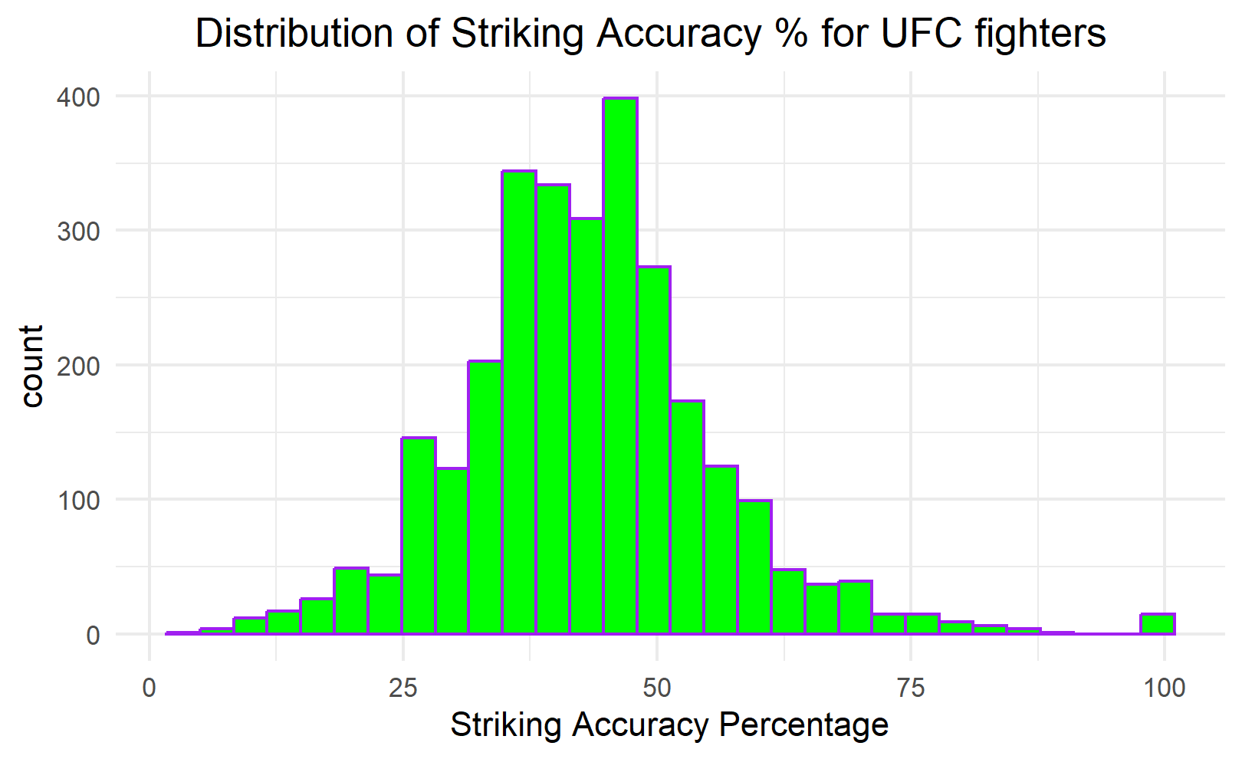

According to UFC fighter data the mean striking accuracy percent is 43.2 with standard deviation 12.6. Assume the distribution is approximately normal.

1. The UFC fight of the year in 2019 was between Israel Adesanya and Kelvin Gastelum. Adesanya had a striking accuracy percentage of 49%. What proportion of fighters had a better striking accuracy percentage than him?
2. Kelvin Gastelum had a striking accuracy percentage of 43%. What proportion of fighters are in between him and Adesanya?
3. Find the z-score of Israel Adesanya’s striking accuracy percentage (49%).
4. What would a high and low z-score mean in the context of the UFC? Explain.
5. Fighters with the top 10% for accuracy percentage have above what accuracy percentage?
6. What striking accuracy percentages cut off the middle 80% of the distribution?
7. Brainstorm some ideas on different types of statistical applications you could use with this data with since it’s approximately normal. Explain.