Go to the following web applet:

**http://www.rossmanchance.com/applets/ConfSim.html**

Make the following changes

* In the box labeled $π$ enter **0.275** (This is a simulation, so we need to specify the “truth”)
* Enter **100** in the box labeled n (this is your sample size)
* Enter **100** in the box labeled intervals (each time you click Sample you will take 100 random samples from the population and construct a 95% confidence interval for $π$, the population proportion)

Click the Sample button 10 times. You have just created 1,000 confidence intervals (based on 1,000 different random samples from the population).  
  
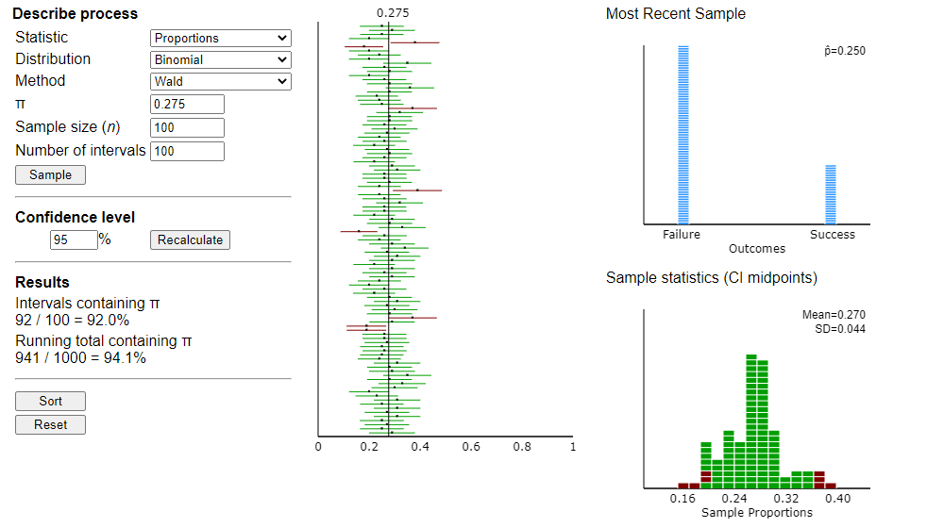

1. Reminder: What is the formula for a confidence interval for p (a population proportion)?
2. What does the black vertical line at 0.275 represent?
3. What do the 100 horizontal lines (some are green and some are red) represent?
4. What do the green intervals represent? What do the red intervals represent?
5. What was your “Running total” (the percent of the 1,000 confidence intervals that contained the parameter, $π$)?
6. What value does the running total seem to be close to? What is “special” about that value?
7. Finish the following sentence: If we take lots of random samples and make 95% confidence intervals from each, then

Hit the “Reset” button. Now make the following changes

* In the first drop-down box change “Proportions” to “Means”
* In the third drop-down box (labeled “Method”) change “z with sigma” to “z with s.”
* In the box labeled “Population mean ($μ)$” enter **70**; in the box labeled “Population Sd $(σ)$” enter **2.8**. (This is a simulation, so we need to specify the “truth”)
* Enter **5** in the box labeled n (this is your sample size)
* Enter **100** in the box labeled intervals (each time you click Sample you will take 100 random samples from the population and construct a 95% confidence interval for **, the population mean)

1. What is our *proposed* formula for a confidence interval for a population mean?
2. Click the Sample button 10 times. You have just created 1,000 confidence intervals (based on 1,000 different random samples from the population). What was your running total (the percent of the 1,000 confidence intervals that contained the population mean, **)?

1. What should the coverage rate have been?