Part of the data table displaying the results of the first day survey is provided below.

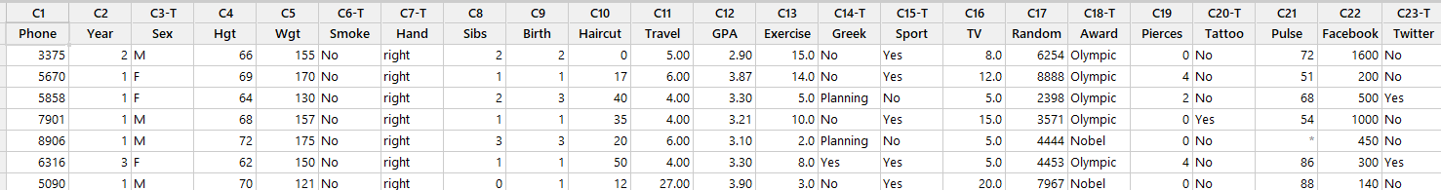

1. What are the cases?
2. Identify some categorical variables:
3. Identify some numerical variables:
4. Pose two research questions involving a single variable:
5. Pose two research questions about the relationship between two variables:

**Bar Charts (One Categorical Variable)**

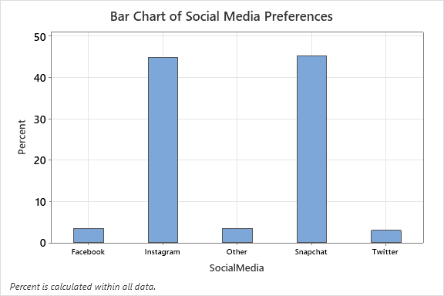 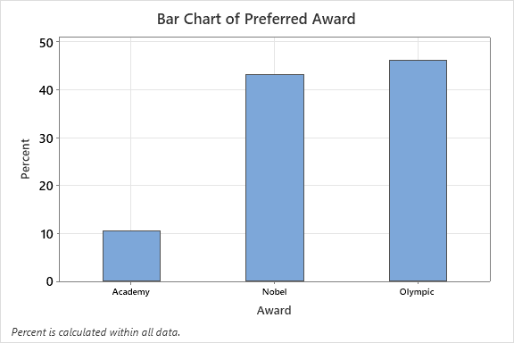

**Dot Plots (One Numerical Variable)**

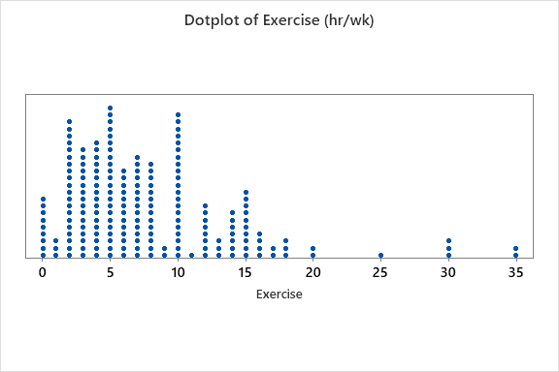 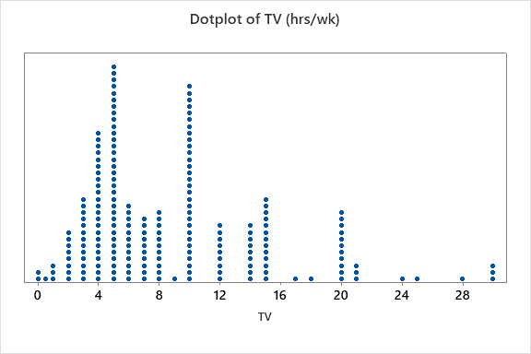

|  |  |  |  |
| --- | --- | --- | --- |
| **Variable** | **N** | **N\*** | **Mean** |
| TV | 200 | 1 | 8.842 |
| Exercise | 198 | 3 | 7.884 |