Question: How much value does a Toyota Camry lose as it ages?

Data: **toyota_camry.csv**

Description: The data contains a sample of 25 used Toyota Camrys collected in 2019 from Autotrader.com. The variables considered here are 1) ***age***- the how old the car is in years and 2) ***price*** - the cost of the vehicle in thousands of dollars.

**Stat > Regression > Fitted Line Plot** (Enter explanatory and response variables)

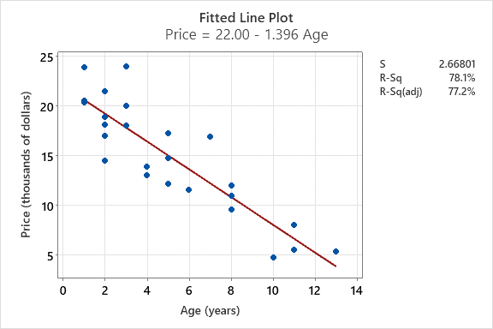

1. What is the explanatory variable in this situation? What is the response variable? What type are both variables?
2. What does each point in the scatterplot represent?
3. Report the least squares regression equation for predicting price from age.

1. What does the model predict the price to be for a Camry that is 5 years old?

1. One of the 5-year-old Camrys in our data costs $17,300. How far off was our prediction for a Camry of this age?
2. Interpret the slope of the model in the context of the application. Be sure to be mindful of the units.
3. Interpret the intercept of the model in the context of the application.
4. Is the intercept interpretation meaningful? Explain.
5. What percent of variation in used Toyota Camry prices is explained by the model using age?
6. What is the sample correlation between the price and age of used Toyota Camrys?