Question: Does a wine’s rating (scale 85 – 100) impact its price?

Data: **CA_wine_pinot_noir.csv**

Description: The data contains a random sample of 100 ratings and prices of Pinot Noirs from California vineyards with scores above 85. The variables considered here are 1) ***points*** - the number of points WineEnthusiast rated the wine on a scale 1 – 100 and 2) ***price*** - the cost for a bottle of the wine.

**Stat > Regression > Fitted Line Plot** (Enter explanatory and response variables)

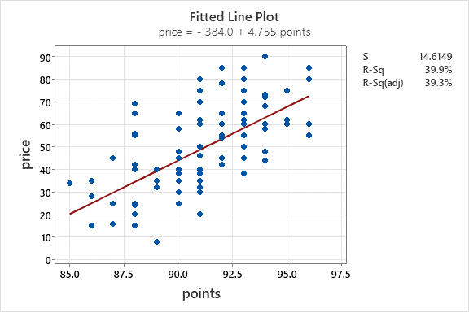

1. What is the explanatory variable in this situation? What is the response variable? What type are both variables?
2. What does each point in the scatterplot represent?
3. Report the least squares regression equation for predicting price from points.
4. Onehope Winery’s 2017 Reserve Pinot Noir (which is not in our sample) scored 91 points and cost $30. What does the model predict the price to be for this wine?
5. How far off was our prediction for the wine in #4? Based on this, should we consider this wine to be a good deal or is it overpriced?
6. Interpret the slope of the model in the context of the application. Be sure to be mindful of the units.
7. Interpret the intercept of the model in the context of the application.
8. Is the intercept interpretation meaningful? Explain.
9. What percent of variation in wine prices is explained by the model using points?
10. What is the sample correlation between the price and points of wines?