**One Categorical and One Numerical: *Stat113Spring2019.csv***

***Graph > Boxplots > With Groups  
Under “Data Options/Group Options” uncheck the two boxes to remove “missing” data  
(Can also add “gridlines” by right-clicking on the graph, choosing “Edit Graph” and clicking “Gridlines” under “Add Item”.)***

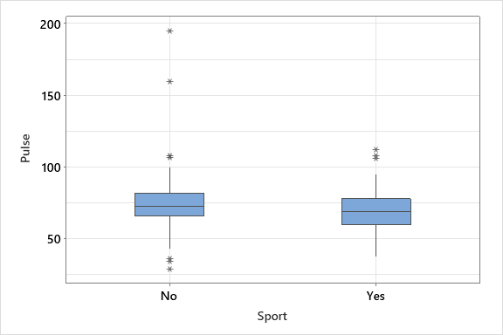

**Two Categorical Variables*:** ***Darwin.csv***

***Tables > Cross Tabulation and Chi-Square  
Graph > Bar chart (Cluster);*** *specify both variables, click “Chart Options”, then “Show Y as Percent” and “Within categories at level 1”****Graph > Bar chart (Stacked);*** *specify both variables, click “Chart Options”, then “Show Y as Percent” and “Within categories at level 1”*

|  |  |  |  |  |  |
| --- | --- | --- | --- | --- | --- |
|  | **High School or Less** | **Some College** | **College Graduate** | **Postgraduate** | **Total** |
| **Believe** | 80 | 133 | 121 | 63 | 397 |
| **Do Not Believe** | 103 | 94 | 48 | 9 | 254 |
| **No Opinion** | 197 | 98 | 59 | 13 | 367 |
| **Total** | 380 | 325 | 228 | 85 | 1018 |

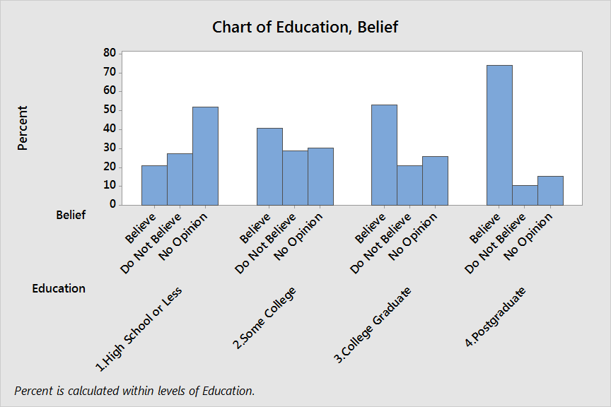 

**Two Numerical Variables: *Diamonds.csv***

Data were recorded on the size (number of carats) and the price of a sample of 1,000 diamonds.



**Visualizing Relationships with Three Variables**

|  |  |
| --- | --- |
| One Numerical Response Variable and Two Categorical Explanatory Variables | Two Numerical Variables (one Explanatory and one Response) and a Categorical Explanatory Variable |
|  |  |
|  |  |