1. Suppose we record the ages of nine squirrels (depicted below). Open the dataset **SquirrelAges.csv**

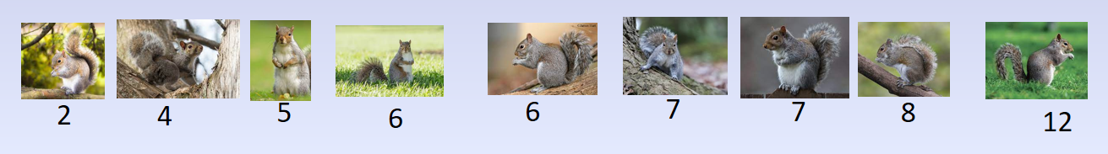

* 1. Report the median squirrel age?
  2. Report the first and third quartiles of our sample.
  3. Find the IQR for our sample.

1. What if I mistyped the age of the oldest squirrel? It should have been 21 instead of 12. When we correct the mistake, how would all of the numerical summaries change?
2. League of Legends is a 5 v. 5 multiplayer online battle arena (MOBA) game developed by Riot Games. In the game, players assume the role of a “champion” with unique abilities and battle against a team of other players or computer-controlled champions. Riot Games continually collects data to evaluate the effect of every champion, adjusting and fine-tuning various aspects associated with each champion, to ensure fair and competitive gameplay. Through various updates (patches) of the game that occur every two weeks, characters might turn out to be either extremely efficient and strong, or they might need adjustments to increase their abilities, as they are on the weaker side. Therefore, in order for an overall game balance to be achieved, developers use two common strategies, known as “nerfing” and “buffing”, within the world of video games. “Nerfing” is the act of reducing the power or effectiveness of a champion or item in a video game, while “buffing” is the act of increasing its power or effectiveness.

|  |  |
| --- | --- |
| Name | Win Rates |
| Fiddlesticks | 56.7 |
| Vi | 56.4 |
| Kled | 56.1 |
| Kog'Maw | 55.6 |
| Elise | 55.4 |
| Aphelios | 47.5 |
| Azir | 47.3 |
| Zeri | 47.2 |
| Pantheon | 46.7 |
| Sion | 44.2 |

* 1. Open the dataset **LOL_patch_12.22.csv** and obtain/report the summary statistics for   
     the Win Rates of the champions.
  2. The five highest and lowest Win Rates are reported in the table to the right. Determine  
      if there are any outliers. Which players need buffing? Which need nerfing?

* 1. Make a boxplots of Win Rates. Sketch below and describe the distribution of Win Rates. Does the boxplot agree with your conclusion from part b?
  2. After analyzing the data from LOL_patch_12.22, the developers of the game released the 12.23 patch of League of Legends with new “nerfed” and “buffed” champions. Now open the dataset **LOL_patch_12.23.csv**. Did the “nerf” or “buff” you suggest in part b work? That is, in Patch 12.23, did the champion(s) you identify in part b have a win rate that is now more in line with the rest of the champions? (Note, you will need to look for your champion’s name in the dataset). Justify your response.