1. Match the histogram to the standard deviations: *s* = 1, *s* = 3, and *s* = 5

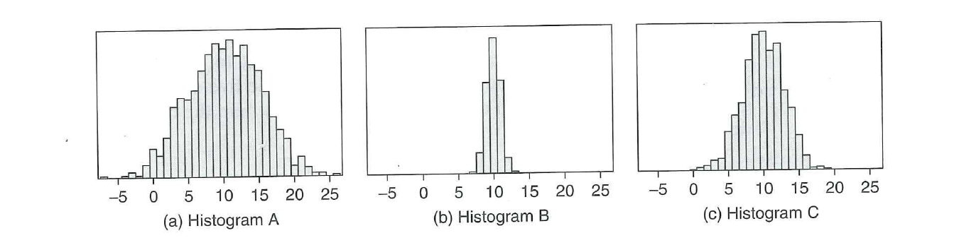

1. Suppose that Samira records the ages of customers at the Northstar Café from 12 – 2pm, while Meredith records the ages of customers at Burger King at the same time. Who will have the larger standard deviation of their ages – Samira or Meredith? Why?
2. Suppose we record the ages of nine squirrels (depicted below).

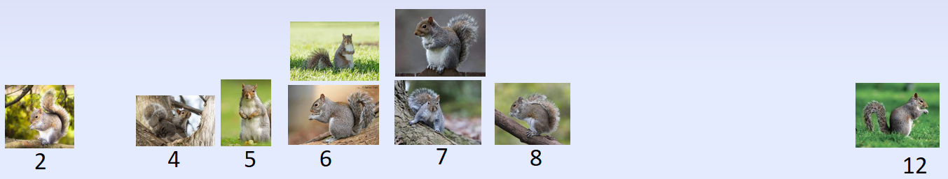

* 1. What is the average squirrel age?
  2. Which squirrel has the largest deviation from the mean (and thus the biggest influence on the standard deviation)?

* 1. What is the standard deviation of squirrel ages?

1. All three distributions have the same mean (14.5), and the same number of observations are depicted in each histogram. Which distribution has the largest standard deviation and which has the smallest?

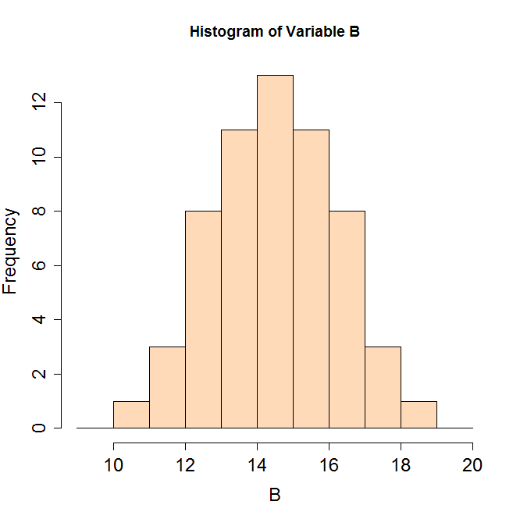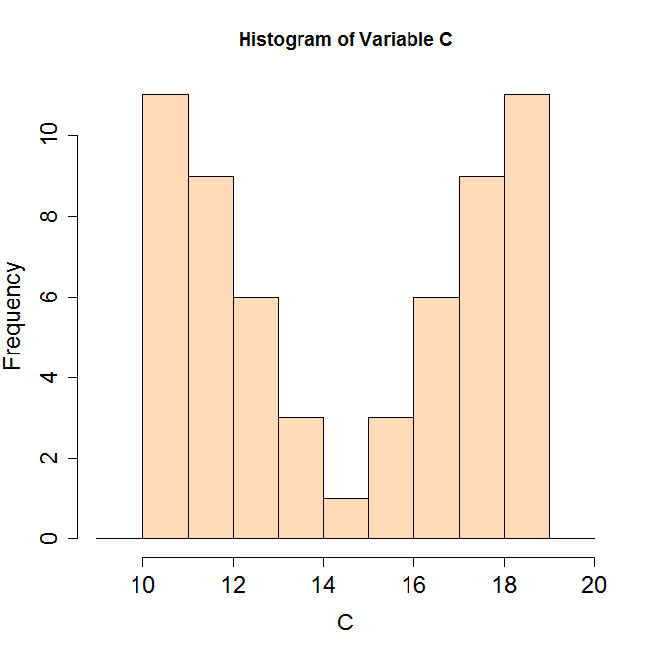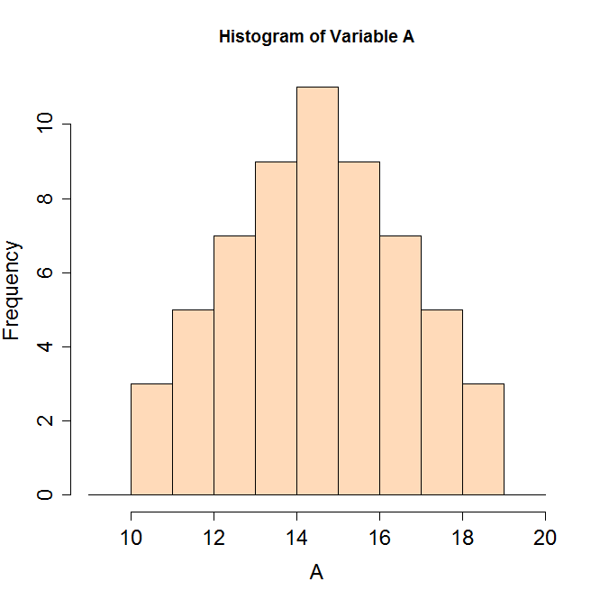

1. Suppose that Natasha achieves a score of 1250 on the SAT, and her brother Boris scores 29 on the ACT.  *Who did better, relative to their peers?*What other information do you need to answer this question?