**Exploring the Ratio of Dumbbell Press to Flat Bench Press**

**Many weightlifters wish to track the ratio between the weight they use for flat dumbbell press compared to barbell bench press.**

A **dumbbell** is a short bar with equal weight on both sides designed to be held in the lifter's hands. Flat dumbbell press is when the lifter lies on a flat bench with their arms positioned at roughly 45-degree angles, lifts two equal sized dumbbells, brings them back to the chest, and then keeps going.

A **barbell** is similar in shape to a dumbbell, but is a longer, much heavier bar where multiple weighted plates can be placed on either side. Barbell bench press is when the lifter lies on a bench with the barbell positioned at their chest, lifts the barbell, and then brings it back down.

Say Melissa is able to flat dumbbell press two 30 lbs dumbbells. The total amount she can flat dumbbell press is 60 lbs (one dumbbell for each arm). On barbell bench press, she can lift 75 lbs. Her ratio would be calculated by dividing flat dumbbell press by barbell bench press (60/75) which equals 0.8, meaning that Melissa can lift two dumbbells up to 80% as heavy as she can bench press the barbell.

The goal of the ratio is to compare how much someone is lifting two dumbbells versus how much they are able to lift the weighted barbell. You obtain the ratio by multiplying the weight of one dumbbell by 2 (to account for the two weights that the person would hold) and dividing that weight by the amount someone is able to barbell bench press.

**The data is sourced from a self-reported Reddit open forum[1]. Users provided their weight for both a flat dumbbell press and a barbell bench press, and it was compiled by another user into the corresponding weight ratio. It is important to note that as this is a self-reported open forum.**

Below is a dataset with observations from 18 weightlifters and their corresponding ratio, as well as summary statistics and a dot plot. These data are also available in the file, dumbbell_barbell_weight_ratio.csv.

1. Based on the dot plot and the data table, what could be a concern regarding the distribution of the data with respect to building a confidence inteval for the average?

With a relatively small sample size, it is difficult to get a good understanding of the shape of the distribution. (e.g., Is it actually unimodel and symmetric?) Luckily, there are any outliers, so the Central Limit Theorem could likely still apply here – assuming we can use the values to represent a population. (It is worth noting that using normality assessing tools such an Normal QQ plots and/or Normality tests indicate that the data look fairly Normal.)

1. What potential problems could arise from the way the data was collected? What population might we still generalize to?

Since the data was based on self-reporting and from an online open forum such as Reddit, we are very limited in to whom these results can be generalized to. For example, are these results reflective of typical young adult fitness enthusiasts or do we have a more limiting data set. With a small sample size coming from a relatively unknown population, we would want to be cautious interpreting these data.

Further, when self-reporting, there is bound to be bias and noise in the data. At best, this will just increase the variability in our data, further decreasing the precision of our results. At worst, it may invalidate the results due to any unforeseeable biases.

1. Regardless of your answer to the previous questions, calculate a 95% confidence interval for the mean ratio between flat dumbbell press and barbell bench press.

If using t-distributions should get (0.682, 0.769) (using df = 17 and t* = 2.110, and se = 0.0205)

If using bootstrap interval, you should get approximately (0.687, 0.765). (See screenshot from StatKey below.)

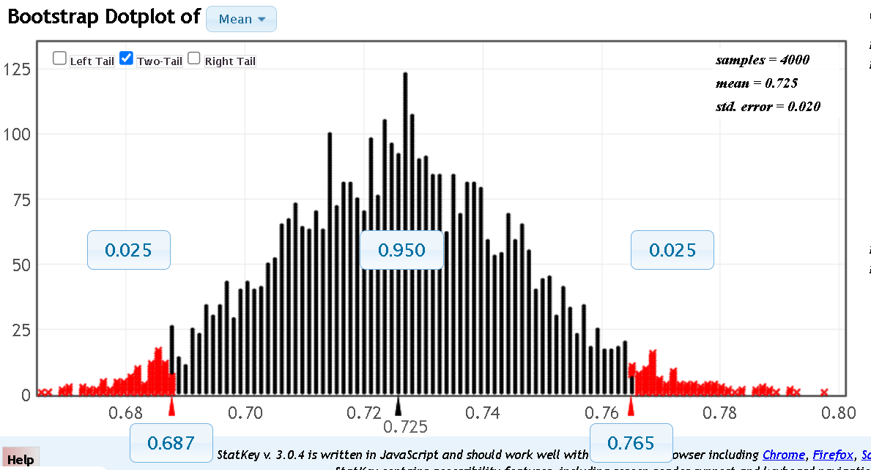

1. Considering your previous concerns regarding data, do you believe that the range of plausible values for the “average ratio” presented in this confidence interval is meaningful? If so, what audience would it apply to? If not, why do you feel it not useful? Explain your answer.

Answers vary and no answer is likely 100% correct. Some answers could mimic something like:

Students that feel it is meaningful:

If we limit ourselves to just people similar to those that would likely be on a fitness subreddit, we can provide them with some rough guidance on what is a meaningful balance between the two exercises.

Students that feel it is not meaningful:

The sample size is too small and there is likely too many issues with the data collection to be able to provide a reasonable, precise estimate for the population mean. As of right now, this would only apply to people who regularly do these exercises and work out, as the people who self-reported their data probably lean more towards that audience. Perhaps if there was a larger sample size, the population mean presented in the confidence interval could apply to a larger audience.

**Again, we note that there is no clear answer to this question. Like many datasets we encounter in real life we need to decide if limited data are still useful, or if their shortcomings invalidate any results. (tldr; is this a case of “garbage in, garbage out?”)**

1. We’ve seen that Melissa has a ratio of 0.8. Suppose that she is an avid follower of r/Fitness. Now, she has a goal to become more “balanced” and have more of an average ratio in line with what she believes to be her peers. What should she do in order to achieve this? Explain both in terms of the ratio and the exercises involved.

Since Melissa’s ratio is above the average she would need to decrease her ratio. Assuming she is interested in gaining strength, she can become more balanced by getting better at barbell bench press (i.e., increasing the denominator of ratio) so that it is even more than to the amount she can flat dumbbell press (the numerator) and thus making the ratio smaller.

1. Suppose you wish to further investigate the strength ratio; how would you go about finding more concrete results and how would that make the data more useful? Be specific.

To get more useful data some of the things that you would need to consider are

1. Devise a (more) clear group of individuals you wish to learn about,
2. Develop a sampling procedure to collect data from the desired population, and
3. Determine how large of a sample size would be sufficient to obtain the wanted precision for the CI.

This question can provide the beginnings of a discussion related to study planning and may then extend into topics such as sampling design and sample size calculations. Further, it allows instructors to discuss with students the difficulty in collecting “perfect data” and/or how crude data, such as from Reddit forums, can be used for generating hypotheses and guiding more extensive, controlled studies.

1. Reddit Thread: <https://www.reddit.com/r/Fitness/comments/35q4i3/how_much_do_you_dumbbell_flat_bench_compared_to/>