Formula 1 is the highest class of single seater racing category with a season featuring a series races, known as Grand Prix, which are held in a variety of countries. A single race has drivers each complete a number of laps at a specific circuit. While laps are generally around the same time, in every Grand Prix, a car will complete anywhere between 1 and 5 pit stops in a race to change tires, replace parts, or check damage on the car. Races can also introduce red flags and yellow flags (that indicate race stoppage or caution due to accidents) that could slow a car’s lap time. This dataset has times from the 2023 F1 Miami Grand Prix, where each driver completed 57 laps (minus the lapped cars in last and second-to-last who only completed 56) as there were no red or yellow flags brought out. This worksheet focuses on only lap times from a single driver, Max Verstappen, the winner of the 2023 F1 Miami Grand Prix.

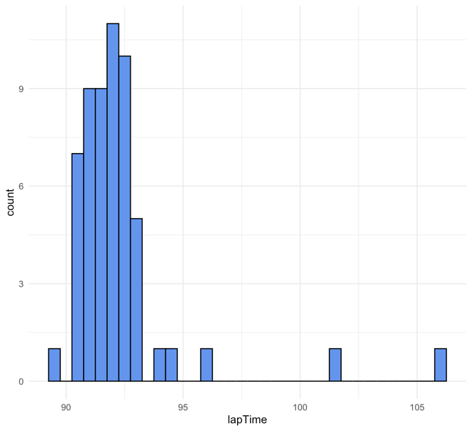
- Indicate the observations (cases) of the data set for the 2023 F1 Miami Grand Prix

- Use the histogram to describe shape, center, and spread of Max Verstappen’s Lap Times during the race

- How many observations are there in the histogram to the right?

- Given the following summary statistics of Verstappen’s lap times…

Min.: 1st Qu: Median: Mean: 3rd Qu: Max:
89.71 91.18 91.83 92.25 92.43 106.12

  - Determine which lap(s) would be considered an outlier?

- Given the general description of an F1 race above, what is one reason that there are some laps that are so far away from the rest of the data?

- Would removing these lap times provide a more accurate analysis of a driver’s or constructor’s race?

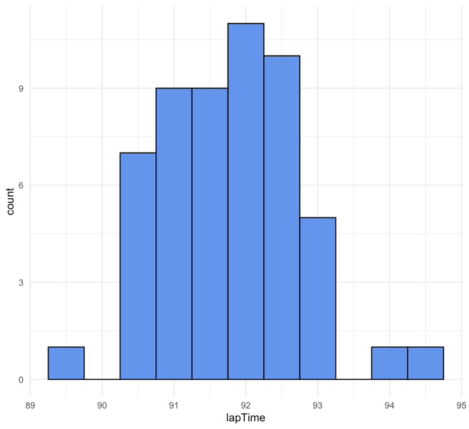
- Describe the histogram with outliers removed from the data

- Would you expect the mean and median lap time to increase or decrease after the outliers are removed? Why?

