The Impact of Outliers: The Raisin River Canoe Race

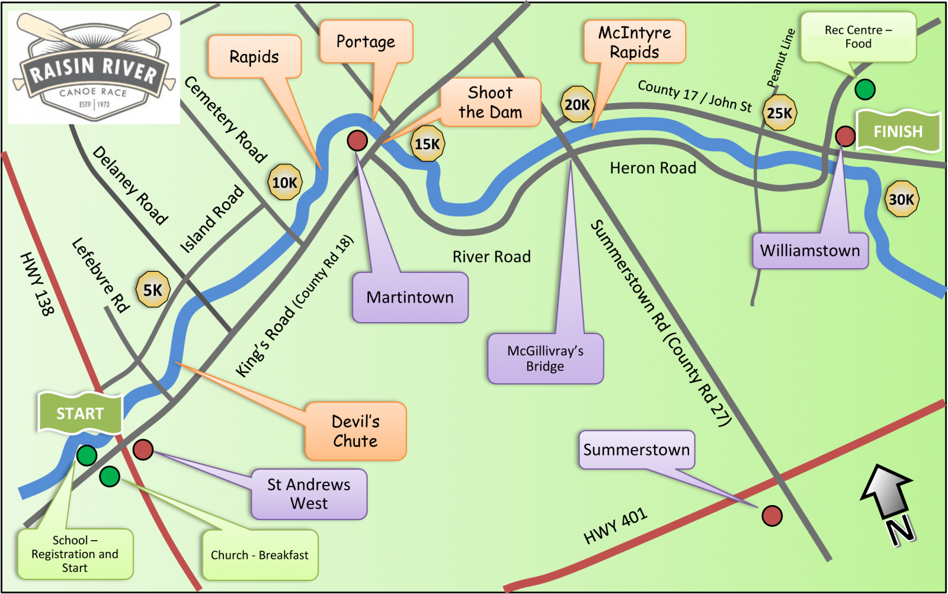
Downriver racing is a sport where competitors take their watercraft (usually a canoe, kayak, or stand-up paddle board) down a race course in competition with other paddlers, sometimes navigating rapids, in an attempt to get the fastest time either overall or in their class (classes are split up by boat and paddler type). The Raisin River Canoe race has been running for over 50 years on the Raisin River in Eastern Ontario. The usual race course is 30 km (about 18.6 miles) and contains rapids that fluctuate in difficulty with the water level.
In race results, a DNF (did not finish) refers to a boat that did not make it to the finish line. Most of the time, these boats are paddlers who at some point decided to drop out of the race. This is most common in longer races (like Raisin River) or races with dangerous rapids. While the rapids on the Raisin River course are not too intimidating, as water level increases, the difficulty (or, more importantly, the fear factor) increases as well.
Race directors are responsible for keeping track of their competitors and making sure they get off the river safely, so it is important that race officials are aware of possible DNFs. Having a way to predict the proportion of participants that may DNF the race based on the water level (information that is known ahead of time) could be very useful. For this activity we will be using data containing DNF and water level measures from the Raisin River Race from 2005-2025 to look at how outliers can impact a model.

The dataset raisin_riverDNF.csv contains information on three variables for the Rasin River race for 9 years between 2015 and 2025 (excluding 2020 and 2021, when the race didn't run, and 2019, which has incomplete data).

year Year of the Raisin River Race
prop_DNF Proportion of boats that did not finish (DNF) the race
flow Flow measurement (indicative of water level) in ft³/sec

Explore the relationship between flow rate and proportion of DNFs
- Create a scatterplot with regression line that shows flow rate as a predictor for proportion of DNF.
- Assess the fitted model.
  - Interpret the value of the slope coefficient of flow in context.
  - What does the p-value for that coefficient indicate about the relationship between flow rate and proportion of DNF?
  - Comment on the appropriateness of the model.
Investigate unsual/influential observations
- Identify any observations that have unusual leverage, standardized residuals, or influence.

Consider the outlier
Your analysis from #3 should show that the 2017 race with a flow rate of 2649 ft³/sec and 0.0051 DNF proportion is unusual. While we shouldn’t automatically exclude any unusual case, we should investigate, when possible, to see if there are circumstances that might warrant dropping that case. In this situation, the water level was dangerously high in 2017, causing the race officials to move the race start to Delaney Road (roughly 4 miles further down the river – see the map). Based on that domain knowledge, we should consider re-doing the analysis without the 2017 data.

- Remove the influential (2017) observation from the data set
- Draw a new scatterplot and show the revised line of best fit. How does this plot compare to the earlier fit?
- Give a revised interpretation for the slope (in context) and discuss the effectiveness of flow as a predictor for proportion DNF in the absence of the 2017 outlier.
- If the flow level is 1100 ft³/sec and there are 200 boats entered in the Raisin River Race, how many DNFs should we expect?

