The Impact of Outliers: The Raisin River Canoe Race
SOLUTIONS

1. Create a scatterplot with regression line that shows flow rate as a predictor for proportion of DNF.

After reading the raisin_river.DNF.csv dataset into software, we produce a scatterplot with the regression line to predict proportion of DNF using flow rate to obtain the plot below.
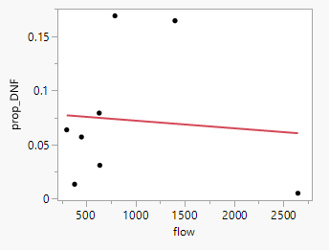

2. Assess the fitted model.

a) Interpret the value of the slope coefficient of flow in context.
Here is some output for fitting this regression model:

Term | Estimate | Std Error | t Ratio | Prob>|t|
Intercept | 0.0791609 | 0.038098 | 2.08 | 0.0830
flow | -7.061e-6 | 3.273e-5 | -0.22 | 0.8363

INTERPRETATION: For every 1000 ft^3/sec increase in flow, we can expect a 0.00706 decrease in the proportion of DNFs.

b) What does the p-value for that coefficient indicate about the relationship between flow rate and proportion of DNF?
The p-value for the flow coefficient is 0.836, which means there is no convincing evidence for flow being a useful predictor of proportion DNF in the linear model made using this dataset.

c) Comment on the appropriateness of the model
Based on the scatterplot and the model summary, a linear model does not appear to be appropriate. There is one observation with a very high flow rate and low DNF influencing the model too much for it to make sense.

Investigate unusual/influential Observations

3. Identify any observations that have unusual leverage, standardized residuals, or influence.

Using software we add values to the original dataset for the leverage (hat values), standardized residuals, and Cook’s D to measure influence.

year | prop_DNF | flow | Hat values | Standardized Res. | COOKs D
2015 | 0.0636 | 300 | 0.210017 | -0.22293 | 0.00661
2016 | 0.0309 | 636 | 0.141764 | -0.69643 | 0.04006
2017 | 0.0051 | 2649 | 0.833427 | -1.99923 | 9.99904
2018 | 0.0570 | 450 | 0.173053 | -0.30771 | 0.00991
2022 | 0.1643 | 1400 | 0.182174 | 1.54884 | 0.26718
2023 | 0.0791 | 630 | 0.142522 | 0.06984 | 0.00041
2024 | 0.1688 | 790 | 0.128045 | 1.50304 | 0.16587
2025 | 0.0134 | 380 | 0.188999 | -1.03244 | 0.12421

INTERPRETATION:
A leverage value beyond 4/n=4/8=0.5 is considered mildly unusual and beyond 6/n=6/8=0.75 is more extreme. We see that the data for 2017 with a leverage value of 0.833 should be flagged as an extreme leverage value.

A standardized residual value beyond $±2$ is mildly unusual and beyond $±3$ is more extreme. None of the standardized residuals are beyond those thresholds, although the value -1.99923 value for 2017 is very close!

Values of Cook’s D beyond 0.5 are considered mildly unusual and beyond 1 are more extreme. The Cook’s D value of just under 10.0 for 2017 would be very extreme.

Consider the outlier
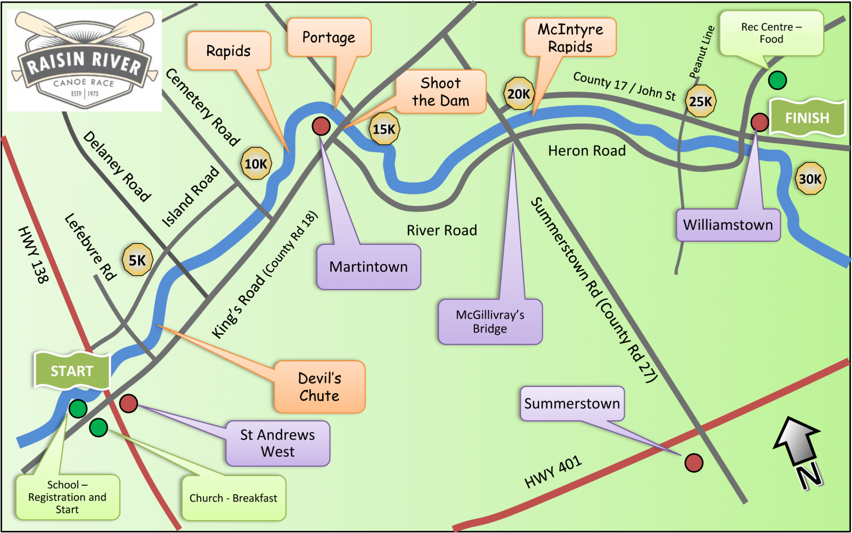
Your analysis from #3 should show that the 2017 race with a flow rate of 2649 ft3/sec and 0.0051 DNF proportion is unusual. While we shouldn’t automatically exclude any unusual case, we should investigate, when possible, to see if there are circumstances that might warrant dropping that case. In this situation, the water level was dangerously high in 2017, causing the race officials to move the race start to Delaney Road (roughly 4 miles further down the river – see the map). Based on that domain knowledge, we should consider re-doing the analysis without the 2017 data.

4. Remove the influential (2017) observation from the data set.

a) Draw a new scatterplot and show the revised line of best fit. How does this plot compare to the earlier fit?
Here is a scatterplot with the regression line to predict proportion of DNF using flow rate after deleting the data from 2017:
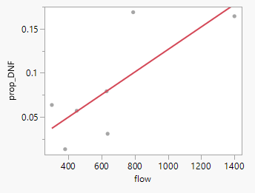
With the 2017 data point omitted, we see a positive association between the flow rate and proportion of DNF.

b) Give a revised interpretation for the fitted slope (in context) and discuss the effectiveness of flow as a predictor for proportion DNF in the absence of the 2017 outlier.

Here is some output for fitting the regression model after the data for 2017 is deleted:

Term | Estimate | Std Error | t Ratio | Prob>|t|
Intercept | -0.001338 | 0.035086 | -0.04 | 0.9710
flow | 0.0001279 | 4.748e-5 | 2.69 | 0.0431*

INTERPRETATION: For every 100 ft^3/sec increase in flow, we expect about a 0.0128 increase in the proportion of DNFs. The p-value for testing this slope (0.0431) is less that 0.05, so we have mildly convincing evidence that a faster flow rate is associated with a higher proportion of boats not finishing the race.

c) If the flow level is 1100 ft^3/sec and there are 200 competitors about how many DNFs can we expect?

Using the revised prediction equation we have
$$\hat{Prop_DNF}=-0.001338+0.0001279\left(1100\right)=0.139352$$
and
$$200*0.19352=27.87$$

If flow rate is 1100 ft\^3/sec and there are 200 competitors, we can expect about 28 DNFs.

