Exploring the Ratio of Dumbbell Press to Flat Bench Press
Many weightlifters wish to track the ratio between the weight they use for flat dumbbell press compared to barbell bench press.
A dumbbell is a short bar with equal weight on both sides designed to be held in the lifter's hands. Flat dumbbell press is when the lifter lies on a flat bench with their arms positioned at roughly 45-degree angles, lifts two equal sized dumbbells, brings them back to the chest, and then keeps going.
A barbell is similar in shape to a dumbbell, but is a longer, much heavier bar where multiple weighted plates can be placed on either side. Barbell bench press is when the lifter lies on a bench with the barbell positioned at their chest, lifts the barbell, and then brings it back down.
Say Melissa is able to flat dumbbell press two 30 lbs dumbbells. The total amount she can flat dumbbell press is 60 lbs (one dumbbell for each arm). On barbell bench press, she can lift 75 lbs. Her ratio would be calculated by dividing flat dumbbell press by barbell bench press (60/75) which equals 0.8, meaning that Melissa can lift two dumbbells up to 80% as heavy as she can bench press the barbell.
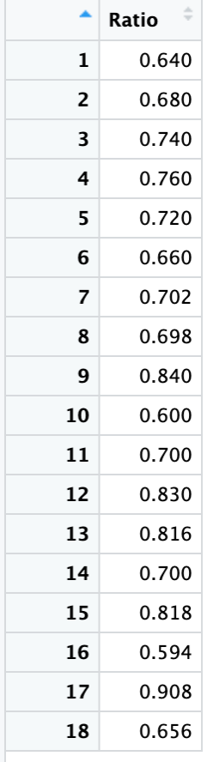
The goal of the ratio is to compare how much someone is lifting two dumbbells versus how much they are able to lift the weighted barbell. You obtain the ratio by multiplying the weight of one dumbbell by 2 (to account for the two weights that the person would hold) and dividing that weight by the amount someone is able to barbell bench press.
The data is sourced from a self-reported Reddit open forum. Users provided their weight for both a flat dumbbell press and a barbell bench press, and it was compiled by another user into the corresponding weight ratio. It is important to note that this is a self-reported open forum.
Below is a dataset with observations from 18 weightlifters and their corresponding ratio, as well as summary statistics and a dot plot. These data are also available in the file, dumbbell_barbell_weight_ratio.csv.
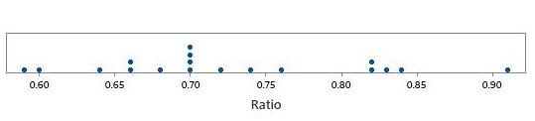
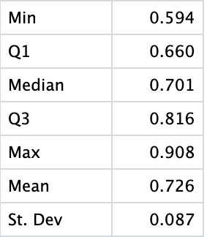

- Based on the dot plot and the data table, what could be a concern regarding the distribution of the data with respect to building a confidence interval for the average?

- What potential problems could arise from the way the data was collected? What population might we still generalize to?

- Regardless of your answer to the previous questions, calculate a 95% confidence interval for the mean ratio between flat dumbbell press and barbell bench press.

- Considering your previous concerns regarding data, do you believe that the range of plausible values for the “average ratio” presented in this confidence interval is meaningful? If so, what audience would it apply to? If not, why do you feel it not useful? Explain your answer.

- We’ve seen that Melissa has a ratio of 0.8. Suppose that she is an avid follower of r/Fitness. Now, she has a goal to become more “balanced” and have more of an average ratio in line with what she believes to be her peers. What should she do in order to achieve this? Explain both in terms of the ratio and the exercises involved.

- Suppose you wish to further investigate the strength ratio; how would you go about finding more concrete results and how would that make the data more useful? Be specific.

Reddit Thread: https://www.reddit.com/r/Fitness/comments/35q4i3/how_much_do_you_dumbbell_flat_bench_compared_to/

