League of Legends is a 5 v. 5 multiplayer online battle arena (MOBA) game developed by Riot Games. In the game, players assume the role of a “champion” with unique abilities and battle against a team of other players or computer-controlled champions. Riot Games continually collects data to evaluate the effect of every champion, adjusting and fine-tuning various aspects associated with each champion, to ensure fair and competitive gameplay. Through various updates (patches) of the game that occur every two weeks, characters might turn out to be either extremely efficient and strong, or they might need adjustments to increase their abilities, as they are on the weaker side. Therefore, in order for an overall game balance to be achieved, developers use two common strategies, known as “nerfing” and “buffing”, within the world of video games. “Nerfing” is the act of reducing the power or effectiveness of a champion or item in a video game, while “buffing” is the act of increasing its power or effectiveness.

Patch 12.22 Win Rates

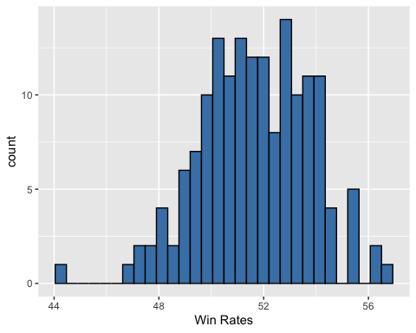

1. Indicate the cases of the data set

Individual League of Legends Champions

1. Describe the histogram of the 12.22 patch of Win Rates

Center: Around 50%  
Shape: Unimodal + Symmetric

Spread: Between 46-55%

Possible Outliers: below 46% and above 55%

1. Given summary statistics and the Champions with the five highest and five lowest Win Rates. Determine if there are any outliers present. Which players need buffing? Which players need nerfing?

1.5 * IQR Rule:  
IQR = 53.27 – 50.2 = 3.07  
1.5(IQR) = 1.5(3.07) = 4.605

Q1 – 4.605 = 50.2 – 4.605 = 45.6  
Q3 + 4.605 = 53.27 + 4.605 = 57.88

By the IQR Rule, there is one champion that would be considered an outlier, Sion. Because Sion has a low Win rate, they need to be buffed.

Note: Calculating z-scores for each obersvation is also another method of determining outliers. In the case of Sion, we see the following

$$z= \frac{44.2-51.66}{2.097}= -3.5574$$

Z-scores outside of ± 3 are considered outliers

|  |  |
| --- | --- |
| Mean | St. Dev |
| 51.66 | 2.097 |

|  |  |  |  |  |
| --- | --- | --- | --- | --- |
| Min | Q1 | Med | Q3 | Max |
| 44.24 | 50.20 | 51.70 | 53.27 | 56.70 |

|  |  |
| --- | --- |
| Name | Win Rates |
| Fiddlesticks | 56.7 |
| Vi | 56.4 |
| Kled | 56.1 |
| Kog'Maw | 55.6 |
| Elise | 55.4 |
| Aphelios | 47.5 |
| Azir | 47.3 |
| Zeri | 47.2 |
| Pantheon | 46.7 |
| Sion | 44.2 |

After analyzing the data, the developers of the game released the 12.23 patch of League of Legends with new “nerfed” and “buffed” champions.

Patch 12.23 Win Rates

1. A picture containing screenshot, diagram, plot, pixel

   Description automatically generatedDescribe the histogram for the new 12.23 patch

Center: Around 52%  
Shape: Unimodal + Symmetric

Spread: Between 48-54%

Possible Outliers: below 48%

1. Given summary statistics and the Champions with the five highest and five lowest Win Rates. Determine if there are any outliers present. Which players need buffing? Which players need nerfing?

1.5 * IQR Rule:  
IQR = 52.41 – 50.29 = 2.12  
1.5(IQR) = 1.5(2.12) = 3.18

Q1 – 4.605 = 50.29 – 3.18 = 47.11  
Q3 + 4.605 = 52.41 + 3.18 = 55.6

By the IQR Rule, there are no outliers in the 12.23 patch.

Note: Calculating z-scores for each obersvation is also another method of determining outliers.

|  |  |
| --- | --- |
| Mean | St. Dev |
| 51.21 | 1.603 |

|  |  |  |  |  |
| --- | --- | --- | --- | --- |
| Min | Q1 | Med | Q3 | Max |
| 46.10 | 50.29 | 51.10 | 52.41 | 54.68 |

|  |  |
| --- | --- |
| Name | Win Rates |
| Vi | 54.7 |
| Elise | 53.5 |
| Fiddlesticks | 52.8 |
| Kled | 52.8 |
| Kog'Maw | 52.2 |
| Zeri | 51.1 |
| Sion | 48.9 |
| Azir | 47.5 |
| Pantheon | 46.7 |
| Aphelios | 46.1 |

1. Did the “nerf” or “buff” that you suggested work by ensuring that the champion(s) win rates were in line with the rest of the champions?

Answers may vary.

Sample Response: Yes. Sion had a win rate of 44.2% (12.22 patch) and was buffed to have 48.9% (12.23 patch) win rate. In the new patch, there are no outliers and the IQR is smaller.