League of Legends is a 5 v. 5 multiplayer online battle arena (MOBA) game developed by Riot Games. In the game, players assume the role of a “champion” with unique abilities and battle against a team of other players or computer-controlled champions. Riot Games continually collects data to evaluate the effect of every champion, adjusting and fine-tuning various aspects associated with each champion, to ensure fair and competitive gameplay. Through various updates (patches) of the game that occur every two weeks, characters might turn out to be either extremely efficient and strong, or they might need adjustments to increase their abilities, as they are on the weaker side. Therefore, in order for an overall game balance to be achieved, developers use two common strategies, known as “nerfing” and “buffing”, within the world of video games. “Nerfing” is the act of reducing the power or effectiveness of a champion or item in a video game, while “buffing” is the act of increasing its power or effectiveness.

Patch 12.22 Win Rates

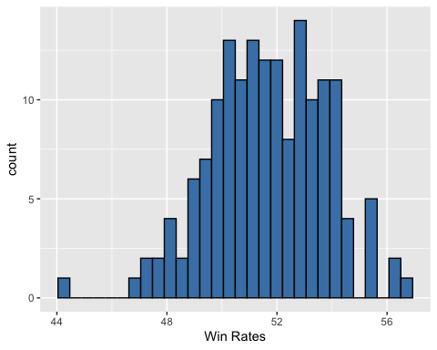

1. Indicate the cases of the data set
2. Describe the histogram of the 12.22 patch of Win Rates
3. Given summary statistics and the Champions with the five highest and five lowest Win Rates. Determine if there are any outliers present. Which players need buffing? Which players need nerfing?

|  |  |
| --- | --- |
| Mean | St. Dev |
| 51.66 | 2.097 |

|  |  |  |  |  |
| --- | --- | --- | --- | --- |
| Min | Q1 | Med | Q3 | Max |
| 44.24 | 50.20 | 51.70 | 53.27 | 56.70 |

|  |  |
| --- | --- |
| Name | Win Rates |
| Fiddlesticks | 56.7 |
| Vi | 56.4 |
| Kled | 56.1 |
| Kog'Maw | 55.6 |
| Elise | 55.4 |
| Aphelios | 47.5 |
| Azir | 47.3 |
| Zeri | 47.2 |
| Pantheon | 46.7 |
| Sion | 44.2 |

After analyzing the data, the developers of the game released the 12.23 patch of League of Legends with new “nerfed” and “buffed” champions.

Patch 12.23 Win Rates

1. A picture containing screenshot, diagram, plot, pixel

   Description automatically generatedDescribe the histogram for the new 12.23 patch
2. Given summary statistics and the Champions with the five highest and five lowest Win Rates. Determine if there are any outliers present. Which players need buffing? Which players need nerfing?

|  |  |
| --- | --- |
| Mean | St. Dev |
| 51.21 | 1.603 |

|  |  |  |  |  |
| --- | --- | --- | --- | --- |
| Min | Q1 | Med | Q3 | Max |
| 46.10 | 50.29 | 51.10 | 52.41 | 54.68 |

|  |  |
| --- | --- |
| Name | Win Rates |
| Vi | 54.7 |
| Elise | 53.5 |
| Fiddlesticks | 52.8 |
| Kled | 52.8 |
| Kog'Maw | 52.2 |
| Zeri | 51.1 |
| Sion | 48.9 |
| Azir | 47.5 |
| Pantheon | 46.7 |
| Aphelios | 46.1 |

1. Suppose that the company took your suggestion from the previous analysis. Did the “nerf” or “buff” that you suggested work by ensuring that the champion(s) win rates were in line with the rest of the champions?