Module

George Charalambous

4/9/2023

* label tables

library(tidyverse)

## ── Attaching core tidyverse packages ──────────────────────── tidyverse 2.0.0 ──  
## ✔ dplyr 1.1.2 ✔ readr 2.1.4  
## ✔ forcats 1.0.0 ✔ stringr 1.5.0  
## ✔ ggplot2 3.4.2 ✔ tibble 3.2.1  
## ✔ lubridate 1.9.2 ✔ tidyr 1.3.0  
## ✔ purrr 1.0.1   
## ── Conflicts ────────────────────────────────────────── tidyverse_conflicts() ──  
## ✖ dplyr::filter() masks stats::filter()  
## ✖ dplyr::lag() masks stats::lag()  
## ℹ Use the conflicted package (<http://conflicted.r-lib.org/>) to force all conflicts to become errors

library(stringr)  
library(readr)

League of Legends is a multiplayer online battle arena (MOBA) game developed by Riot Games. In the game, players assume the role of a “champion” with unique abilities and battle against a team of other players or computer-controlled champions. The objective is to destroy the enemy team’s “Nexus,” a structure located in their base. Along the way, players must defeat minions, jungle monsters, and enemy champions to gain gold and experience points, which can be used to purchase items and improve their champion’s abilities.

* Idea of game balance
* Restructure the paragraph and introduce the idea of outliers, thorugh the introduction of nerfing and buffing

Within the world of gaming, the terms “nerfing” and “buffing” are commonly used. “Nerfing” is the act of reducing the power or effectiveness of a champion or item in a video game, while “buffing” is the act of increasing its power or effectiveness.

+Introduce the idea that LoL continually collects data evaluates the effect of the champions. Nerfing and buffing as needed. These changes refer to as patches per versions of the game. Patches happen approximately every two weeks.

This module uses data from the 12.23 “patch” (version) of the game, within the 5v5 (summoners rift) +introduce the game mode, similar to bball game play, different roles+ to identify if there is a relationship between the win rates associated for every champion.

A. Indicate the cases of the data set.

# lol <- read_csv("data/LOL Data .csv", skip = 3) %>%  
# mutate(WRate = parse_number(`Win %`),  
# PickRate = parse_number(`Pick %`),   
# RolePerc = parse_number(`Role %`),   
# BanPerc = parse_number(`Ban %`),   
# Name = stringr::str_sub(Name, 1, nchar(Name)/2)  
# )%>%  
# group_by(Name)%>%  
# slice_max(RolePerc, n=1)%>%  
# ungroup() |>  
# select("Name", "Role", "KDA", "WRate", "PickRate", "RolePerc", "BanPerc")  
#   
# lol22.22<- read_csv("data/12.22 dataset.csv") %>%  
# mutate(WRate = parse_number(`Win %`),   
# PickRate = parse_number(`Pick %`),   
# RolePerc = parse_number(`Role %`),  
# BanPerc = parse_number(`Ban %`),  
# Name = stringr::str_sub(Name, 1, nchar(Name)/2)) %>%  
# group_by(Name)%>%  
# slice_max(RolePerc, n=1)%>%  
# ungroup()|>  
# select("Name", "Role", "KDA", "WRate", "PickRate", "RolePerc", "BanPerc")

# write_csv(lol, file = "data/LOL_patch_12.23.csv")  
# write_csv(lol22.22, file = "data/LOL_patch_12.22.csv")

lol <- read_csv("data/LOL_patch_12.23.csv")

## Rows: 162 Columns: 7  
## ── Column specification ────────────────────────────────────────────────────────  
## Delimiter: ","  
## chr (2): Name, Role  
## dbl (5): KDA, WRate, PickRate, RolePerc, BanPerc  
##   
## ℹ Use `spec()` to retrieve the full column specification for this data.  
## ℹ Specify the column types or set `show_col_types = FALSE` to quiet this message.

lol22.22 <- read_csv("data/LOL_patch_12.22.csv")

## Rows: 162 Columns: 7  
## ── Column specification ────────────────────────────────────────────────────────  
## Delimiter: ","  
## chr (2): Name, Role  
## dbl (5): KDA, WRate, PickRate, RolePerc, BanPerc  
##   
## ℹ Use `spec()` to retrieve the full column specification for this data.  
## ℹ Specify the column types or set `show_col_types = FALSE` to quiet this message.

B. Within a few sentences, describe the distribution of the Win Rates, given the histogram below.

ggplot(data = lol22.22, mapping = aes(x = WRate))+  
 geom_histogram(fill = "steelblue", color = "black")+  
 labs(x = "Win Rates")

## `stat_bin()` using `bins = 30`. Pick better value with `binwidth`.

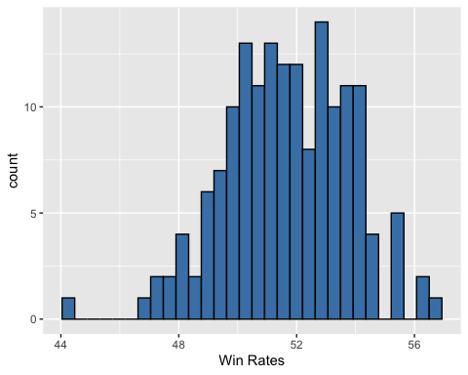

The distribution seems to follow a normal trend, with a slight left skewness. Data is centered at around 51%, with obvious outliers at above 60% and below 40% Win Rates.

* Make sure the tables are sorted

C. Here is the five number summary, mean and standard deviation of the Win Rates. Additionally here is a table of the five highest and five lowest Win Rates. Use this information to determine if there are any outliers in the 12.22 patch.

summary(lol22.22$WRate)

## Min. 1st Qu. Median Mean 3rd Qu. Max.   
## 44.24 50.20 51.70 51.66 53.27 56.70

sd(lol22.22$WRate)

## [1] 2.096617

top5 <- lol22.22 |>  
 slice_max(WRate, n = 5)  
  
bottom5 <- lol22.22 |>  
 slice_min(WRate, n = 5)  
  
list22 <- bind_rows(top5, bottom5) |>  
 select(Name,WRate) |>  
 arrange(desc(WRate))  
list22

## # A tibble: 10 × 2  
## Name WRate  
## <chr> <dbl>  
## 1 Fiddlesticks 56.7  
## 2 Vi 56.4  
## 3 Kled 56.1  
## 4 Kog'Maw 55.6  
## 5 Elise 55.4  
## 6 Aphelios 47.5  
## 7 Azir 47.3  
## 8 Zeri 47.2  
## 9 Pantheon 46.7  
## 10 Sion 44.2

D. Based on your calculations, if you were part of the developer team, which changes, if any, would you suggest to champions for game balance. As part of your rationale, you should use terms such as nerfing or buffing. Explain your rationale.

* Copy from the sheet

For the patch 12.23 of this game mode, the table below shows the Win Rates for the same ten champions as the previous one. Additionally, below is the five number summary of the Win Rates of all champions in the patch 12.23.

ggplot(data = lol, mapping = aes(x = WRate)) +  
 geom_histogram(fill = "steelblue", color = "black") +  
 labs(x = "Win Rates")

## `stat_bin()` using `bins = 30`. Pick better value with `binwidth`.

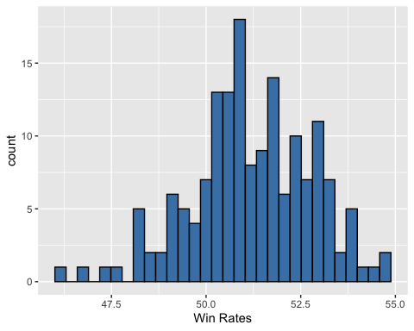

lol23.temp <- lol |>  
 select(Name, WRate) |>  
 rename(WRate_12.23 = WRate)  
  
left_join(list22, lol23.temp, by="Name")|>  
 rename(WRate_12.22 = WRate)

## # A tibble: 10 × 3  
## Name WRate_12.22 WRate_12.23  
## <chr> <dbl> <dbl>  
## 1 Fiddlesticks 56.7 52.8  
## 2 Vi 56.4 54.7  
## 3 Kled 56.1 52.8  
## 4 Kog'Maw 55.6 52.2  
## 5 Elise 55.4 53.5  
## 6 Aphelios 47.5 46.1  
## 7 Azir 47.3 47.5  
## 8 Zeri 47.2 51.1  
## 9 Pantheon 46.7 46.7  
## 10 Sion 44.2 48.9

summary(lol23.temp$WRate_12.23)

## Min. 1st Qu. Median Mean 3rd Qu. Max.   
## 46.10 50.29 51.10 51.21 52.41 54.68

sd(lol23.temp$WRate_12.23)

## [1] 1.603193

F. Suppose that the company took your suggestion from the previous analysis. Did the “nerf” or “buff” that you suggested work by ensuring that the champion(s) win rates were in line with the rest of the champions? Briefly explain…

G. Based on the data you have available, do you have any new game balance suggestions to apply when the next patch comes out?