This statistics worksheet examines the goals and shots in two prominent lacrosse leagues: the Premier Lacrosse League (PLL) and the National Lacrosse League (NLL). The PLL and NLL are highly regarded professional lacrosse leagues that feature top-tier athletes from around the world. The NLL is played in an indoor, smaller field while the PLL plays on an outdoor field with traditional dimensions. This worksheet will provide an analysis of goal-scoring within these leagues. The data is collected from the PLL and NLL website. Specifically, all games played in the 2021-2022 season.

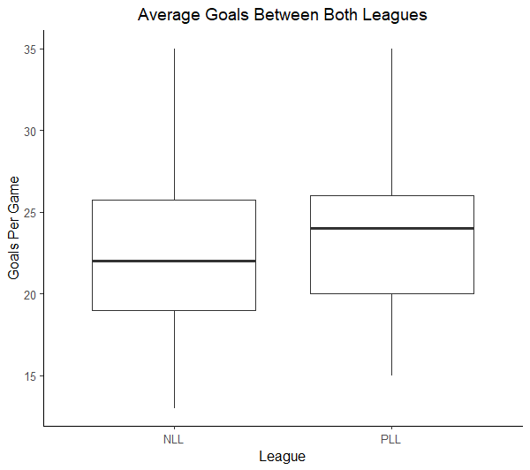

**Descriptive Statistics for Goals:**

|  |  |  |  |
| --- | --- | --- | --- |
| **League** | **N** | **Mean** | **StDev** |
| NLL | 126 | 22.262 | 4.847 |
| PLL | 36 | 23.889 | 4.496 |

1. Identify both variables in this data.

League (NLL/PLL)– Categorical

Number of Goals Scored - Numerical

1. Do these data provide evidence that, on average, goals scored in the PLL and NLL differ? Include all details of the appropriate hypothesis test.

Part 3: Test Statistic

$$t= \frac{\left(23.889-22.262\right)-0}{\sqrt{\frac{{(4.496)}^{2}}{36}+\frac{{(4.847)}^{2}}{126}}}=\frac{1.627}{0.8648}=1.88$$

p-value = P(|T| > 1.88) = 0.034 + 0.034 = 0.068 with df = 35

Part 1: $μ_{NLL/PLL}=$ mean goals for all NLL/PLL lacrosse leagues

Ho: Ha:

Part 2: Conditions  
1. Randomness (Not Explicitly Stated)  
 But, sample is representative

Part 4: Reject the Null. There is weak evidence to suggest that the PLL and NLL average goals differ from one another

2. Nearly Normal $126 ≥25$ $36 ≥25$

1. Construct a 95% confidence interval in average goals for NLL and PLL lacrosse games. What do you notice about this confidence interval?

Note: Any of the inference procedures for this activity could also be done with simulation-based inference.

PLL – NLL

$$\left({\overline{y}}_{1}-{\overline{y}}_{2}\right) ±(t^{*})(SE)$$

$$\left(23.889-22.262\right) ±(2.03)(0.86484)$$

( -.1286, 3.38)

With 95% confidence, on average, the PLL is expected to have between -.1286 and 3.38 more goals per game than the NLL.

**Zero is contained in this confidence interval**

Upon further analysis of the leagues, you discover that the NLL and the PLL play their games for different amounts of time. The PLL plays games for 48 minutes, while the NLL’s games are 60 minutes long. In an effort to correct this mistake, we will “scale down” the NLL goals to a 48 minute rate.

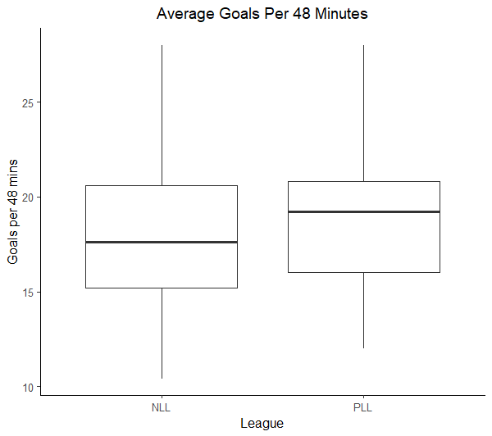

**Descriptive Statistics for Goals (per 48 minutes):**

|  |  |  |  |
| --- | --- | --- | --- |
| **League** | **N** | **Mean** | **StDev** |
| NLL | 126 | 17.810 | 3.877 |
| PLL | 36 | 23.889 | 4.496 |

1. Do the new data provide evidence that, on average, goals scored in the PLL and NLL differ? Compute a new test statistic and state your findings.

Part 4: Reject the Null

There is very strong evidence to suggest that the PLL and NLL average goals (in 48 minute games) differ from one another

Part 3: Test Statistic

$$t= \frac{\left(23.889-17.81\right)-0}{\sqrt{\frac{{(4.496)}^{2}}{36}+\frac{{(3.877)}^{2}}{126}}}=\frac{6.079}{.8251}=7.367$$

p-value =P(|T|>7.367) = 0.000 with df = 35

1. Construct a 95% confidence interval in average goals for NLL and PLL lacrosse games per 48 minutes.   
   What is different about this confidence interval?

PLL – NLL

$$\left({\overline{y}}_{1}-{\overline{y}}_{2}\right) ±(t^{*})(SE)$$

$$\left(23.889-17.81\right) ±(2.03)(0.8251)$$

(4.404, 7.754)

With 95% confidence, on average, the PLL is expected to have between 4.404 and 7.754 more goals per game than the NLL.

** Zero is no longer contained in the confidence interval**