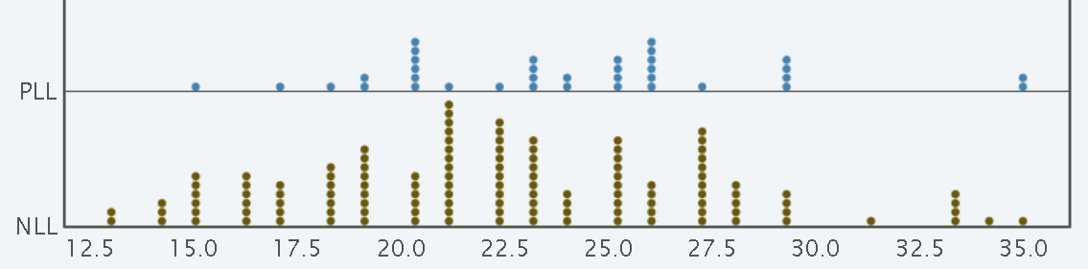This statistics worksheet examines the goals and shots in two prominent lacrosse leagues: the Premier Lacrosse League (PLL) and the National Lacrosse League (NLL). The PLL and NLL are highly regarded professional lacrosse leagues that feature top-tier athletes from around the world. The NLL is a box lacrosse league that is played in an indoor, smaller field while the PLL is a field lacrosse league that plays on an outdoor field with larger dimensions. This worksheet will provide an analysis of goal-scoring within these leagues. The data is collected from the PLL and NLL website. Specifically, all games played in the 2021-2022 season. Below is some summary information for these data.

|  |  |  |  |
| --- | --- | --- | --- |
| **League** | **N** | **Mean** | **StDev** |
| NLL | 126 | 22.262 | 4.847 |
| PLL | 36 | 23.889 | 4.496 |

1. Identify both the variables in this data. For any numerical variables, denote the units and for categorical variables, list the levels.
2. Suppose you are interested in using these data to determine if there is evidence that, on average, goals scored in the PLL and NLL differ. We say the difference is statistically significant if it is larger than we would reasonably expect to see by random chance alone. We will start addressing this by setting up a randomization test for the difference in means.
   1. For the observed data, how much do scoring rates between the leagues differ?
   2. Suppose for a minute that we replayed the 2021-2022 season. Why should we not expect the average scoring rate for NLL to be 22.262 again?
   3. If, in general, PLL and NLL did have different scoring rates, how would the average number of goals compare between the two leagues?
   4. If, in general, PLL and NLL did not have different scoring rates, how would the average number of goals compare between the two leagues? Why would you not expect them to be exactly the same?
   5. In general, we say that a difference is statistically significant if it is larger than we would reasonably expect to see by random chance alone.