This statistics worksheet examines the goals and shots in two prominent lacrosse leagues: the Premier Lacrosse League (PLL) and the National Lacrosse League (NLL). The PLL and NLL are highly regarded professional lacrosse leagues that feature top-tier athletes from around the world. The NLL is a box lacrosse league that is played in an indoor, smaller field while the PLL is a field lacrosse league that plays on an outdoor field with larger dimensions. This worksheet will provide an analysis of goal-scoring within these leagues. The data is collected from the PLL and NLL website. Specifically, all games played in the 2021-2022 season.

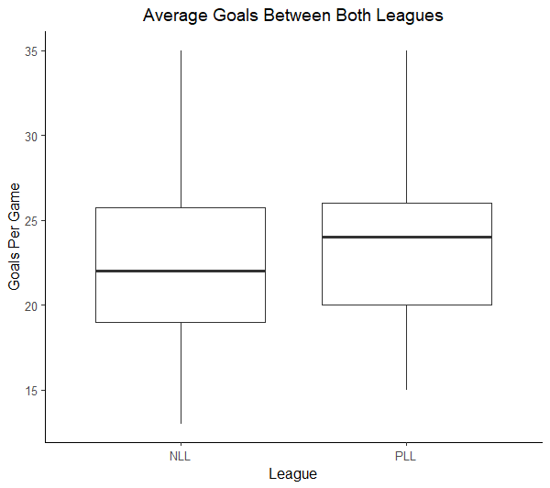

**Descriptive Statistics for Goals:**

|  |  |  |  |
| --- | --- | --- | --- |
| **League** | **N** | **Mean** | **StDev** |
| NLL | 126 | 22.262 | 4.847 |
| PLL | 36 | 23.889 | 4.496 |

1. Identify both the variables in this data. For any numerical variables, denote the units and for categorical variables, list the levels.
2. Suppose you are interested in using these data to determine if there is statistically discernible evidence that, on average, goals scored in the PLL and NLL differ.
   1. Identify the statistical inference procedure that would be appropriate to answer this research question.
   2. Define appropriate parameters of interest that could be used to address the research question based on the procedure you identified in the previous part.
   3. List any assumptions that must be made about these data and inference procedure you will use. Assess them and explain any weaknesses in them.
   4. Record the null and alternative hypotheses associated with the research question.
   5. Calculate the appropriate test statistic and p-value.
   6. Using the p-value, provide an appropriate conclusion for the research question. Be sure to provide full context of the application.
3. Construct a 95% confidence interval in average goals for NLL and PLL lacrosse games. What do you notice about this confidence interval?

Upon further analysis of the leagues, you discover that the NLL and the PLL play their games for different amounts of time. The PLL plays games for 48 minutes, while the NLL’s games are 60 minutes long. In an effort to correct this mistake, we will “scale down” the NLL goals to a 48 minute rate.

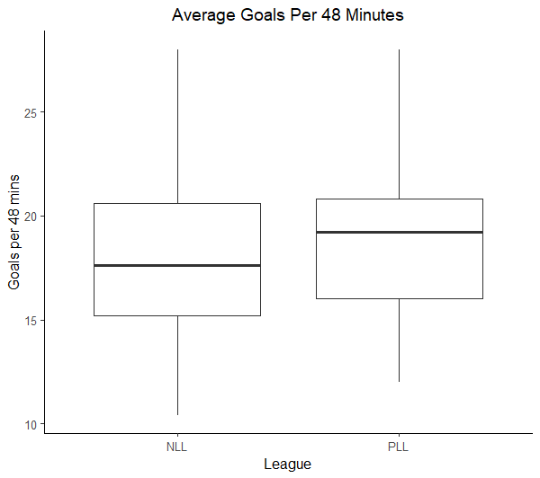

**Descriptive Statistics for Goals (per 48 minutes):**

|  |  |  |  |
| --- | --- | --- | --- |
| **League** | **N** | **Mean** | **StDev** |
| NLL | 126 | 17.810 | 3.877 |
| PLL | 36 | 23.889 | 4.496 |

1. Do the new data provide evidence that, on average, goals scored in the PLL and NLL differ? Compute a new test statistic and state your findings.
2. Construct a 95% confidence interval in average goals for NLL and PLL lacrosse games per 48 minutes.   
   What is different about this confidence interval?