The dataset **ironman_lake_placid_female.csv** contains data on female finishers of the Lake Placid Ironman Triathlon from 2002 to 2022. The motivation for this data analysis is to explore the relationship between swim, bike, and run times (in minutes) in order to gain insights into the performance patterns of the athletes. For this activity, we will specifically focus on times from 2022 Canadian Finishers. Use the output provided on the final pages to help answer the following questions.

Model 1: Bike Times

1. Fit and report the least squares regression equation for predicting **Run Time** (the last stage of the event) using **Bike Time** (in minutes).
2. Examine residual plots for this model. Do you have any concerns about the appropriateness of this linear model?
3. Test (include all steps) if there is evidence that **Bike Time** (in minutes) is a useful predictor of **Run Time**?

Model 2: Swim Times

1. Fit and report the least squares regression equation for predicting **Run Time** using **Swim Time** (in minutes).
2. Examine residual plots for this model. Do you have any concerns about the appropriateness of this linear model?
3. Construct and interpret a 95% confidence interval for the population slope relating **Run Time** and **Swim Time**.

1. Based on your confidence interval, is there evidence that **Swim Time** is a useful predictor of **Run Time**? Explain briefly.

Model 3: Both

1. Now put both **Bike Time** and **Swim Time.** (in minutes) in the model as predictors of **Run Time**. Report the resulting equation below. This is a *multiple linear regression model*.
2. Predict the **Run Time** of Melanie McQuaid who had Bike Time of 305.53 minutes and a Swim time of 58.05 minutes
3. Compute the residual of the Melanie McQuaid. The actual run time was 205.75 minutes
4. Contrast the output from this multiple linear regression model with the output from Models 1 and 2. What differences do you notice?
5. Which model would you recommend using and why?

Model 1 Output

**Regression Equation**

|  |  |  |
| --- | --- | --- |
| Run.Time | = | -72.4 + 0.9109 Bike.Time |

**Coefficients**

|  |  |  |  |  |  |
| --- | --- | --- | --- | --- | --- |
| **Term** | **Coef** | **SE Coef** | **T-Value** | **P-Value** | **VIF** |
| Constant | -72.4 | 34.2 | -2.11 | 0.039 |  |
| Bike.Time | 0.9109 | 0.0819 | 11.12 | 0.000 | 1.00 |

**Model Summary**

|  |  |  |  |
| --- | --- | --- | --- |
| **S** | **R-sq** | **R-sq(adj)** | **R-sq(pred)** |
| 30.1830 | 66.62% | 66.08% | 64.64% |

**Analysis of Variance**

|  |  |  |  |  |  |
| --- | --- | --- | --- | --- | --- |
| **Source** | **DF** | **Adj SS** | **Adj MS** | **F-Value** | **P-Value** |
| Regression | 1 | 112706 | 112706 | 123.72 | 0.000 |
| Bike.Time | 1 | 112706 | 112706 | 123.72 | 0.000 |
| Error | 62 | 56483 | 911 |  |  |
| Total | 63 | 169188 |  |  |  |

**Fits and Diagnostics for Unusual Observations**

|  |  |  |  |  |  |  |
| --- | --- | --- | --- | --- | --- | --- |
| **Obs** | **Run.Time** | **Fit** | **Resid** | **Std Resid** |  |  |
| 1 | 205.75 | 205.95 | -0.20 | -0.01 |  | X |
| 44 | 375.48 | 307.76 | 67.72 | 2.26 | R |  |
| 57 | 399.78 | 337.29 | 62.50 | 2.10 | R |  |
| 63 | 417.40 | 355.22 | 62.18 | 2.10 | R |  |

*R  Large residual  
X  Unusual X*

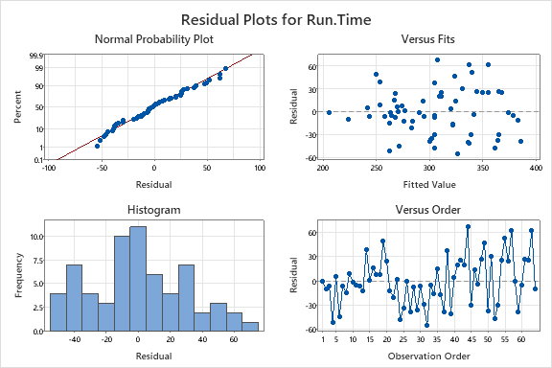

Model 2 Output

**Regression Equation**

|  |  |  |
| --- | --- | --- |
| Run.Time | = | 305.88 + 0.0015 Swim.Time |

**Coefficients**

|  |  |  |  |  |  |
| --- | --- | --- | --- | --- | --- |
| **Term** | **Coef** | **SE Coef** | **T-Value** | **P-Value** | **VIF** |
| Constant | 305.88 | 6.84 | 44.73 | 0.000 |  |
| Swim.Time | 0.0015 | 0.0154 | 0.10 | 0.923 | 1.00 |

**Model Summary**

|  |  |  |  |
| --- | --- | --- | --- |
| **S** | **R-sq** | **R-sq(adj)** | **R-sq(pred)** |
| 52.2344 | 0.02% | 0.00% | 0.00% |

**Analysis of Variance**

|  |  |  |  |  |  |
| --- | --- | --- | --- | --- | --- |
| **Source** | **DF** | **Adj SS** | **Adj MS** | **F-Value** | **P-Value** |
| Regression | 1 | 26 | 25.78 | 0.01 | 0.923 |
| Swim.Time | 1 | 26 | 25.78 | 0.01 | 0.923 |
| Error | 62 | 169163 | 2728.43 |  |  |
| Lack-of-Fit | 60 | 167361 | 2789.36 | 3.10 | 0.275 |
| Pure Error | 2 | 1801 | 900.63 |  |  |
| Total | 63 | 169188 |  |  |  |

**Fits and Diagnostics for Unusual Observations**

|  |  |  |  |  |  |  |
| --- | --- | --- | --- | --- | --- | --- |
| **Obs** | **Run.Time** | **Fit** | **Resid** | **Std Resid** |  |  |
| 34 | 305.9 | 311.1 | -5.3 | -3.99 | R | X |
| 63 | 417.4 | 306.0 | 111.4 | 2.15 | R |  |

*R  Large residual  
X  Unusual X*

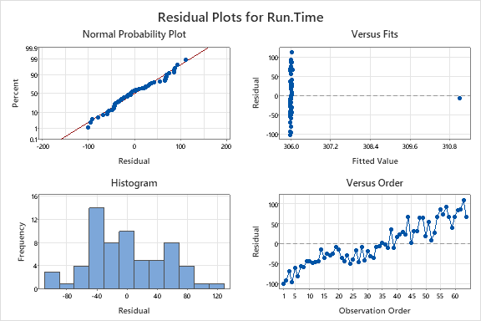

Model 3 Output

**Regression Equation**

|  |  |  |
| --- | --- | --- |
| Run.Time | = | -72.9 - 0.00494 Swim.Time + 0.9138 Bike.Time |

**Coefficients**

|  |  |  |  |  |  |
| --- | --- | --- | --- | --- | --- |
| **Term** | **Coef** | **SE Coef** | **T-Value** | **P-Value** | **VIF** |
| Constant | -72.9 | 34.4 | -2.12 | 0.038 |  |
| Swim.Time | -0.00494 | 0.00896 | -0.55 | 0.584 | 1.00 |
| Bike.Time | 0.9138 | 0.0825 | 11.07 | 0.000 | 1.00 |

**Model Summary**

|  |  |  |  |
| --- | --- | --- | --- |
| **S** | **R-sq** | **R-sq(adj)** | **R-sq(pred)** |
| 30.3540 | 66.78% | 65.69% | 0.00% |

**Analysis of Variance**

|  |  |  |  |  |  |
| --- | --- | --- | --- | --- | --- |
| **Source** | **DF** | **Adj SS** | **Adj MS** | **F-Value** | **P-Value** |
| Regression | 2 | 112985 | 56493 | 61.31 | 0.000 |
| Swim.Time | 1 | 279 | 279 | 0.30 | 0.584 |
| Bike.Time | 1 | 112959 | 112959 | 122.60 | 0.000 |
| Error | 61 | 56203 | 921 |  |  |
| Total | 63 | 169188 |  |  |  |

**Fits and Diagnostics for Unusual Observations**

|  |  |  |  |  |  |  |
| --- | --- | --- | --- | --- | --- | --- |
| **Obs** | **Run.Time** | **Fit** | **Resid** | **Std Resid** |  |  |
| 34 | 305.9 | 305.4 | 0.4 | 0.78 |  | X |
| 44 | 375.5 | 308.1 | 67.4 | 2.24 | R |  |
| 57 | 399.8 | 337.6 | 62.2 | 2.07 | R |  |
| 63 | 417.4 | 355.6 | 61.8 | 2.08 | R |  |

*R  Large residual  
X  Unusual X*

