1. The below graphic is a histogram of points for all countries. Describe the distribution of points. Is there a skew, if so, what is it and what does it mean?

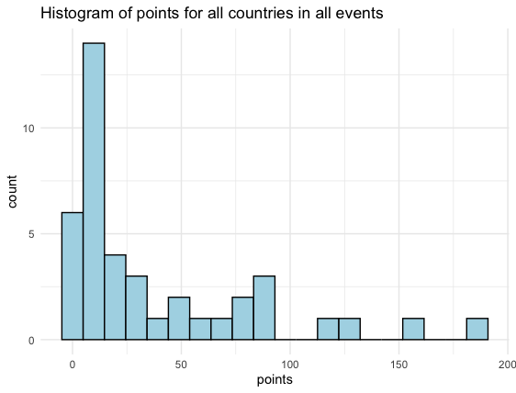The data is right-skewed meaning that the values are clustered around the smaller values for points, so it is more common for nations to get fewer medals in Olympic rowing.

The summary statistics for points are provided below.



* 1. The table shows the top 5 nations ranked by *points*. Using the summary statistics, determine if there are any outliers for *points*.

UK is an outlier

IQR = Q3-Q1 = 57-6 = 51

1.5*IQR = 1.5*51 = 76.5

Q3 +1.5* IQR = 57 + 76.5 = 133.5

154> 133.5

USA is an outlier.

187>133.5

131<133

121<133

87<133

1. Using your answer to Question 2 draw a boxplot of points.

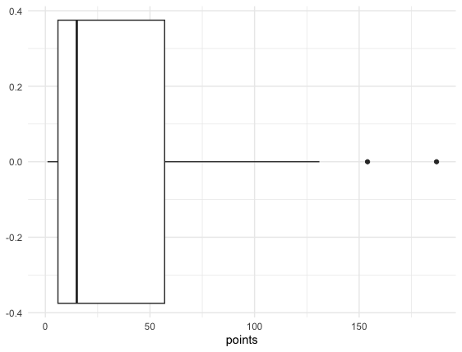

1. The below bar plot shows NOC ranked by medals to showcase the distribution of *medals* per nation. Can you think of any possible reasons why some nations win more than others?.

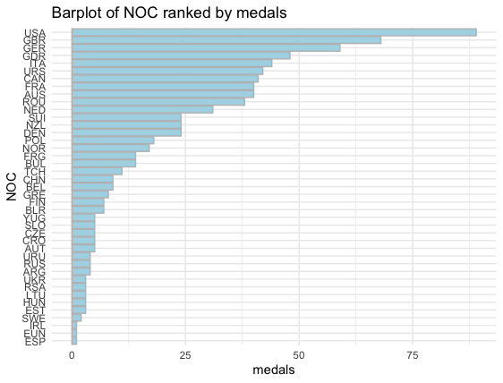

Lots of possible answers, For example, some countries might have bigger populations to draw athletes from or wealthier countries might be better able to afford expensive rowing programs.

1. In the bar plot in Question 4, notice that the German Democratic Republic (GDR) or East Germany is listed as a country. Since the end of the Cold War the GDR is no longer a country. What would you do with countries in the dataset that are no longer existent today? How would it impact the data?

Open ended, no right or wrong answer, credit for answering.

1. There is a lot of debate about how to best weigh the points for the different types of medals. Read [this link](https://www.topendsports.com/events/summer/medal-tally/rankings-weighted.htm)(https://www.topendsports.com/events/summer/medal-tally/rankings-weighted.htm) about different medal point weighing and decide on a method you think would be best. How would the new method alter the data?

Open ended, no right or wrong answer, credit for answering.