During the period of winter training when rowers cannot be on the water, their main form of practice is using an ergometer, commonly called the erg, to build and test fitness. The erg tracks metrics like the duration and distance of a piece and the split (time per 500 meters). These metrics give rowers an idea of where their performance is at during the time period where they cannot be on the water. Collegiate rowers participate in test pieces that give them and their coaches a sense of their performance in comparison to other athletes. These test pieces are typically 6k and 2k in length and are completed at full intensity.
Before their test pieces rowers are encouraged to make a goal for where they want to be at. Their goal is described as one that is “achievable”, but they should be “very excited if they meet their goal”, meaning that it should not be easily attained. As rowers do more test pieces and have a better sense of their own capabilities this goal setting becomes more reliable, and they can better set goals that are realistic but still challenge them to compete at their highest performance.

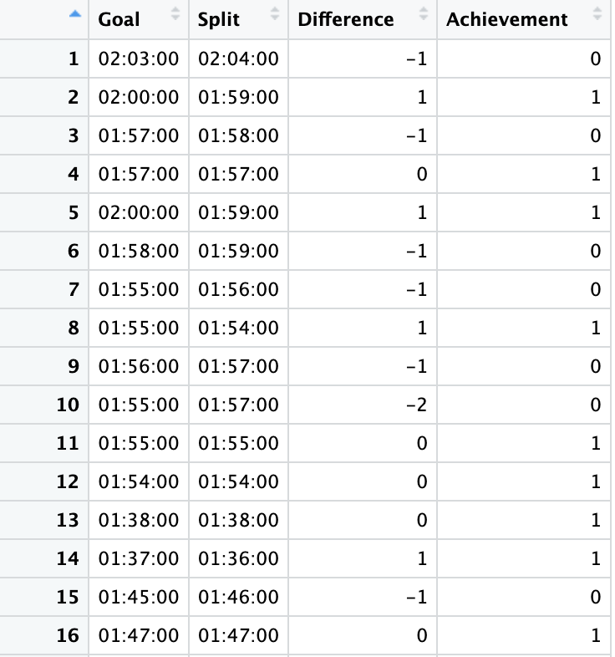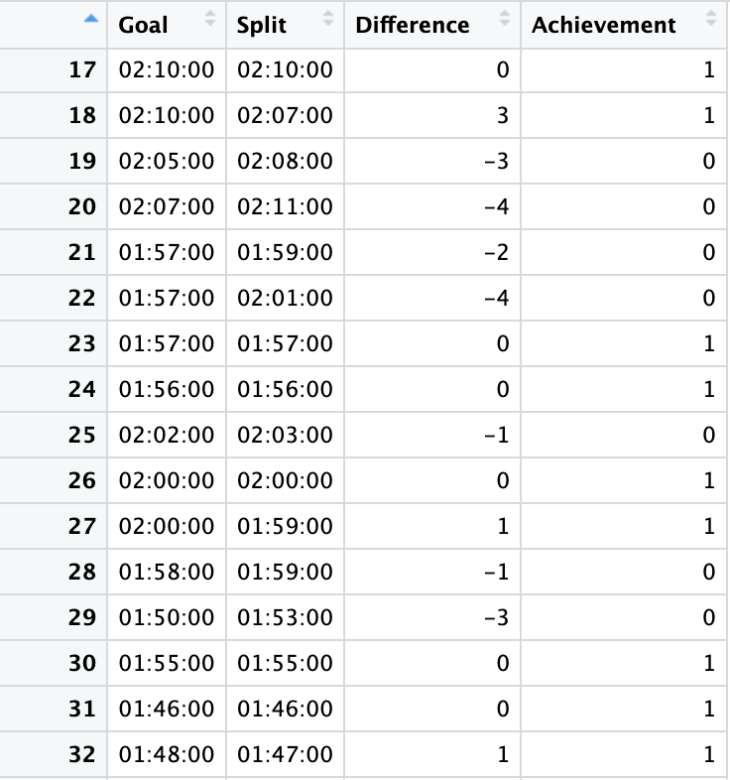

Above is 32 of 104 observations. Difference is a variable that is Goal – Split and is used to determine if the athlete’s goal was met or not. A Difference greater than or equal to 0 means the goal was met or exceeded, and a negative value indicates that the goal was not met. The Achievement variable indicates 0 for falling short of a goal and 1 for achieving it.

Of the 104 observations, 62 athletes met or exceeded their goal during their test piece.

- What is the sample statistic for the proportion of athletes that meet their goal?

$$\hat{p} = \frac{62}{104} = 0.596$$

- Detail how you would use the given data to calculate a bootstrap statistic by hand for the proportion of rowers that meet their goal.

You could have a piece of paper with each yes or no indicating whether the goal was met. To calculate the bootstrap statistic (proportion) you need to sample with replacement. So, you would randomly pick a piece of paper with a yes or no, record it, and then put that piece of paper back. You would do that 32 times in total as there are 32 observations and then you would calculate the proportion of the yeses you selected.

- Using StatKey, based on the information provided to you, what test would you select and what values would you input to create this bootstrap distribution?

Under Bootstrap Confidence Intervals select CI for Single Proportion
Count = 62, Sample Size = 104

- Using StatKey, create a bootstrap distribution for the proportion of athletes that met their goal. Describe and draw the shape of the distribution. What is the standard error? Use at least 5000 samples.
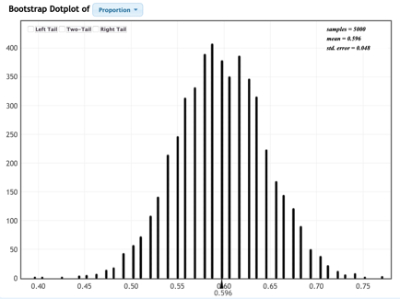
The distribution is normal shaped and centered
around the sample statistic (0.596). From this
distribution on StatKey, we can see that the
standard error of the distribution is about
0.048 (could vary slightly based on random
sampling).

- Using the standard error, create a 95% confidence interval for the proportion of athletes that met their goal. Interpret it in context.

95% CI: = Statistic +- 2 * SE
= 0.596 +- 2* 0.0488 = (0.4984, 0.6936)
We can say with 95% confidence that the proportion of athletes that met their goal is between 0.4984 and 0.6936.

- Using StatKey, find a 95% confidence interval for the proportion using a two-tail test and interpret. How does this interval compare to the interval you found above? Does this make sense, why or why not?

Using a two-tail test in StatKey, we can say with 95% confidence that the proportion of athletes that met their goal is between 0.500 and 0.692 which is very similar to the interval we found before. This makes sense because it is the same test but different methods of finding the answer.

- If we change our confidence level to 98%, how does that affect our bounds and what does that mean for our confidence interval?

We are more confident if we change to 98% so the interval will be wider than an interval with 95% confidence and will include more possible values to increase confidence.

- Using StatKey, find and interpret a 98% confidence interval for the proportion of athletes that met their goal. Explain how this compares to the 95% confidence interval and whether or not that makes sense with your answer above.

Using a two-tail test in StatKey, we can say with 98% confidence that the proportion of athletes that met their goal is between 0.481 and 0.712 which is still centered around the sample proportion of 0.596 but is wider than the 95% confidence interval. This makes sense because we are more confident, so more values are included.

- Interpreting in context: What does this interval tell us? If a coach is looking for rowers to set generally ambitious yet achievable goals, does this confidence interval imply that the team is setting goals in the way that they should be?

The confidence interval tells us that athletes on the team are achieving their goals about 60% of the time. This means the coach should encourage the team to set more ambitious goals than they have been.

