During the period of winter training when rowers cannot be on the water, their main form of practice is using an ergometer, commonly called the erg, to build and test fitness. The erg tracks metrics like the duration and distance of a piece and the split (time per 500 meters). These metrics give rowers an idea of where their performance is at during the time period where they cannot be on the water. Collegiate rowers participate in test pieces that give them and their coaches a sense of their performance in comparison to other athletes. These test pieces are typically 6k and 2k in length and are completed at full intensity.
Before their test pieces rowers are encouraged to make a goal for where they want to be at. Their goal is described as one that is “achievable”, but they should be “very excited if they meet their goal”, meaning that it should not be easily attained. As rowers do more test pieces and have a better sense of their own capabilities this goal setting becomes more reliable, and they can better set goals that are realistic but still challenge them to compete at their highest performance.

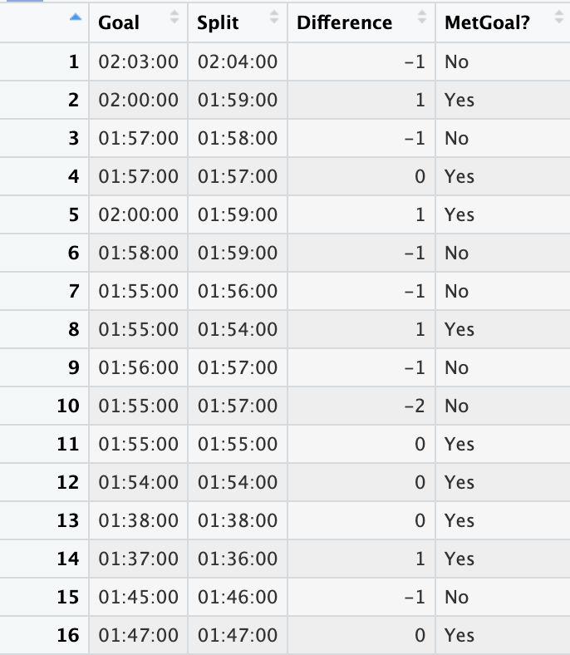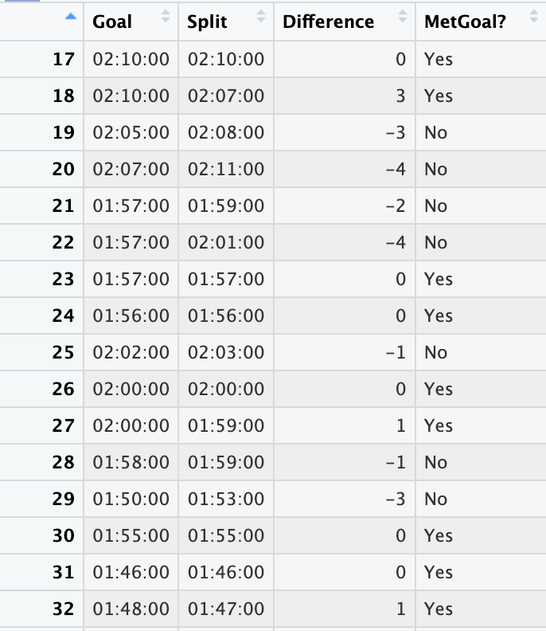

Above is 32 of 104 observations. Difference is a variable that is Goal – Split and is used to determine if the athlete’s goal was met or not. A difference greater than or equal to 0 means the goal was met or exceeded.

Of the 104 observations, 62 athletes met or exceeded their goal during their test piece.

- What is the sample statistic for the proportion of athletes that meet their goal?

- Detail how you would use the given data to calculate a bootstrap statistic by hand for the proportion of rowers that meet their goal.

- Using StatKey, based on the information provided to you, what test would you select and what values would you input to create this bootstrap distribution?

- Using StatKey, create a bootstrap distribution for the proportion of athletes that met their goal. Describe the shape of the distribution. What is the standard error? Use at least 5000 samples.

- Using the standard error, create a 95% confidence interval for the proportion of athletes that met their goal. Interpret it in context.

k
- Using StatKey, find a 95% confidence interval for this proportion using a two-tail test and interpret it. Does this match what you found using the percentile method? Does this make sense, why or why not?

- If we change our confidence level to 98%, how does that affect our bounds and what does that mean for our confidence interval?

- Using StatKey, find and interpret a 98% confidence interval for the proportion of athletes that met their goal. Explain how this compares to the 95% confidence interval and whether or not that makes sense with your answer above.

