Clinton Canoe Regatta: Looking at Histograms and Data Distribution
Downriver racing is a sport where competitors take their watercraft (usually a canoe, kayak, or stand-up paddle board) down a race course in competition with other paddlers. The General Clinton Canoe Regatta (nicknamed "the 70-miler") is a prominent race in the sport that has been running since the 1960s. The race is a 63 mile course down the Susquehanna River in New York (from Cooperstown to Bainbridge). Paddlers compete against each other to achieve the fastest time in their class, with the fastest boats finishing about 7-8 hours after they start.
Completing this race is an impressive feat, and this combined with the race’s fame means there is usually high attendance. However, unlike most races, where the turnout is mostly recreational paddlers, the difficulty of this race means that most paddlers at the General Clinton are pros. This phenomenon has interesting impacts on data from the race as pro boats are designed to be faster but also require more skill to maneuver effectively.
For this activity, each canoe is only included in the data once, regardless of the number of paddlers (which can typically range from 1-4) and canoes who were disqualified or who failed to finish have been removed from the data.
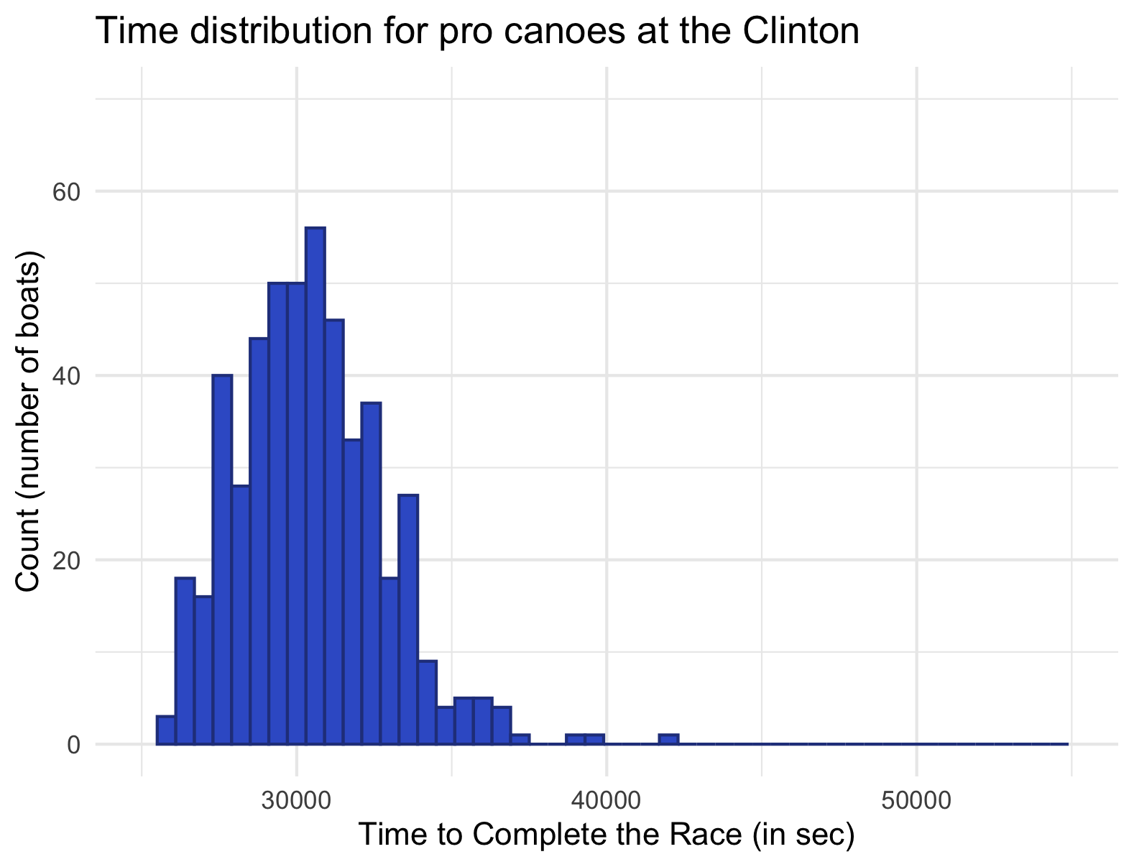
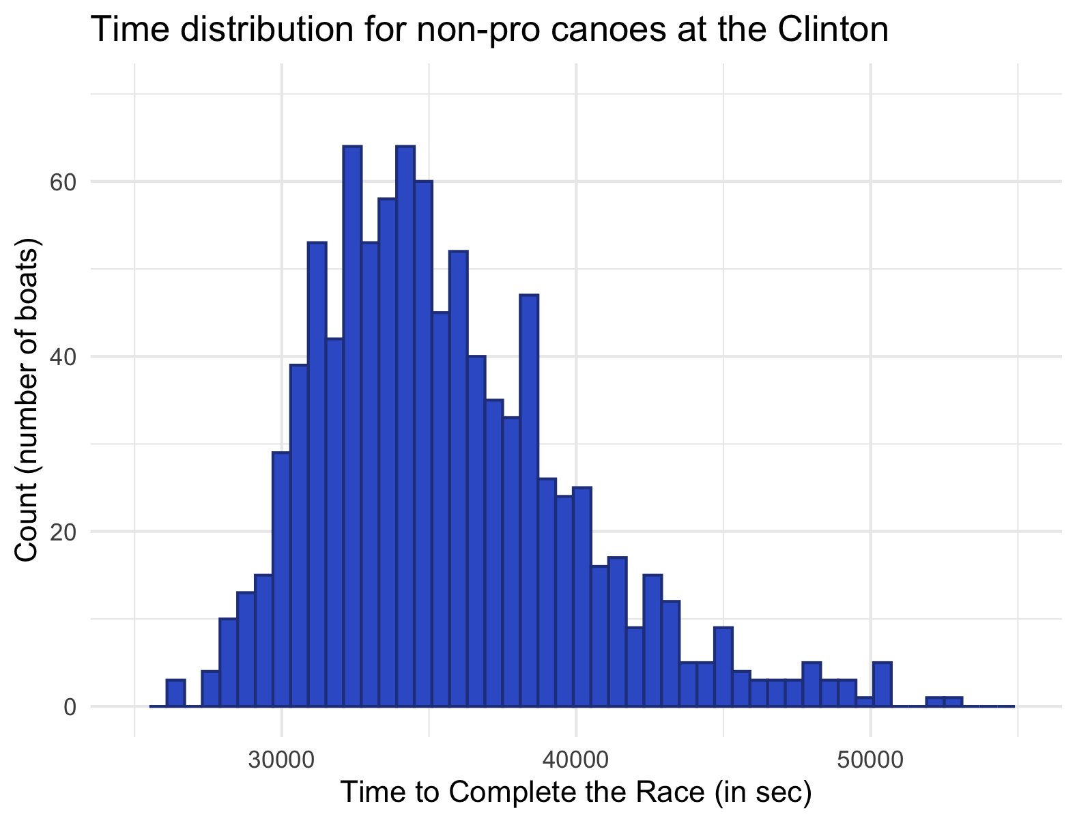
1. The histogram on the left shows the distribution of times on the Clinton from 2014-2025 for only the 497 pro canoes. The histogram on the right shows the distribution of times on the Clinton from 2014-2025 for all 954 canoes that are not pros. Use the histograms to complete the following activities.

- Describe the shape, spread, and center of the pro canoe data.

- Describe the shape, spread, and center of the non-pro canoe data.

- Based on the histograms, describe the differences between the distributions’ shapes. Use the context provided to propose a possible explanation of any differences you notice.

2. The following table shows the summary statistics for the pro and non-pro data. Use it to complete the following activities:
 | Pro | Non-Pro
Mean | 30420.13 | 35565.78
SD | 2361.809 | 4417.876
Min | 25899 | 26501
1Q | 28760 | 32404
Median | 30283 | 34817.5
3Q | 31840 | 38156.5
Max | 41761 | 52967

- Compare the measures of center and the spreads. Again, use the context provided to propose a possible explanation of any differences you notice.

- Sketch a boxplot of the data with pro vs. non-pro as the boxes and completion time for the race on the y axis.

3. In 2025, Adam Blanchard and Rebecca Sutton placed first in the C2 Stock (not pro) Mixed class with a time of 8 hours, 32 minutes, and 21 seconds (30741 seconds). In the same year, Dean Brown & Chris Prater placed 40th in the pro class with a time of 8 hours, 3 minutes and 11 seconds (28991 seconds). Which of these times is better (relatively)? How did you draw your conclusion?

