Scenario: The US Census states that 27.5% of US adults who are at least 25 years old have a college bachelor’s degree or higher. Suppose we take a random sample of 50 adults (age 25 and older).
- In words, describe what $p$ represents in this context.

- In words, describe what $\hat{p}$ represents in this context.

- Summarize the process used to create the dotplot below.

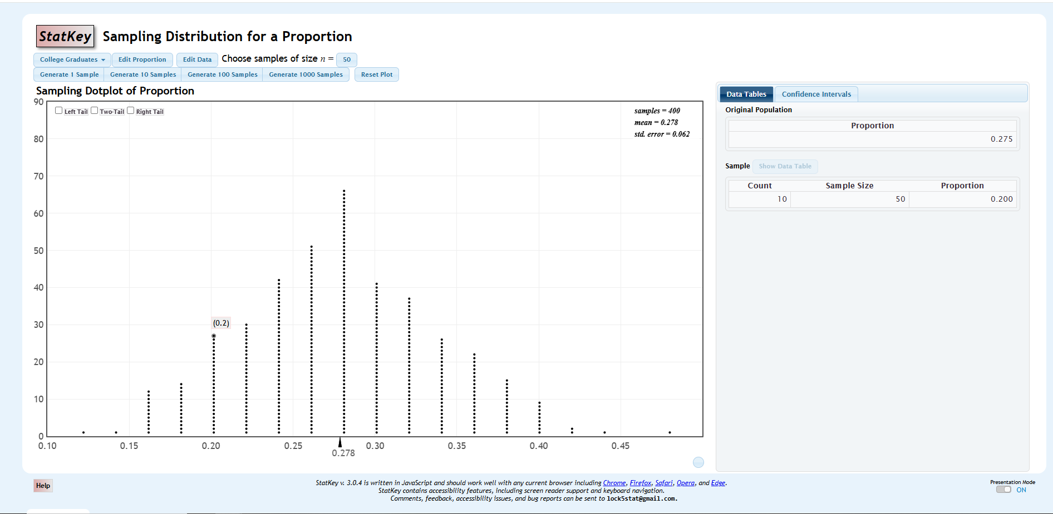
What does a sampling distribution “do” for us?

- Circle and label on the above screenshot where we enter the population proportion for a problem.
- Circle and label where we enter the desired sample size.
- Label the x-axis on the dotplot depicted above.
Now go to Statkey (Sampling Distributions: Proportions) and enter the population proportion (0.275) and sample size (50) for our problem. Use Statkey to simulate 4000 hypothetical samples from this population.
- What is the center of this sampling distribution? What is the center close to? What does this “say” in this context?

- What is the spread (“std. error”) of this sampling distribution? What does this “say” in this context?
- What are the smallest and largest $\hat{p}$ values in this sampling distribution? What does this “say” in this context?

Now reset the plot and change the desired sample size to 100. Once again, use Statkey to simulate 4000 hypothetical samples from this population.
- What is the center of this sampling distribution? How does this compare to your answer for Question 8?
- What is the spread (“std. error”) of this sampling distribution? How does this compare to your answer for Question 9?

Important Observations

Use the sampling distribution of $\hat{p}$ when $n=100$ to answer the following questions:
- What proportion of random samples have $\hat{p}$ values of 0.2 or less?

- What proportion of random samples have $\hat{p}$ values of 0.4 or higher?

- How would you describe the shape of this sampling distribution?

