- Non-Normal Population (variable = Movie Budgets)
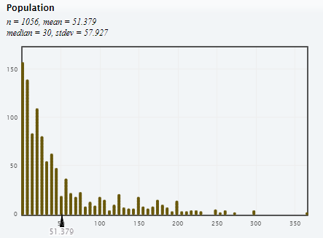 | What does each dot in the dotplot represent?  What are the mean and standard deviation of this variable?  Does a Normal model look reasonable for this shape?
Sampling Distributions for $\overline{y}$ (four different sample sizes)
$$n=5$$ |  | $$n=10$$
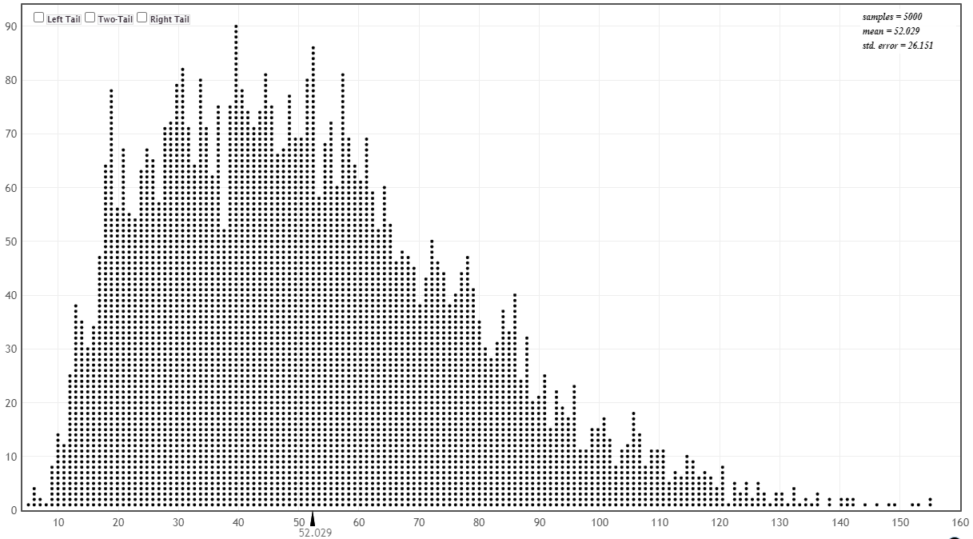  What does each dot on this dotplot represent? |  | 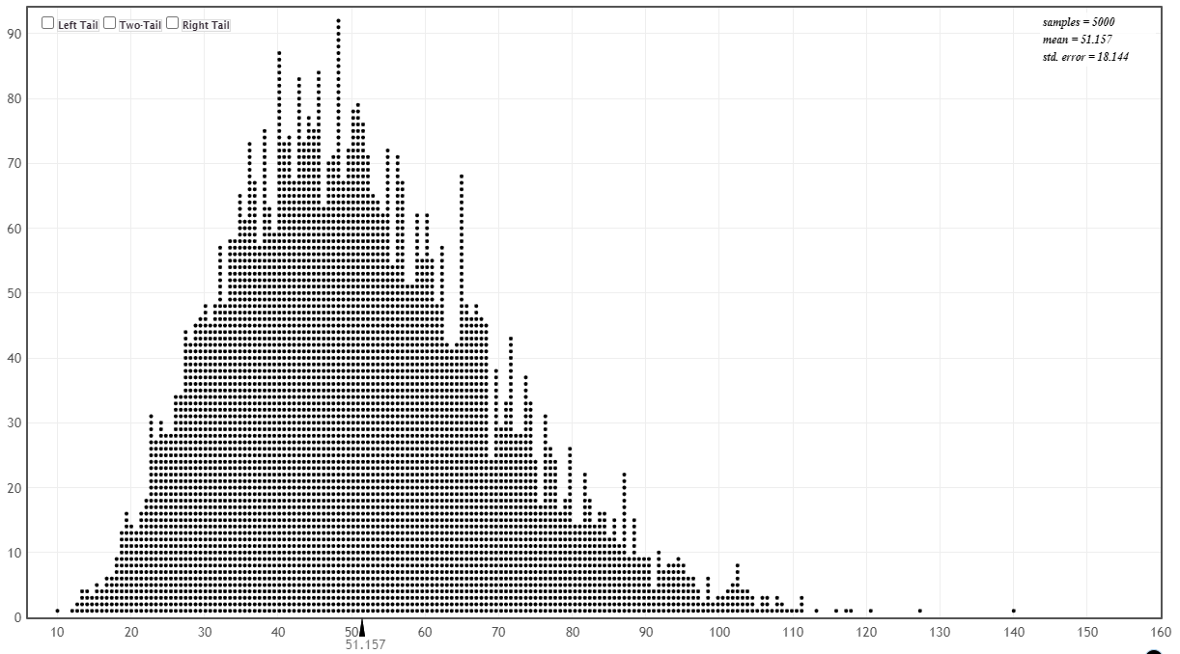  What does each dot on this dotplot represent?
$$n=25$$ |  | $$n=50$$
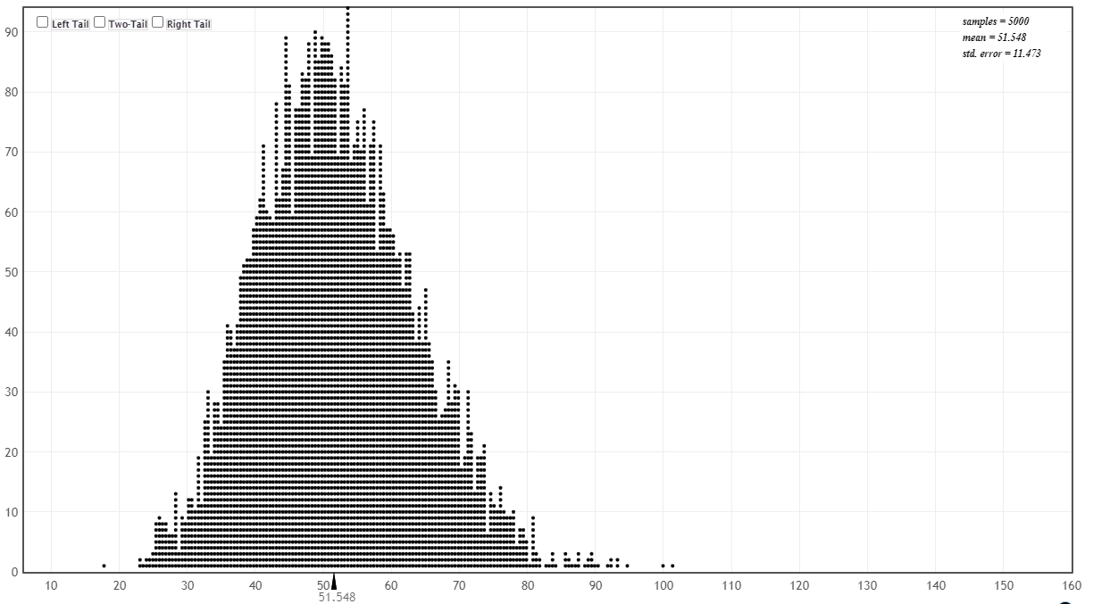  What does each dot on this dotplot represent? |  | 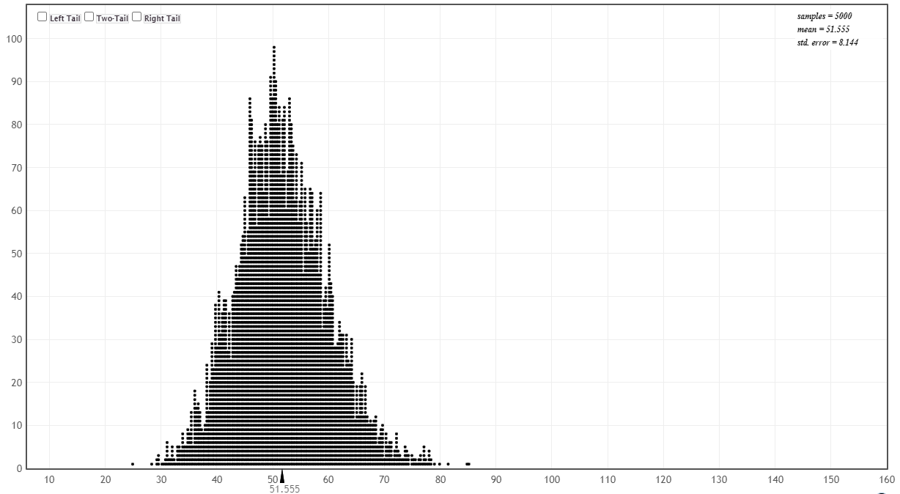  What does each dot on this dotplot represent?
Sample Size | Shape | Center | Spread
n = 5
n = 10
n = 25
n = 50
- Normal Population (variable = men_heights):
When we have a population with mean$=μ$ and standard deviation $=σ$, the sampling distribution of $\overline{y}$ can be modeled as

