The 2025 PBR (Professional Bull Riders) season ended with a victory for Jose Vitor Leme who, for the third time in his riding career, was named the PBR World Champion. Since his start in 2017, Jose has had 467 rides resulting in valid scores (rather than zeros due to an early buck off); 8 of those rides were at the 2025 World Finals and 23 were during the 2025 season (including the finals).

The joseCareerScores.csv contains scores for each of Leme’s 467 successful rides.

- Construct a dotplot of Leme’s scores for a ride. To do so,
  - Go to https://www.lock5stat.com/StatKey/index.html
  - In the Descriptive Statistics and Graphs column, click on One Quantitative Variable.
  - Click on the Upload File button, then navigate to your copy of the joseCareerScores.csv file. Click ‘Open’, then click on score, then ‘Ok’.
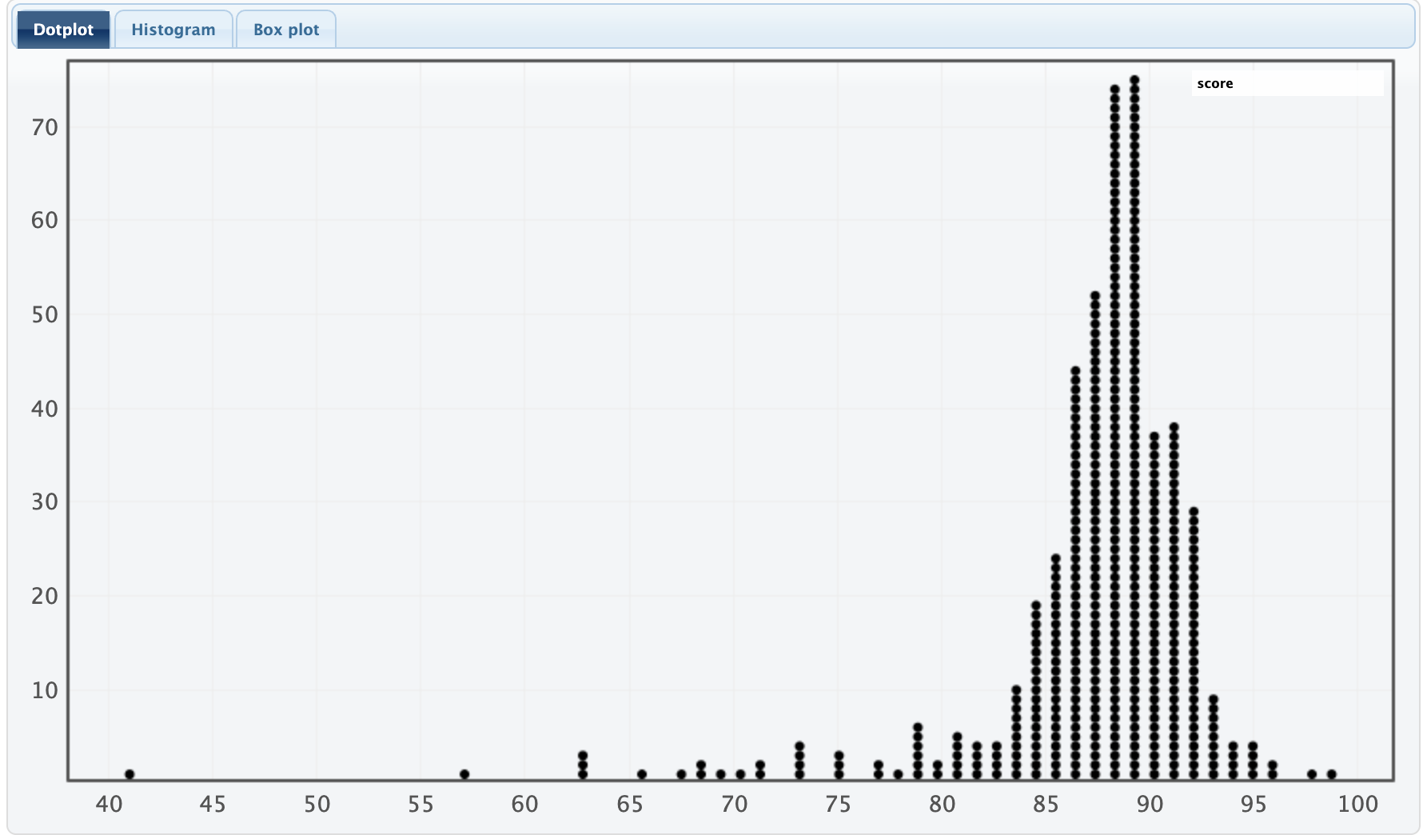
- Describe the shape, center, and spread of the distribution displayed in your dotplot.

The distribution is left-skewed. The range is 41 to 100, but most rides have scores between 75 and 95. There are some rides between 55 and 75 and even one in the low 40s. These low scores are the cause of the skewness. The center of the distribution is in the high 80s, around 87.

- If we are interested in observing Leme’s average scores in an n=8 ride period (like the PBR World Finals), we can use StatKey to simulate this scenario. To do so:
- In StatKey go to Sampling Distribution for a Mean.
- Click on the pull-down menu just below the StatKey button and choose joseCareerScores.csv: score. This will load the score data.
  - Notice that this creates a smaller version of the dotplot from before on the right hand side (labeled Population).
- Click on ‘Choose samples of size n =’ and change it to 8
- Click Generate 1 Sample

- You should now have one dot on your graph. What does this dot represent?
  - Tip: On the right side of the screen, what is being displayed in the lower dotplot (labeled Sample)? (You can also click on ‘Show Data Table’ just above that plot.)

The dot represents the average score from a random sample of 8 rides.

- Now click on Generate 1 Sample again. What happens?

Another dot appears on the plot, representing another average score from a random sample of 8 rides.

- We will now simulate 1000 more eight ride scenarios for Leme. Do so by clicking on the Generate 1000 Samples button.
- This dotplot (on the main window) shows the Sampling Distribution for the Mean number of Scores in a random sample of 8 Rides by Jose Vitor Leme. Describe the shape, center, and spread of this distribution.

(Answers will vary) The distribution is left-skewed. The range is 78 to 91, but most rides are between 84 and 91. The mean of the distribution is 87.026.

- Record the mean and std. error for this simulation.

The mean is about 87 and the std. error is about 1.86.

- During the 2025 World Finals, Leme’s actual score per ride was 87.80. Based on your sampling distribution, does this seem unusually high, unusually low, or fairly typical? Explain your reasoning.

This seems fairly typical. It falls slightly above the mean, but by looking at the right tail of the distribution we can see that about 39% of the simulated sample means were greater than or equal to 87.80.

- Now set the sample size (n) to 23 to mimic the number of scored rides Leme had during his 2025 season, and generate 1000 samples.
- What does each dot in this simulation represent?

The average score per ride for a random sample of 23 rides.

- Describe the shape, center, and spread of this distribution.

(Answers will vary) The distribution is still slightly left-skewed, but is fairly symmetric. The range is about 83 to 90, with most rides falling between 85 and 88.5. The mean for the distribution is 86.875.

- Record the mean and std. error for this simulation.

The mean is about 87 and the std. error is about 1.12.

- Leme’s actual score per ride in his 2025 season was 88.10. Based on your sampling distribution, does this seem unusually high, unusually low, or fairly typical? Explain your reasoning.

Based on the sampling distribution, this seems unusually high. It falls above the mean, and, looking at the right tail of the distribution, we can see that only about 14% of the sample means were greater than or equal to 88.10.

- General Rules and Trends: Based on your two simulations, using sample sizes of 8 and 23, what general patterns or trends do you notice about the shape, center, and spread of the sampling distributions?

Increasing the sample size to 23 from 8 made the distribution more normal (bell-shaped, less skewness) and decreased the spread. Both distributions had centers around 87, but the std. error for the sample size of 23 (1.12) was smaller than the std. error for the sample size of 8 (1.86). Increasing the sample size made the samples more consistent.

- As the sample size increased from 8 to 23, the sampling distributions began to look more symmetric and bell-shaped. Would it be reasonable to use a Normal distribution to model these sampling distributions?

(Answers may vary) It is reasonable to use a normal distribution for the sampling distribution with n = 23. The distribution is fairly symmetric and bell-shaped. However, the sampling distribution with n = 8 is noticeably left-skewed. A normal distribution is less reasonable in this case.

- If so, which Normal distribution (i.e., which center and spread) would you use for distribution of average points in a 23 ride sample?

A normal distribution with a center of 86.88 and a std. error of 1.12.

Note that this can then be used to lead into the Central Limit Theorem approach of $\underline{Y}\sim Normal\left(μ,\frac{σ}{\sqrt{n}}\right)$

