The 2025 PBR (Professional Bull Riders) season ended with a victory for Jose Vitor Leme who, for the third time in his riding career, was named the PBR World Champion. Since his start in 2017, Jose has had 467 rides resulting in valid scores (rather than zeros due to an early buck off); 8 of those rides were at the 2025 World Finals and 23 were during the 2025 season (including the finals).

The joseCareerScores.csv contains scores for each of Leme’s 467 successful rides.

- Construct a dotplot of Leme’s scores for a ride. To do so,
  - Go to https://www.lock5stat.com/StatKey/index.html
  - In the Descriptive Statistics and Graphs column, click on One Quantitative Variable.
  - Click on the Upload File button, then navigate to your copy of the joseCareerScores.csv file. Click ‘Open’, then click on score, then ‘Ok’.
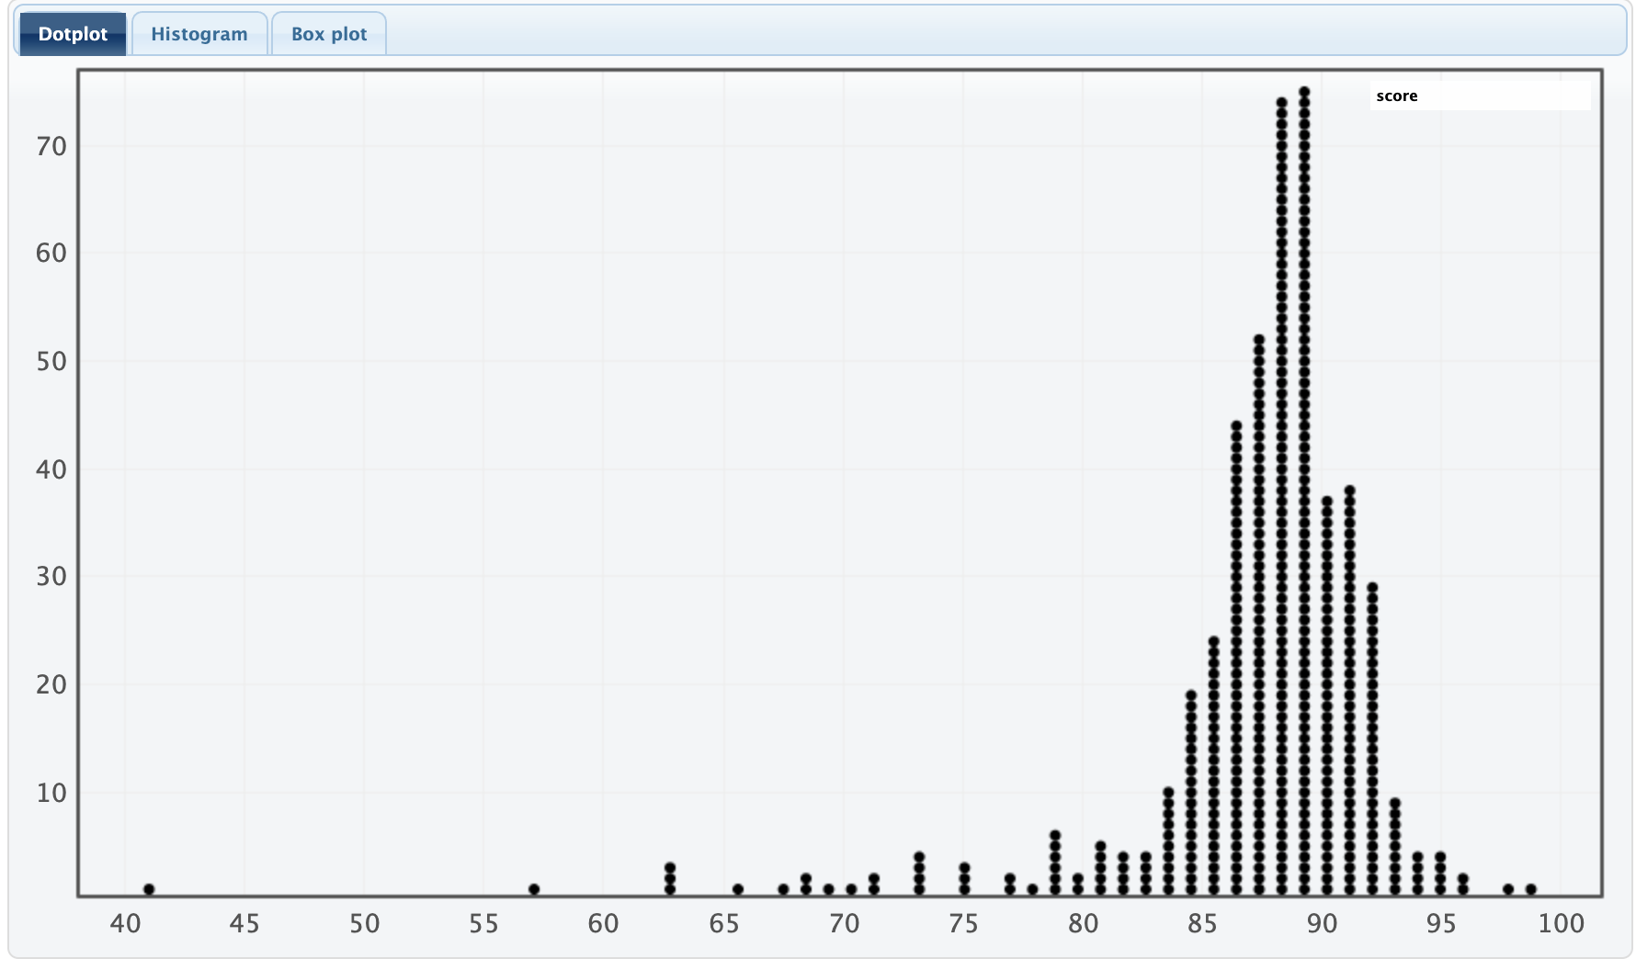
- Describe the shape, center, and spread of the distribution displayed in your dotplot.

- If we are interested in observing Leme’s average scores in an n=8 ride period (like the PBR World Finals), we can use StatKey to simulate this scenario. To do so:
- In StatKey go to Sampling Distribution for a Mean.
- Click on the pull-down menu just below the StatKey button and choose joseCareerScores.csv: score. This will load the score data.
  - Notice that this creates a smaller version of the dotplot from before on the right hand side (labeled Population).
- Click on ‘Choose samples of size n =’ and change it to 8
- Click Generate 1 Sample

- You should now have one dot on your graph. What does this dot represent?
  - Tip: On the right side of the screen, what is being displayed in the lower dotplot (labeled Sample)? (You can also click on ‘Show Data Table’ just above that plot.)

- Now click on Generate 1 Sample again. What happens?

- We will now simulate 1000 more eight ride scenarios for Leme. Do so by clicking on the Generate 1000 Samples button.
- This dotplot (on the main window) shows the Sampling Distribution for the Mean number of Scores in a random sample of 8 Rides by Jose Vitor Leme. Describe the shape, center, and spread of this distribution.

- Record the mean and std. error for this simulation.

- During the 2025 World Finals, Leme’s actual score per ride was 87.80. Based on your sampling distribution, does this seem unusually high, unusually low, or fairly typical? Explain your reasoning.

- Now set the sample size (n) to 23 to mimic the number of scored rides Leme had during his 2025 season, and generate 1000 samples.
- What does each dot in this simulation represent?

- Describe the shape, center, and spread of this distribution.

- Record the mean and std. error for this simulation.

- Leme’s actual score per ride in his 2025 season was 88.10. Based on your sampling distribution, does this seem unusually high, unusually low, or fairly typical? Explain your reasoning.

- General Rules and Trends: Based on your two simulations, using sample sizes of 8 and 23, what general patterns or trends do you notice about the shape, center, and spread of the sampling distributions?

- As the sample size increased from 8 to 23, the sampling distributions began to look more symmetric and bell-shaped. Would it be reasonable to use a Normal distribution to model these sampling distributions?

- If so, which Normal distribution (i.e., which center and spread) would you use for distribution of average points in a 23 ride sample?

Note that this can then be used to lead into the Central Limit Theorem approach of $\underline{Y}\sim Normal\left(μ,\frac{σ}{\sqrt{n}}\right)$

