The Tampa Bay Lightning established themselves as one of the best modern NHL teams by winning back-to-back Stanley Cup Championships in the 2019-20 and 2020-21 seasons. The NHL playoffs are structured as four round, best of seven series tournament: the First Round, Second Round, Conference Finals, and the Stanley Cup Final. To win the championship, a team must win 16 games over the course of multiple high stakes series, facing the toughest opponents in rapid succession.
At the core of the Lightning's run was Andrei Vasilevskiy, the team's starting goaltender. Known for his athleticism, composure, and consistency, Vasilevskiy played a crucial role in Tampa Bay's title runs. In the 2020-21 playoffs, he posted on of the most dominant performances by a goalie in recent memory and was awarded the Conn Smythe Trophy as the most valuable player of the postseason. His ability to perform under pressure, especially in elimination games, helped solidify his reputation as one of the best goaltenders of his era.
This module allows us to explore how statistical tools (such as Statkey) can be used to simulate real-world scenarios. By treating Vasilevskiy's game-by-game save percentages from the 2019-20 and 2020-21 regular seasons as the population, we can model specific playoff situations by drawing random samples of different sizes. These simulations help us understand how much variation we might expect in his performances and how likely different playoff outcomes are based on his regular season save percentages.
The data in vasilevskiy_save_percentage.csv contains the save percentage in each regular season game from the 2019-20 and 2020-21 NHL seasons by Andrei Vasilevskiy.
- Construct a dotplot of Andrei Vasilevskiy’s save percentage in a game. To do so,
  - Go to https://www.lock5stat.com/StatKey/index.html
  - In the Descriptive Statistics and Graphs column, click on One Quantitative Variable.
  - Click on the Upload File button, then navigate to your copy of the vasilevskiy_save_percentage.csv file. Click Open, then click on points, then Ok.
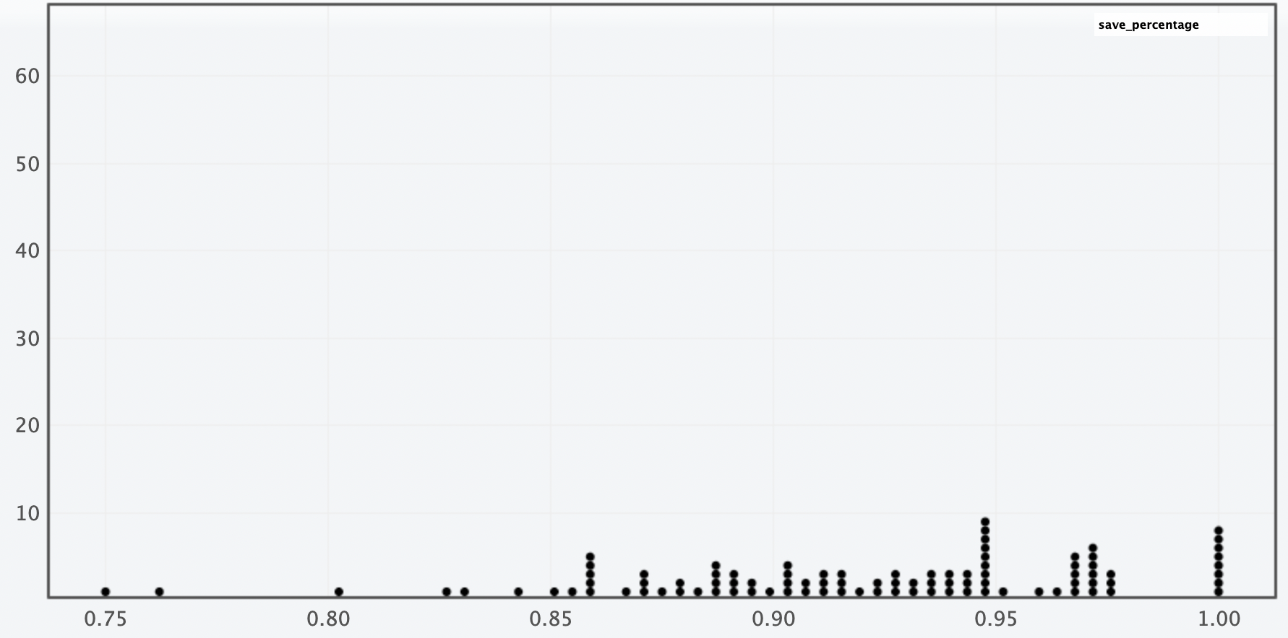
- Describe the shape, center, and spread of the distribution displayed in your dotplot.
Shape: The distribution is slightly left-skewed, most games fall between 0.85 and 1.0, but there are games in the 0.7’s that stretch the left tail of the distribution. Center: The center appears to be around 0.925, which is right around his season points per game of 0.919. Spread: The range is 0.75 to 1.0, and most games fall between 0.85 and 1.0.

- Suppose we’re interested in understanding Vasilevskiy’s average save percentage during a n=11 game period. (This is motivated by the fact that the Vasilevskiy has played in 11 Stanley Cup Final games during 2020 and 2021 playoffs.)
Follow these instructions to simulating a “Stanley Cup Final Scenario” (i.e., 11 game periods) for Vasilevskiy’s save percentage.
- In StatKey go to Sampling Distribution for a Mean.
- Click on the pull-down menu just below the StatKey button and choose vasilevskiy_save_percentage.csv. This will load the points data into this procedure.
  - Notice that this creates a smaller version of the dotplot from before on the right hand side (labeled Population).
- Click on Choose samples of size n = and change it to 11
- Click Generate 1 Sample

- You should now have one dot on your graph. What does this dot represent?
  - Tip: On the right side of the screen, what is being displayed in the lower dotplot (labeled Sample)? (You can also click on Show Data Table just above that plot.)

The average save percentage from a random sample of 11 games.

- Now click on Generate 1 Sample again. What happens?

- We will now simulate 1000 more five game periods for Vasilevskiy. Do so by clicking on the Generate 1000 Samples button.
- This dotplot (on the main window) shows the Sampling Distribution for the Mean Save Percentage in a random sample of 11 games by Vasilevskiy. Describe the shape, center, and spread of this distribution.

Solution: Answers will slightly vary. Shape: The sampling distribution is roughly symmetric. Center: The mean of the sampling distribution is 0.918. Spread: The range is roughly between 0.875 and 0.955, with most games between 0.89 and 0.94. Also, std error = 0.014

- Record the mean and std. error for this simulation.

Roughly 0.918 and 0.014 respectively

- Vasilevskiy’s actual average save percentage in these Stanley Cup Final games is 0.924 (92.4%). Based on your sampling distribution, does this seem unusually high, unusually low, or fairly typical? Explain your reasoning.

Solution: Vasilevskiy’s actual save percentage average falls above the mean of the sampling distribution. Approximately 63% of simulated sample means were less than or equal to 0.924. Even though it is above the mean, it is still fairly typical.

- Now set the sample size (n) to 48 to mimic the number of playoff games Vasilevskiy has played in during the 2020 and 2021 playoffs and generate 1000 samples.
- What does each dot in this simulation represent?

Solution: The average save percentage from a random sample of 48 games.

- Describe the shape, center, and spread of this distribution.

Solution: Answer will slightly vary. Shape: The sampling distribution is roughly symmetric. Center: The mean of the sampling distribution is 0.919. Spread: The range is roughly between 0.902 and 0.930, with most games between 0.910 and 0.928. Also, std error = 0.0054.

- Record the mean and std. error for this simulation.

Approximately 0.919 and 0.0054, respectively.

- Vasilevskiy’s actual average save percentage in the 2020 and 2021 playoff games is 0.932 (93.2%). Based on your sampling distribution, does this seem unusually high, unusually low, or fairly typical? Explain your reasoning.

Solution: Answers will slightly vary. Vasilevskiy’s actual average save percentage falls above the mean of the sampling distribution. Approximately 99% of simulated sample means were less than or equal to 0.932. This falls well above the mean showing that the sample mean is usually high. Vasilevskiy overperformed throughout the entire playoffs.

- General Rules and Trends: Based on your two simulations, using sample sizes of 11 and 48, what general patterns or trends do you notice about the shape, center, and spread of the sampling distributions?

Solution: Shape: When n = 48, the distribution was much smoother and more bell-shaped, when n = 11 it was more irregular and bumpy. Center: In both simulations, the sampling distributions were centered close to the same value of 0.92, which matches the mean of the original population. Spread: The std. error was larger when n = 11 (0.014) and smaller when n = 48 (0.0054). Meaning that larger samples lead to more consistent sample means.

- As the sample size increased from 11 to 48, the sampling distributions began to look more symmetric and bell-shaped. Would it be reasonable to use a Normal distribution to model these sampling distributions?

- If so, which Normal distribution (i.e., which center and spread) would you use for distribution of average save percentage in a 11 game sample?
- What about for a 28 game sample?

Solution: Students should respond
Normal(mean of sampling distribution, st error of sampling distribution)

Note that this can then be used to lead into the Central Limit Theorem approach of $\overline{Y}\sim Normal\left(μ,\frac{σ}{\sqrt{n}}\right)$

