The Kansas City Chiefs have cemented themselves as a modern NFL dynasty, winning three Super Bowls in five seasons and reaching the AFC Championship game nearly every year since 2018. The NFL playoffs are structured as a single elimination tournament with four rounds: Wild Card, Divisional Round, Conference Championship, and the Super Bowl.
At the core of the Cheifs’ run has been Patrick Mahomes, the quarterback of the team. He is widely regarded as one of the most talented players in NFL history. Mahomes has already collected multiple MVP awards, Super Bowl titles, and countless clutch performances. Despite only playing eight seasons so far, Mahomes is frequently mentioned alongside legendary quarterbacks like Tom Brady and Joe Montana.
This module allows us to explore how statistical tools (such as StatKey) can be used to simulate real-world scenarios. By treating Mahomes' regular season passing yard totals as the population, we can model specific playoff situations by drawing random samples of different sizes. These simulations help us understand how much variation we might expect in his performances and how likely different playoff outcomes are based on his regular season passing.
The data in mahomes_pass_yards.csv contains the passing yards in each regular season game by Patrick Mahomes.
- Construct a dotplot of Patrick Mahomes’ passing yards in a game. To do so,
  - Go to https://www.lock5stat.com/StatKey/index.html
  - In the Descriptive Statistics and Graphs column, click on One Quantitative Variable.
  - Click on the Upload File button, then navigate to your copy of the sga_points_2025.csv file. Click Open, then click on points, then Ok.
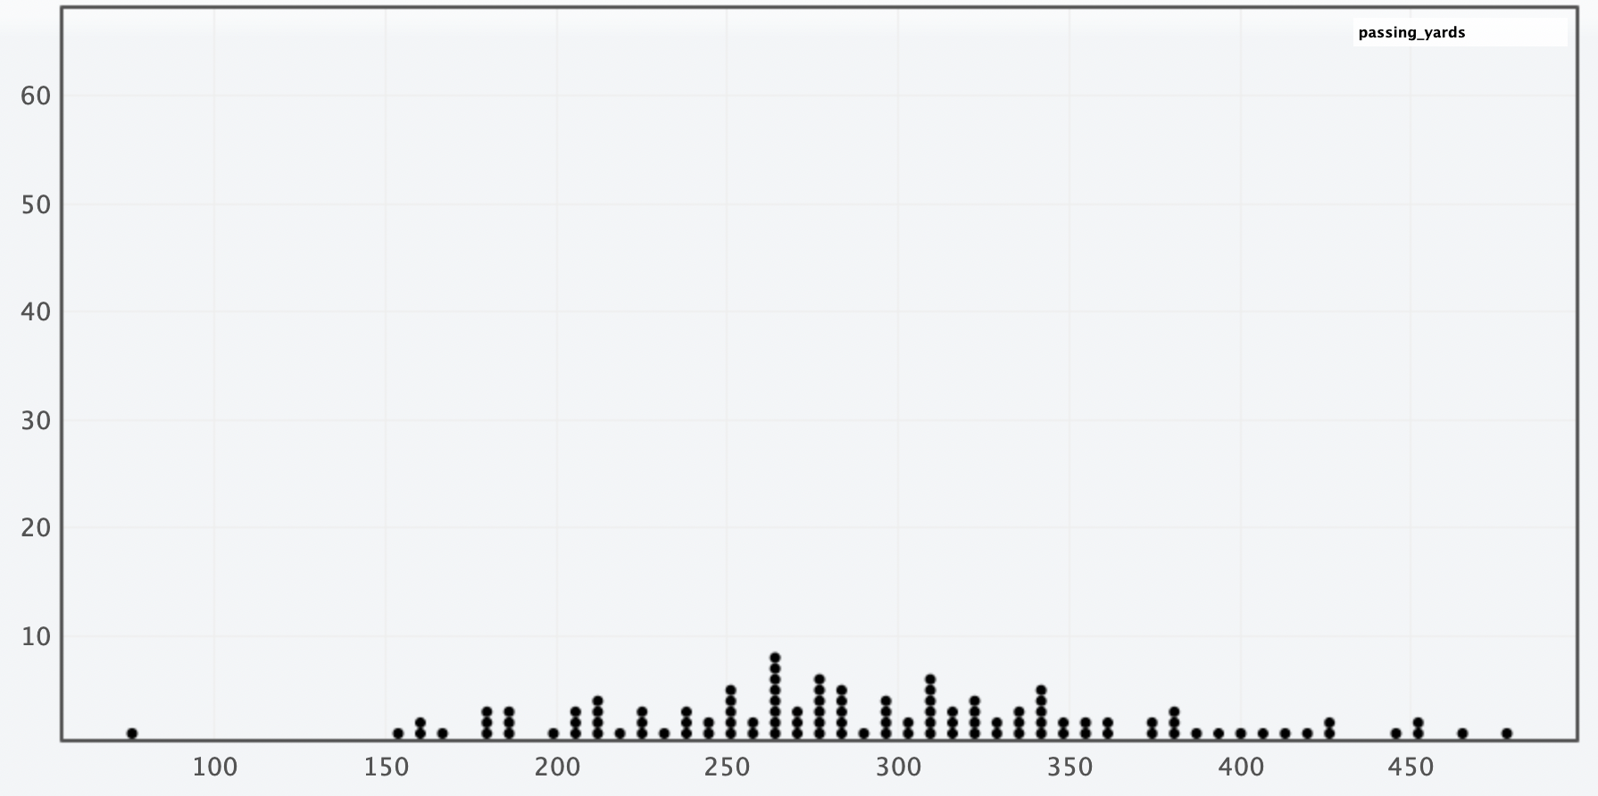
- Describe the shape, center, and spread of the distribution displayed in your dotplot.
Shape: The distribution is slightly right-skewed, most games fall between 175 and 425, but there are games in the 400’s that stretch the right tail of the distribution. Center: The center appears to be around 280, which is right around his season points per game of 288.9. Spread: The range is 76 to 478, and most games fall between 175 and 425.

- Suppose we’re interested in understanding Mahomes’ average passing yards during a n=5 game period. (This is motivated by the fact that the Mahomes has played in 5 Super Bowls during his career.)
Follow these instructions to simulating a “Super Bowl Scenario” (i.e., 5 game periods) for Mahomes’ passing yards.
- In StatKey go to Sampling Distribution for a Mean.
- Click on the pull-down menu just below the StatKey button and choose mahomes_pass_yards.csv: points. This will load the points data into this procedure.
  - Notice that this creates a smaller version of the dotplot from before on the right hand side (labeled Population).
- Click on Choose samples of size n = and change it to 5
- Click Generate 1 Sample

- You should now have one dot on your graph. What does this dot represent?
  - Tip: On the right side of the screen, what is being displayed in the lower dotplot (labeled Sample)? (You can also click on Show Data Table just above that plot.)

The average passing yards from a random sample of 5 games.

- Now click on Generate 1 Sample again. What happens?

- We will now simulate 1000 more five game periods for Mahomes. Do so by clicking on the Generate 1000 Samples button.
- This dotplot (on the main window) shows the Sampling Distribution for the Mean number of Passing Yards in a random sample of 5 games by Mahomes. Describe the shape, center, and spread of this distribution.

Solution: Answers will slightly vary. Shape: The sampling distribution is roughly symmetric. Center: The mean of the sampling distribution is 289.2. Spread: The range is roughly between 224 and 352, with most games between 240 and 335. Also, std error = 23.57

- Record the mean and std. error for this simulation.

Roughly 289.2 and 23.57 respectively

- Mahomes’ actual passing yards per game in his career Super Bowl appearances is 265.6. Based on your sampling distribution, does this seem unusually high, unusually low, or fairly typical? Explain your reasoning.
Solution: Mahomes’ actual passing yards average falls below the mean of the sampling distribution. Approximately 15% of simulated sample means were less than or equal to 265.6.

- Now set the sample size (n) to 21 to mimic the number of playoff games Mahomes’ has played in throughout his career and generate 1000 samples.
- What does each dot in this simulation represent?

Solution: The average passing yards from a random sample of 21 games.

- Describe the shape, center, and spread of this distribution.

Solution: Answer will slightly vary. Shape: The sampling distribution is roughly symmetric. Center: The mean of the sampling distribution is 288.34. Spread: The range is roughly between 247 and 333, with most games between 260 and 315. Also, std error = 15.01

- Record the mean and std. error for this simulation.

Approximately 288.34 and 15.01, respectively.

- Mahomes’ actual passing yards per game in the playoffs throughout his career is 276.9. Based on your sampling distribution, does this seem unusually high, unusually low, or fairly typical? Explain your reasoning.

Solution: Answers will slightly vary. Mahomes’ actual passing yards per game falls below the mean of the sampling distribution. Approximately 23% of simulated sample means were less than or equal to 276.9. Even though this falls below the mean it is still fairly typical.

- General Rules and Trends: Based on your two simulations, using sample sizes of 5 and 21, what general patterns or trends do you notice about the shape, center, and spread of the sampling distributions?

Solution: Shape: When n = 21, the distribution was much smoother and more bell-shaped, when n = 5 it was more irregular and bumpy. Center: In both simulations, the sampling distributions were centered close to the same value of 289, which matches the mean of the original population. Spread: The std. error was larger when n = 5 (23.57) and smaller when n = 21 (15.01). Meaning that larger samples lead to more consistent sample means.

- As the sample size increased from 5 to 21, the sampling distributions began to look more symmetric and bell-shaped. Would it be reasonable to use a Normal distribution to model these sampling distributions?

- If so, which Normal distribution (i.e., which center and spread) would you use for distribution of average points in a 5 game sample?
- What about for a 21 game sample?

Solution: Students should respond
Normal(mean of sampling distribution, st error of sampling distribution)

Note that this can then be used to lead into the Central Limit Theorem approach of $\overline{Y}\sim Normal\left(μ,\frac{σ}{\sqrt{n}}\right)$

