Analyzing Difference in Run Times in Women’s World Cup GS
In World Cup Giant Slalom (GS), there are two runs. Only the thirty fastest racers from the first run take a second run. If a racer is disqualified (DSQ) or did not finish (DNF) their first run, they do not take a second run. The order for the first run is determined by taking all racers and ordering them by their World Cup points, from highest to lowest. From that, the top 30 racers are put into three groups. The best seven racers are randomly assigning them a bib 1-7. The next eight best competitors are randomly assigned a bib 8-15. The next best 15 racers are randomly assigned a bib 16-30. The remaining racers go in descending order of points. For the second run, the course is reset. Competitors race in reverse order of their results on the first run, so the 30th fastest racer on the first run goes 1st on the second run and so on. This data set includes data from only the top thirty finishers as any racers who placed higher than 30th do not take a second run. In this worksheet, you will be tasked with creating a histogram of the run time differences and analyzing its distribution.

- We are interested in seeing if the differences in run times for this race are normally distributed. First, create a variable for the run time difference between the first and second run (Run1_Time – Run2_Time). Then, make a histogram of this variable. What is its shape?
This histogram comes from R. It appears normally distributed.
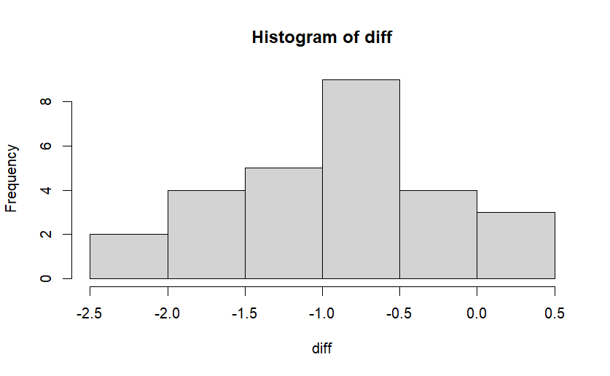

- Now, let’s compare these findings to a theoretical distribution. First, find the mean and standard deviation, then use these results to look at a normal theoretical distribution using StatKey.
Mean = -0.9003704
Standard deviation = 0.7064455
The theoretical distribution looks very similar.

- Now, we want to see if other races follow this same distribution. Use the Copper Mountain race data to follow the same steps as above.
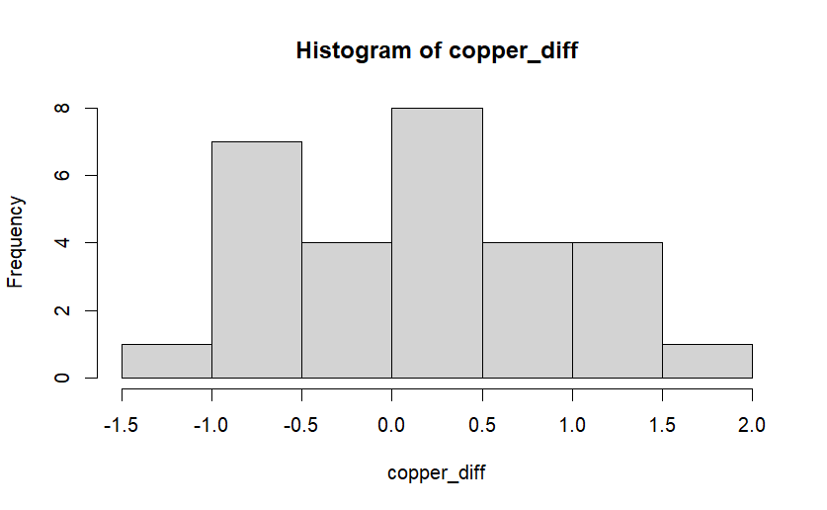
This appears pretty normally distributed, but a minor concern is the hump in the -1.0 to -0.5 bin.
Mean = 0.1296552
Standard Deviation = 0.7348152
The above graph follows the theoretical distribution pretty similarly, except for the hump noted above.

