Examining the Relationship Between First Run Order and Final Rank in Women’s World Cup GS
In World Cup Giant Slalom (GS), there are two runs. Only the thirty fastest racers from the first run take a second run. If a racer is disqualified (DSQ) or did not finish (DNF) their first run, they do not take a second run. The order for the first run is determined by taking all racers and ordering them by their World Cup points, from highest to lowest. From that, the top 30 racers are put into three groups. The best seven racers are randomly assigning them a bib 1-7. The next eight best competitors are randomly assigned a bib 8-15. The next best 15 racers are randomly assigned a bib 16-30. The remaining racers go in descending order of points. For the second run, the course is reset. Competitors race in reverse order of their results on the first run, so the 30th fastest racer on the first run goes 1st on the second run and so on. This data set includes data from only the top thirty finishers as any racers who placed higher than 30th do not take a second run. In this worksheet, you will be tasked with understanding your data, finding summary statistics, performing a t-test, constructing a confidence interval, and interpreting your findings in the context of this setting.

- We are interested in exploring the relationship between first run order and final rank. Based on the description above, sketch out what you would hypothesize the boxplots for final results for each of the bib groups to look like. (Group 1 = Bibs 1-7, Group 2 = Bibs 8-15, Group 3 = Bibs 16-30, Group 4 = Bibs 31+)
Answers will vary based on students’ hypotheses. Based on the description, students will likely hypothesize that Final_Rank will increase for each group and Final_Rank will be similar to start order.

- Now, use technology to create boxplots using the real data. What do they display? Compare this to your response to the question above.
Below is a boxplot created in R. It appears that racers who start with bibs 1-7 tend to have final ranks in that range, whereas it’s harder to predict final rank for Groups 2, 3, and 4. This does not align with the hypothesis that racers will rank in the range of their bib group.
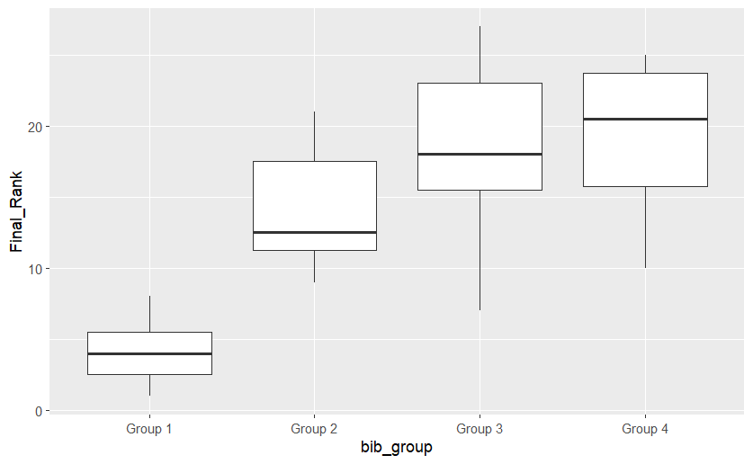

- We can run an ANOVA model and use Tukey’s HSD to determine which groups are significantly different. Does this match with your findings in the question above?

