Incorporating Indicator Variables: United Rugby Championships
Unlike other sports, which often have a “look”, rugby is unique in that it is intended to be accessible to players of various shapes and sizes. Different positions have distinct expectations and therefore are best suited to people with distinct physiques. This makes the height and weight data interesting to explore, especially with regard to position.
This data contains players from the United Rugby Championship from 6 positions: prop, hooker, lock, scrum-half, fly-half, and fullback. Props, hookers, and locks are forwards; locks, scrum-halves, and fly-halves are backs.
Props are relied on for strength and power and are often used like battering rams against the other team. The hooker is responsible for more technical game play, like winning the ball back and restarting play. Locks are the main source of power on the team and are usually tall and strong in their legs. The scrum-half is responsible for covering many different parts of the pitch and is also useful in attacks, meaning they must be very fast. The fly-half is usually the most important player on the pitch and defines the strategy of the team, making their role more tactical than strength-based. The fullback is the furthest back player on the pitch and needs to be quick to be the last line of defense against attacks.

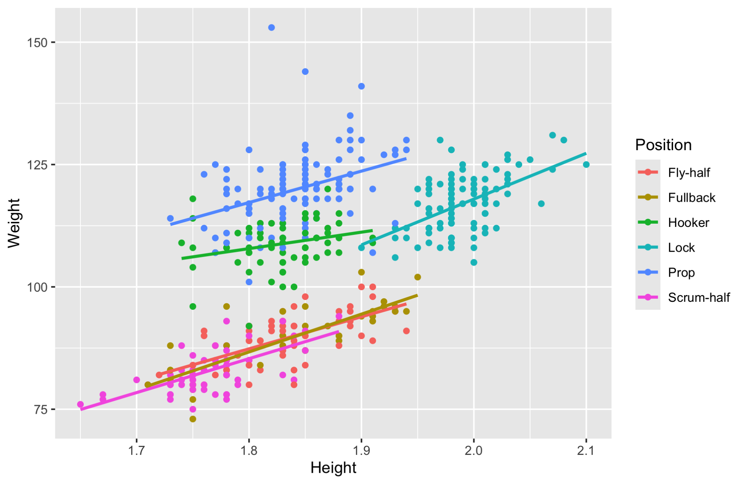
This scatterplot shows height of players being used as a predictor for weight. The graph has a separate line for each position.
In the graph, we can see that the lines of best fit for some positions have very different intercepts than others. To make a model that accounts for this, we will have to use indicator variables. There are 6 positions present in the data set, so we need 5 indicator variables—for prop, lock, hooker, scrum-half, and fullback.

- Fit a model that uses `Height` as a predictor for `Weight` and includes all of the indicator variables. Look at the model summary.
  - What does the summary tell you? Is it consistent with the scatterplot?

- Is it helpful to have indicator variables for ALL of the different positions in this dataset? Why or why not?

- Regardless of your answer to number 2, refit the model without the indicator variables for scrum-half and fullback. Instead we will leave them grouped in with the fly-halves. We will call this group the Backs. Look at the model summary.

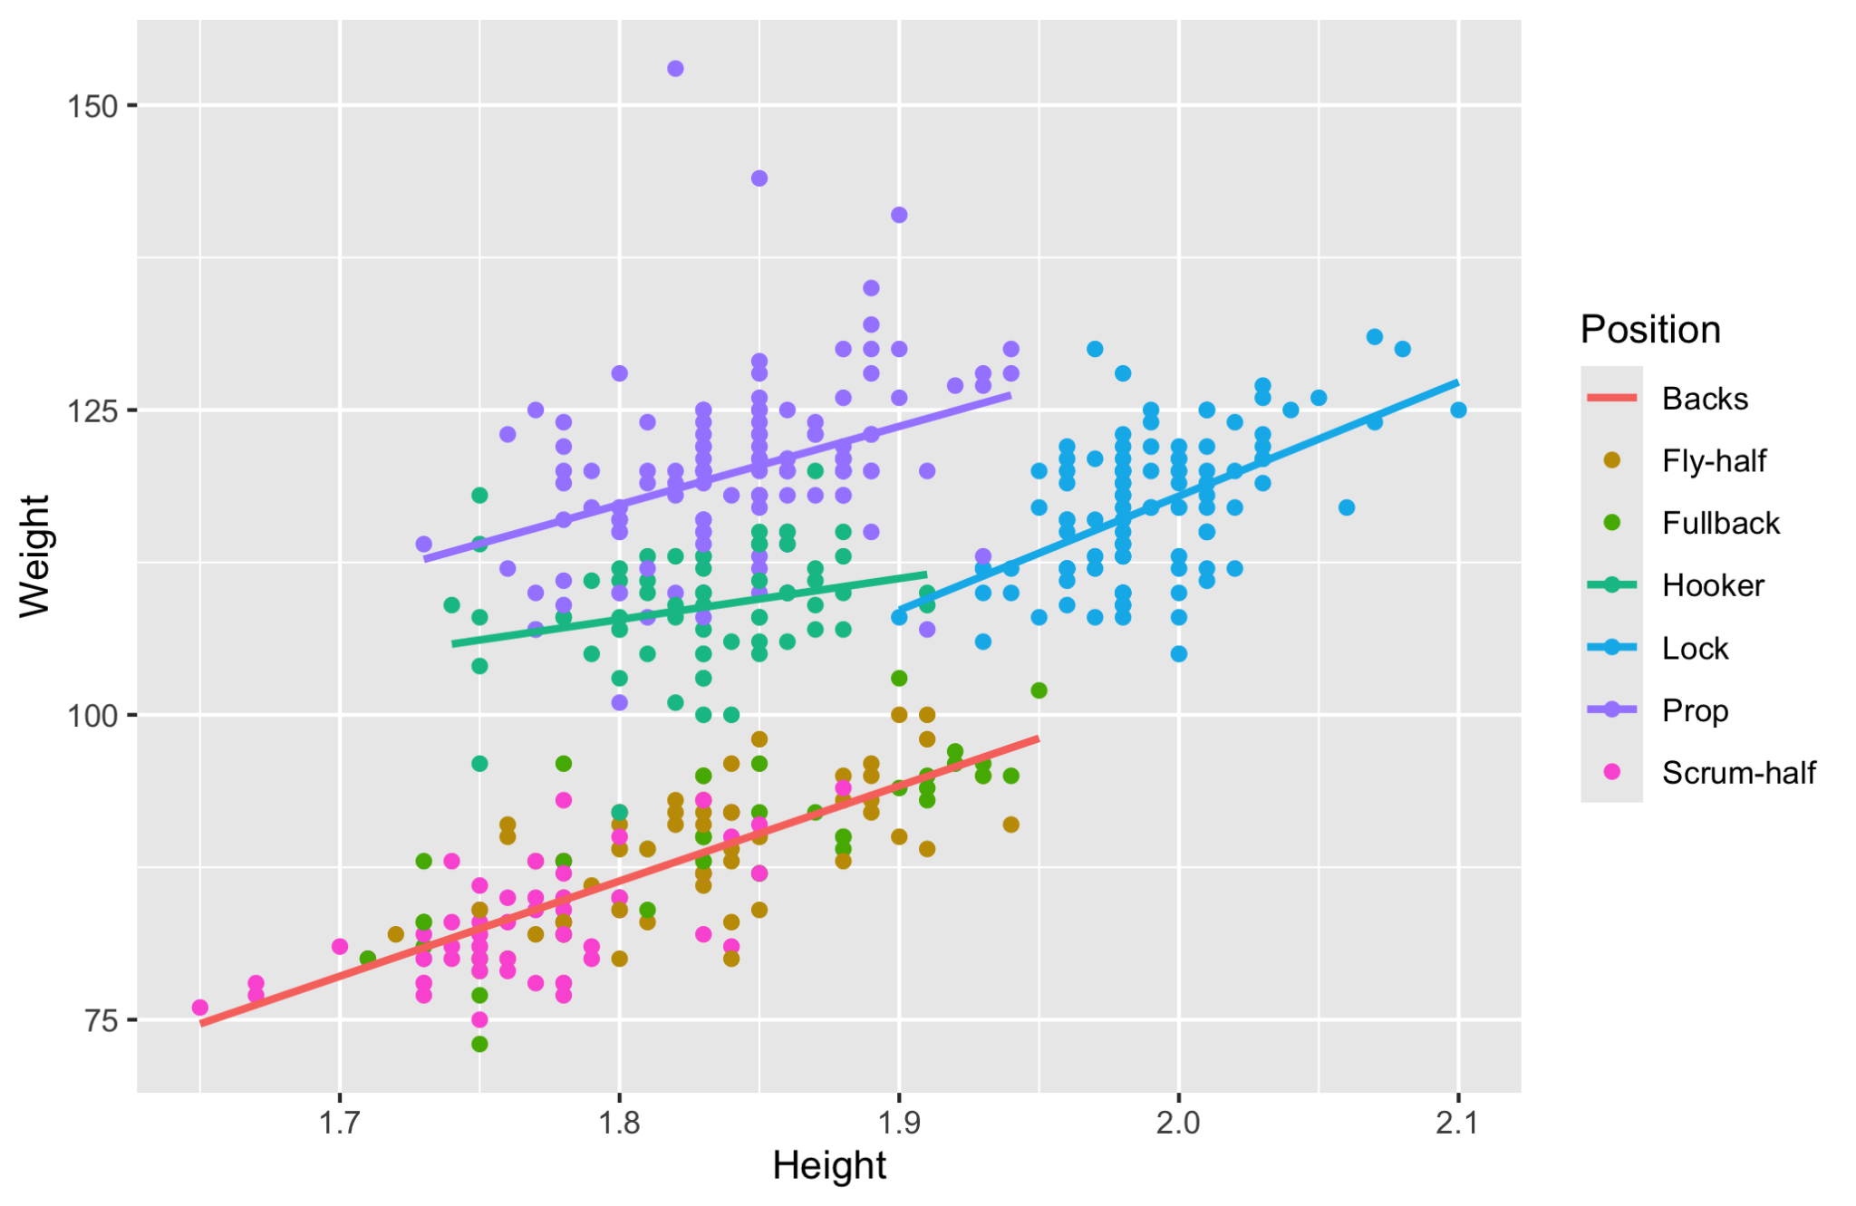
This scatterplot reflects the change in the model by switching to a single line for the scrum-halves, fullbacks, and fly-halves (the backs).
- What does the t-test on the prop indicator variable tell us?

- Interpret, in context, the coefficient for one of the indicator variables.

