TRIE (PREFIX TREE)
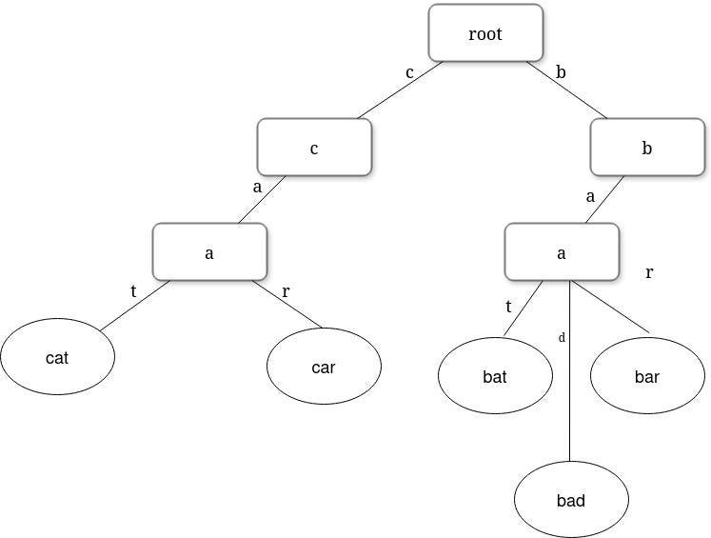
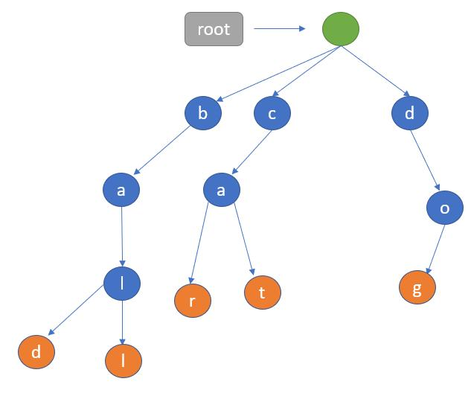
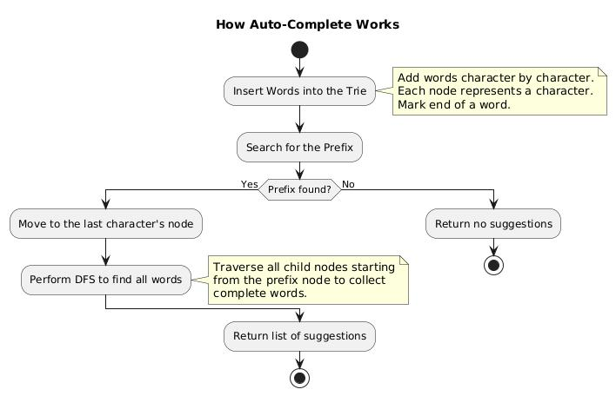
6

✅ Definition
Trie is a tree-like data structure used to store strings efficiently, especially for searching and prefix matching

📘 Core Idea
👉 Store characters node by node
- Each path = a word
- Root = empty
- Nodes = characters

🔷 STRUCTURE OF TRIE
- Each node contains:
✔ Array of children (size = alphabet)
✔ Boolean (isEndOfWord)

🔷 OPERATIONS IN TRIE

🔹 1. INSERT OPERATION
⚙️ Working
Insert character by character
📌 Steps
- Start at root
- For each character:
  - Calculate index (c - 'a')
  - If node not present → create
  - Move to next node
- Mark last node as end of word

⏱ Complexity
- Time: O(n)
- Space: O(n)

🔹 2. SEARCH OPERATION
⚙️ Working
Traverse characters
📌 Steps
- Start at root
- For each character:
  - Check if exists
  - Move to next node
- If last node marked → word exists

⏱ Complexity
- Time: O(n)
- Space: O(1)

🔹 3. PREFIX SEARCH
⚙️ Working
Check only prefix path
📌 Steps
- Start at root
- Traverse prefix characters
- If all found → prefix exists

⏱ Complexity
- Time: O(n)
- Space: O(1)

🔷 EXAMPLE
Insert: and, ant, dad
Trie Structure
- Root
├── a → n → d (end)
├── a → n → t (end)
└── d → a → d (end)

🔷 ADVANTAGES
✔ Fast search (O(n))
✔ No hashing needed
✔ No collisions
✔ Supports prefix search
✔ Can print words in sorted order

🔷 DISADVANTAGES
❌ High memory usage
❌ Many pointers per node

🔷 USE CASES
- Autocomplete (Google search)
- Dictionary
- Spell checker
- IP routing
- Prefix matching

🔄 TRIE vs HASHING
Feature | Trie | Hashing
Search | O(n) | O(1) avg
Prefix search | Yes | No
Memory | High | Low
Collisions | No | Yes

🧠 FINAL MEMORY TRICK
👉 Trie = Tree of characters
👉 Path = word
👉 End flag = word exists

🧾 FINAL 5-LINE EXAM ANSWER
- Trie stores strings efficiently
- Each node represents a character
- Supports fast search and prefix queries
- Time complexity O(n)
- Used in autocomplete and dictionaries

