Stack

🔹 1. What is a Stack?
A Stack is a linear data structure that follows:
👉 LIFO (Last In First Out)
👉 FILO (First In Last Out)

🔹 Real-Life Intuition
Think of a stack of plates 🍽️:
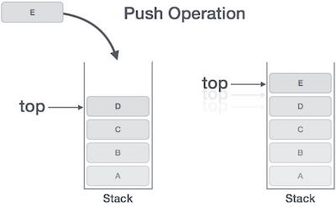
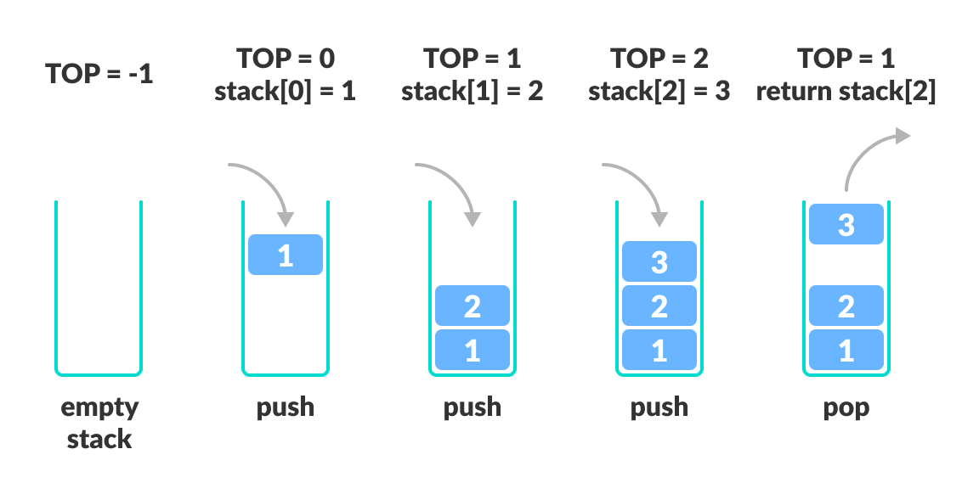
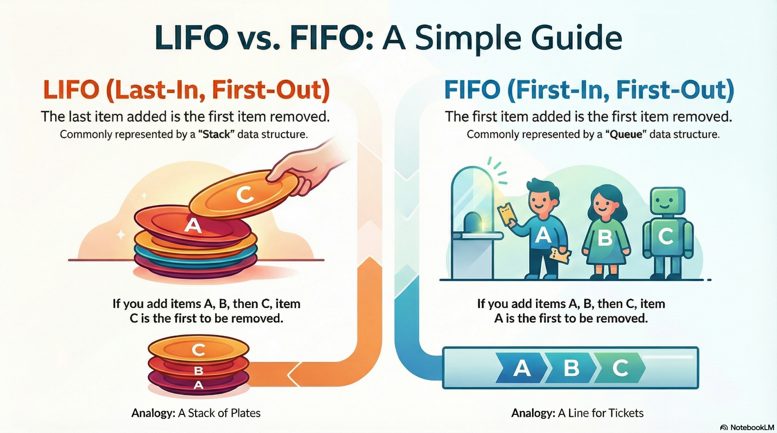
- Add plate → push
- Remove plate → pop
- Only top plate is accessible
👉 You cannot remove from middle

🔵 2. Basic Operations
Operation | Description
push() | Add element to top
pop() | Remove top element
peek() | View top element
isEmpty() | Check if empty
size() | Number of elements

🟡 3. Stack Properties (Theory)
- Access only top element
- No random access
- All operations happen at one end
- Efficient operations → O(1)

🔴 4. Stack Implementation Methods

🔹 1. Array Implementation
💡 Theory
- Use array + top pointer
- top = -1 → empty stack

✅ Java Implementation
class StackArray {
int[] arr;
int top;
int size;
StackArray(int size) {
this.size = size;
arr = new int[size];
top = -1;
}
void push(int x) {
if (top == size - 1) {
System.out.println("Stack Overflow");
return;
}
arr[++top] = x;
}
int pop() {
if (top == -1) {
System.out.println("Stack Underflow");
return -1;
}
return arr[top--];
}
int peek() {
if (top == -1) return -1;
return arr[top];
}
}

✔ Advantages
- Fast
- Simple
❌ Disadvantages
- Fixed size (overflow issue)

🔹 2. Linked List Implementation
💡 Theory
- Dynamic size
- No overflow (until memory ends)

✅ Java Implementation
class Node {
int data;
Node next;
Node(int data) {
this.data = data;
}
}
class StackLL {
Node top;
void push(int x) {
Node newNode = new Node(x);
newNode.next = top;
top = newNode;
}
int pop() {
if (top == null) {
System.out.println("Stack Empty");
return -1;
}
int val = top.data;
top = top.next;
return val;
}
int peek() {
if (top == null) return -1;
return top.data;
}
}

✔ Advantages
- Dynamic size
- Efficient memory usage

🔹 3. Using Java Built-in Stack
import java.util.Stack;
Stack<Integer> stack = new Stack<>();
stack.push(10);
stack.push(20);
System.out.println(stack.pop()); // 20
System.out.println(stack.peek()); // 10

🔹 4. Using Deque (Recommended in Interviews)
💡 Why?
- Faster than Stack class
- More modern
import java.util.*;
Deque<Integer> stack = new ArrayDeque<>();
stack.push(10);
stack.push(20);
stack.pop();
stack.peek();

🟣 5. Internal Working (Important Theory)

🔹 Push Operation
- Increment top
- Insert element
🔹 Pop Operation
- Return top element
- Decrement top

🔹 Example Flow
Push: 10 → 20 → 30
Stack:
| 30 | ← top
| 20 |
| 10 |
Pop → removes 30

🟠 6. Applications of Stack

🔹 1. Expression Evaluation
- Infix → Postfix → Prefix

🔹 2. Balanced Parentheses
boolean isValid(String s) {
Stack<Character> st = new Stack<>();
for (char c : s.toCharArray()) {
if (c == '(') st.push(c);
else {
if (st.isEmpty()) return false;
st.pop();
}
}
return st.isEmpty();
}

🔹 3. Undo/Redo Operations
- Used in editors

🔹 4. Function Calls (Recursion)
- Uses call stack internally

🔹 5. DFS (Depth First Search)
- Uses stack

⚫ 7. Important Interview Problems

🔹 Reverse a Stack
void reverse(Stack<Integer> st) {
if (st.isEmpty()) return;
int x = st.pop();
reverse(st);
insertAtBottom(st, x);
}

🔹 Next Greater Element
int[] nextGreater(int[] arr) {
Stack<Integer> st = new Stack<>();
int[] res = new int[arr.length];
for (int i = arr.length - 1; i >= 0; i--) {
while (!st.isEmpty() && st.peek() <= arr[i]) {
st.pop();
}
res[i] = st.isEmpty() ? -1 : st.peek();
st.push(arr[i]);
}
return res;
}

🟢 8. Time Complexity
Operation | Time
Push | O(1)
Pop | O(1)
Peek | O(1)

🔥 Final Understanding
👉 Stack is best when:
- Need reverse order processing
- Need tracking history
👉 Key idea:
- Only top matters

🟢 Stack Data Structure – Complete Theory + Methods

🔹 1. Definition
A Stack is a linear data structure that follows:
👉 LIFO (Last In First Out)
👉 All insertions and deletions happen at TOP

🔹 2. Terminologies
- Top → index/reference of last inserted element
- Push → insert element
- Pop → remove element
- Peek/Top → view top element
- Overflow → stack full
- Underflow → stack empty

🔵 3. Core Functions / Methods

🔹 Basic Stack Operations (Abstract)
Function | Description
push(x) | Insert element
pop() | Remove top
peek() | Return top
isEmpty() | Check empty
isFull() | Check full (array)
size() | Number of elements

🔹 Java Built-in Stack Methods
Stack<Integer> stack = new Stack<>();
Method | Description
push(x) | Add element
pop() | Remove & return top
peek() | Return top
empty() | Check empty
size() | Returns size
search(x) | Position from top

✅ Example
stack.push(10);
stack.push(20);
System.out.println(stack.peek()); // 20
System.out.println(stack.pop()); // 20
System.out.println(stack.empty()); // false

🟡 4. Deque Stack Methods (Recommended)
Deque<Integer> stack = new ArrayDeque<>();
Method | Description
push(x) | Add to front
pop() | Remove from front
peek() | View front
isEmpty() | Check empty

✅ Example
stack.push(1);
stack.push(2);
System.out.println(stack.pop()); // 2

🔴 5. Stack Implementation Functions

🔹 Array-Based Stack Functions
boolean isEmpty() {
return top == -1;
}
boolean isFull() {
return top == size - 1;
}
void push(int x) {
if (isFull()) return;
arr[++top] = x;
}
int pop() {
if (isEmpty()) return -1;
return arr[top--];
}
int peek() {
if (isEmpty()) return -1;
return arr[top];
}

🔹 Linked List Stack Functions
boolean isEmpty() {
return top == null;
}
void push(int x) {
Node newNode = new Node(x);
newNode.next = top;
top = newNode;
}
int pop() {
if (isEmpty()) return -1;
int val = top.data;
top = top.next;
return val;
}
int peek() {
if (isEmpty()) return -1;
return top.data;
}

🟣 6. Types of Stack

🔹 1. Simple Stack
- Standard LIFO
🔹 2. Dynamic Stack
- Resizes automatically
🔹 3. Multiple Stack
- More than one stack in one array
🔹 4. Min Stack (Important)
👉 Supports retrieving minimum in O(1)
class MinStack {
Stack<Integer> stack = new Stack<>();
Stack<Integer> minStack = new Stack<>();
void push(int x) {
stack.push(x);
if (minStack.isEmpty() || x <= minStack.peek()) {
minStack.push(x);
}
}
void pop() {
if (stack.pop().equals(minStack.peek())) {
minStack.pop();
}
}
int getMin() {
return minStack.peek();
}
}

🟠 7. Utility Stack Functions (Important Patterns)

🔹 Reverse Stack
void insertBottom(Stack<Integer> st, int x) {
if (st.isEmpty()) {
st.push(x);
return;
}
int temp = st.pop();
insertBottom(st, x);
st.push(temp);
}

🔹 Check Balanced Parentheses
boolean isValid(String s) {
Stack<Character> st = new Stack<>();
for (char c : s.toCharArray()) {
if (c == '(') st.push(c);
else {
if (st.isEmpty()) return false;
st.pop();
}
}
return st.isEmpty();
}

🔹 Evaluate Postfix Expression
int evaluate(String[] tokens) {
Stack<Integer> st = new Stack<>();
for (String t : tokens) {
if (t.equals("+")) {
st.push(st.pop() + st.pop());
} else if (t.equals("-")) {
int b = st.pop(), a = st.pop();
st.push(a - b);
} else {
st.push(Integer.parseInt(t));
}
}
return st.pop();
}

⚫ 8. Applications (Conceptual)
- Expression evaluation
- Undo/Redo systems
- Backtracking
- DFS (Graph traversal)
- Browser history

🟢 9. Time Complexity
Operation | Time
Push | O(1)
Pop | O(1)
Peek | O(1)

🔥 Final Summary (Important)
👉 Stack = LIFO structure
👉 Only top element is accessible
👉 Most problems use:
- Monotonic stack
- Parentheses
- Next Greater Element

