Queue

🔹 1. Definition
A Queue is a linear data structure that follows:
👉 FIFO (First In First Out)
👉 First element inserted → first element removed

🔹 Real-Life Intuition
Think of a line at a ticket counter 🎟️
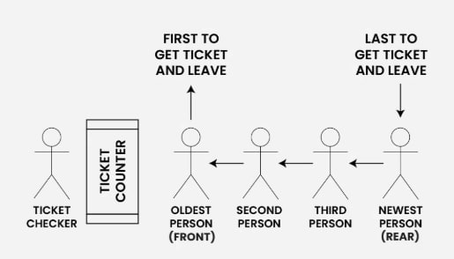
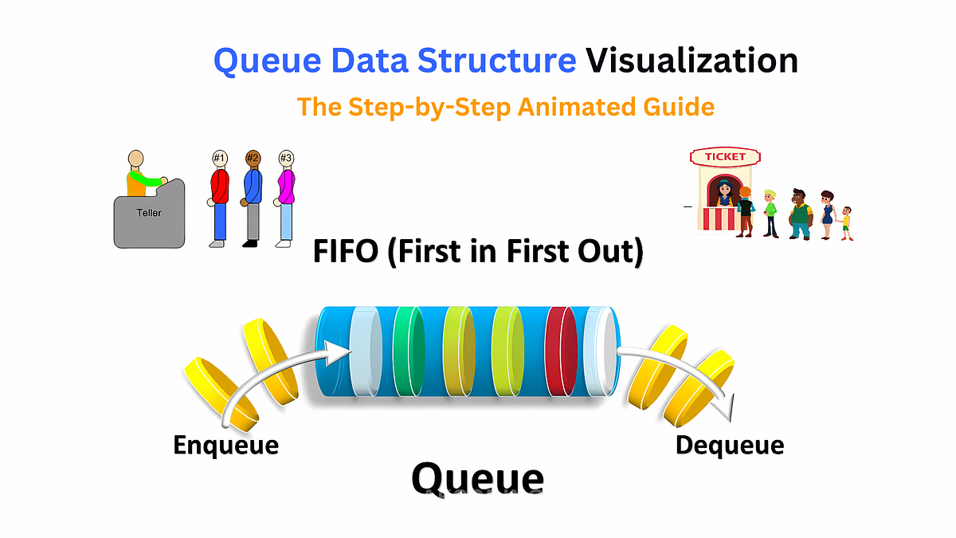
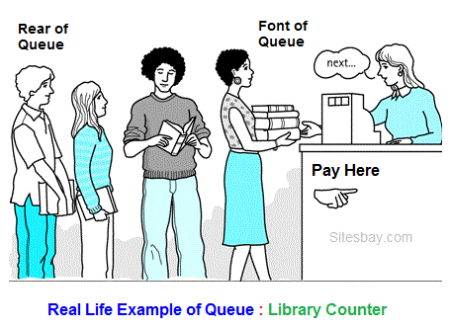
- Person joins → rear (enqueue)
- Person leaves → front (dequeue)

🔵 2. Basic Terminologies
Term | Meaning
Front | First element (to be removed)
Rear | Last element (recently added)
Enqueue | Insert at rear
Dequeue | Remove from front
Size | Number of elements
Capacity | Max size

🟡 3. Core Operations (Functions)
Function | Description
enqueue(x) | Add element
dequeue() | Remove element
peek() / front() | View front
getRear() | View last element
isEmpty() | Check empty
isFull() | Check full (array)
size() | Total elements

🔴 4. Types of Queue

🔹 1. Simple Queue
- FIFO strictly followed
- Insert → rear
- Delete → front

🔹 2. Circular Queue
💡 Theory
- Array treated as circular
- Avoids memory waste
👉 Uses:
index = (index + 1) % size;

🔹 3. Deque (Double Ended Queue)
- Insert/delete from both ends

🔹 4. Priority Queue
- Elements processed based on priority, not order

🟣 5. Queue Implementation

🔹 1. Array Implementation (Simple)
💡 Theory
- Insert at rear
- Delete from front → requires shifting → slow

✅ Java Code
class QueueArray {
int[] arr;
int front = 0, rear = -1, size = 0, capacity;
QueueArray(int capacity) {
this.capacity = capacity;
arr = new int[capacity];
}
void enqueue(int x) {
if (size == capacity) return;
rear++;
arr[rear] = x;
size++;
}
int dequeue() {
if (size == 0) return -1;
int val = arr[front];
// shift elements (costly)
for (int i = 1; i <= rear; i++) {
arr[i - 1] = arr[i];
}
rear--;
size--;
return val;
}
}
👉 Dequeue = O(n) (bad)

🔹 2. Circular Queue (Efficient)
💡 Theory
- No shifting
- Both operations = O(1)

✅ Java Code
class CircularQueue {
int[] arr;
int front = 0, rear = -1, size = 0, capacity;
CircularQueue(int capacity) {
this.capacity = capacity;
arr = new int[capacity];
}
void enqueue(int x) {
if (size == capacity) return;
rear = (rear + 1) % capacity;
arr[rear] = x;
size++;
}
int dequeue() {
if (size == 0) return -1;
int val = arr[front];
front = (front + 1) % capacity;
size--;
return val;
}
}
👉 Best array implementation

🔹 3. Linked List Implementation
💡 Theory
- Dynamic size
- Maintain:
  - front
  - rear

✅ Java Code
class Node {
int data;
Node next;
Node(int data) {
this.data = data;
}
}
class QueueLL {
Node front, rear;
void enqueue(int x) {
Node newNode = new Node(x);
if (rear == null) {
front = rear = newNode;
return;
}
rear.next = newNode;
rear = newNode;
}
int dequeue() {
if (front == null) return -1;
int val = front.data;
front = front.next;
if (front == null) rear = null;
return val;
}
}
👉 All operations = O(1)

🟠 6. Java Queue Interface (Very Important)
👉 Queue is an interface, cannot be created directly

🔹 Declaration
Queue<Integer> q = new LinkedList<>();

🔹 Common Implementations
- LinkedList
- ArrayDeque
- PriorityQueue

🔹 Important Methods
Method | Description
add(x) | Insert (throws error if fails)
offer(x) | Insert (safe)
remove() | Remove (throws error)
poll() | Remove (safe)
peek() | View front
element() | View front (error if empty)

✅ Example
Queue<Integer> q = new LinkedList<>();
q.add(10);
q.add(20);
System.out.println(q.peek()); // 10
System.out.println(q.poll()); // 10

🟤 7. Priority Queue (Special Case)
Queue<Integer> pq = new PriorityQueue<>();
pq.add(50);
pq.add(10);
pq.add(30);
System.out.println(pq); // sorted order
👉 Removes smallest element first (min-heap)

⚫ 8. Time Complexity
Operation | Time
Enqueue | O(1)
Dequeue | O(1)
Peek | O(1)

🔥 9. Applications of Queue
- CPU scheduling
- Printer queue
- BFS (Graph traversal)
- Streaming data
- Call center systems

🧠 Stack vs Queue (Important)
Feature | Stack | Queue
Order | LIFO | FIFO
Insert | Top | Rear
Delete | Top | Front

