RECURSION
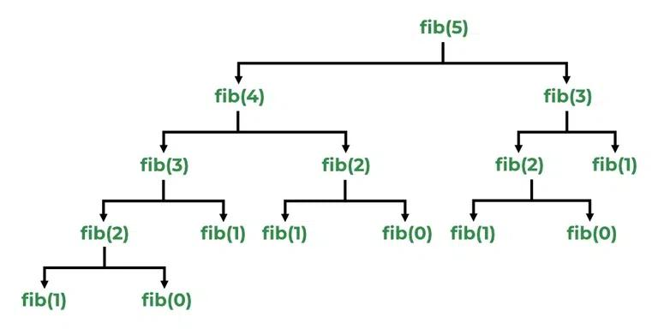
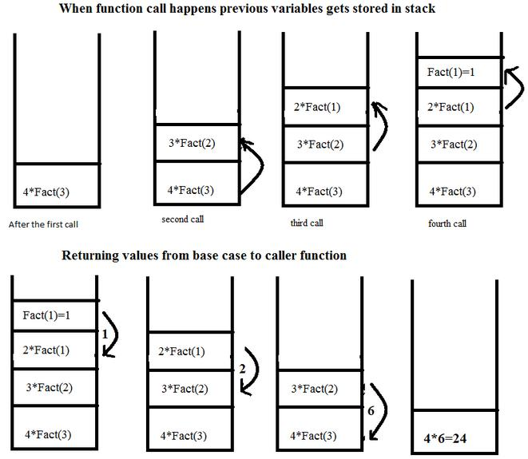
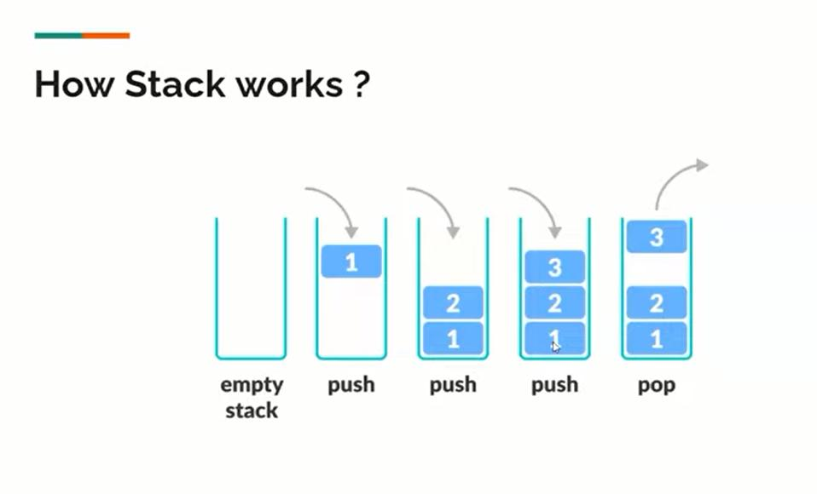
6
✅ Definition
Recursion is a process where a function calls itself directly or indirectly to solve a problem.
📌 A function that does this is called a recursive function

📘 Explanation
- A recursive function solves a problem by breaking it into smaller subproblems
- It keeps calling itself until it reaches a base condition
- After reaching base case, it starts returning values
👉 Example flow:
sum(3) → sum(2) → sum(1) → returns → combine results

⚙️ STEPS TO IMPLEMENT RECURSION
- Base Case → stopping condition
- Recursive Case → divide into smaller problem
- Ensure termination → must reach base case
- Combine results → final answer

🔹 EXAMPLE 1: SUM OF N NUMBERS
Algorithm
sum(n):
if n == 1:
return 1
return n + sum(n-1)
Explanation
- sum(3) = 3 + sum(2)
- sum(2) = 2 + sum(1)
- sum(1) = 1

⏱ Time Complexity
- O(n)
💾 Space Complexity
- O(n) (due to recursion stack)

🔹 EXAMPLE 2: FACTORIAL
Algorithm
fact(n):
if n == 0:
return 1
return n * fact(n-1)
⏱ Time Complexity
- O(n)
💾 Space Complexity
- O(n)

🔹 EXAMPLE 3: FIBONACCI
Recurrence Relation
T(n) = T(n-1) + T(n-2)
⏱ Time Complexity
- O(2ⁿ) (very slow)
💾 Space Complexity
- O(n)

⚠️ STACK OVERFLOW
📌 Occurs when:
- Base case is missing or incorrect
- Recursion never stops
👉 Infinite calls → memory full → crash

🔄 TYPES OF RECURSION
🔹 Direct Recursion
Function calls itself
🔹 Indirect Recursion
Function A → calls B → calls A

🔹 Tail Recursion
Recursive call is last operation
✔ More efficient

🔹 Non-Tail Recursion
Work remains after recursive call

🧠 MEMORY WORKING
- Uses stack (LIFO)
- Each call gets its own memory
- Stack grows → shrinks after returning

🎯 USE CASES OF RECURSION
- Tree traversal (DFS)
- Graph algorithms
- Divide & Conquer (Merge Sort, Quick Sort)
- Backtracking (N-Queens)
- Fibonacci, Factorial

⚖️ RECURSION vs ITERATION
Feature | Recursion | Iteration
Approach | Function calls | Loops
Memory | High (stack) | Low
Code | Simple | Complex sometimes
Speed | Slower | Faster
Use | Complex problems | Simple problems

🔄 WITH vs WITHOUT RECURSION
✔ With Recursion
- Cleaner code
- Easy for complex problems
- Natural for trees/graphs
❌ Without Recursion (Iteration)
- Better memory usage
- Faster execution
- No stack overflow risk

✅ ADVANTAGES
- Easy to understand
- Reduces code complexity
- Useful for divide & conquer

❌ DISADVANTAGES
- Uses more memory
- Can cause stack overflow
- Slower than iteration

🧠 FINAL SUMMARY
- Recursion = function calling itself
- Needs base case + recursive case
- Uses stack memory
- Powerful but must be used carefully

