Prefix Sum Technique

1. Definition
Prefix sum is an array technique where a new array is created to store cumulative sums from the beginning up to each index.
For an array arr of size n:
prefix[i] = arr[0] + arr[1] + ... + arr[i]
Valid for 0 ≤ i < n.

2. Why use it
It allows fast calculation of sums of contiguous segments after a one time preprocessing step.
- Preprocessing time: O(n)
- Each range query: O(1)

3. Range Sum Formula
Without prefix sum
Compute from index i to j by looping.
Time: O(j - i + 1)
With prefix sum
sum(i, j) = prefix[j] - prefix[i - 1] if i > 0
sum(0, j) = prefix[j]
Time: O(1)

4. How to Build
prefix[0] = arr[0]
for i from 1 to n-1:
prefix[i] = prefix[i-1] + arr[i]

5. Applications
- Range sum queries
- Counting elements in a range that satisfy a condition
- Finding subarrays with a given sum
- 2D matrix sub rectangle sum
- Difference array and range updates
- Cumulative frequency and histogram based queries
- Fast repeated summation

6. When to Recognize This Pattern
Look for clues like:
- Sum of elements in a range or subarray
- Many repeated queries
- Need cumulative counts
- Subarray checking problems

7. Benefits
- Reduces repeated work
- Converts nested iteration into simple subtraction
- Turns O(n^2) style summation into near O(n) overall with constant time queries

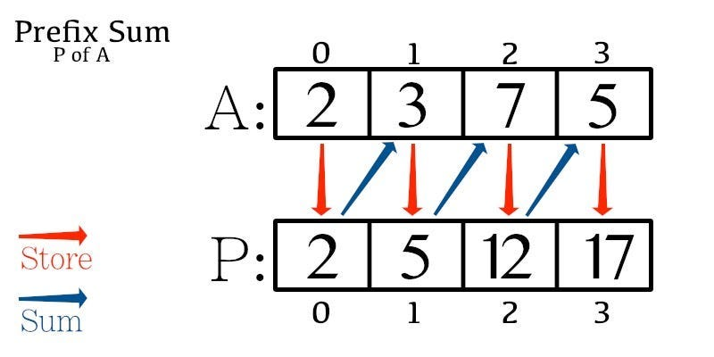

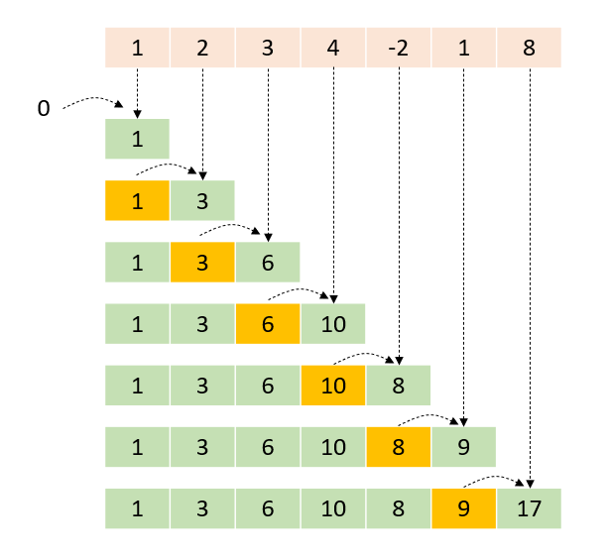

🔹 8) Interview Expectations
They want to see whether you can:
- trade space for time
- precompute smartly
- recognize subtraction trick
- combine with HashMap for counting

🔹 9) Practice Problems with leetcode problem number.
Easy
- Running Sum of 1d Array → 1480
- Range Sum Query – Immutable → 303
- Find Pivot Index → 724

Medium
- Subarray Sum Equals K → 560
- Continuous Subarray Sum → 523
- Binary Subarrays With Sum → 930
- Maximum Size Subarray Sum Equals k → 325
- Count Number of Nice Subarrays → 1248

Medium to Hard
- Subarrays Divisible by K → 974
- Contiguous Array → 525
- Product of Array Except Self → 238

Hard
- Range Sum Query 2D – Immutable → 304
- Count of Range Sum → 327
- Number of Submatrices That Sum to Target → 1074
- Make Sum Divisible by P → 1590

