Matrices & Island (Matrix Traversal)

1) Definition
Matrix / Grid Problems
- Problems represented as a 2D grid (matrix)
- Each cell acts like a node in a graph
- Movement typically in 4 directions: up, down, left, right (sometimes diagonals)
- Traversal techniques: DFS or BFS
Island Problems
- Grid where certain cells represent land (1 / true) and others water (0 / false)
- Adjacent land cells form a connected component called an island
- Goal is to count, measure, or analyze these components

2) Use Cases / Applications
- Counting connected components (islands)
- Shortest path in grid
- Flood fill problems
- Region marking and clustering
- Virus spread / diffusion simulation
- Maze and map navigation
- Territory detection

3) Key Concepts & Keywords
- Grid, matrix, land, water
- Connected groups
- Visited cells
- Marking regions
- Shortest path
- Boundaries and edges
- Multi source spread
- Rotten oranges type propagation

4) Benefits / Why Important
- Very common interview topic
- Demonstrates DFS and BFS mastery
- Models many real world spatial problems
- Efficient solutions usually run in O(m × n)

5) Recognition Pattern
Use matrix traversal when you see:
- 2D grid input
- Need to explore neighbors
- Words like island, region, cluster, area, boundary
- Need to count groups or measure components
- Spread over time or shortest distance in grid

6) Common Problem Categories
A. Counting / Group Detection (DFS)
- Number of islands
- Connected components
- Distinct islands
- Enclaves
B. Area / Shape Measurement (DFS)
- Max area of island
- Perimeter of island
- Shape comparison
C. Shortest Path (BFS)
- Nearest distance to target
- Binary matrix shortest path
- Multi source BFS problems
D. Spread Simulation (BFS)
- Rotten oranges
- Fire spread
- Infection propagation
E. Flood Fill / Region Change (DFS/BFS)
- Replace region color
- Capture surrounded regions

7) Standard Algorithm Steps
General Matrix Traversal
- Create a visited structure (boolean matrix)
or modify grid in place
- Scan grid cell by cell
- When target cell found (land or source):
  - Run DFS or BFS
  - Explore all connected neighbors
- Process according to problem:
  - Count islands
  - Measure area
  - Track distance
  - Mark region
- Handle boundaries carefully

DFS Approach (Typical for Islands)
If cell is land and not visited:
DFS(cell):
mark visited
explore all valid neighbors
Use for:
- Counting islands
- Area calculation
- Region marking

BFS Approach (Typical for Shortest Path / Spread)
Initialize queue with source cells
While queue not empty:
process level by level
push valid neighbors
Use for:
- Minimum distance
- Multi source spread
- Time based propagation

8) Boundary Handling Rules
- Check indices are within grid
- Avoid revisiting cells
- Skip water or blocked cells
- Prevent out of bound errors

9) Time & Space Complexity
- Time: O(m × n) since each cell processed once
- Space:
  - DFS recursion stack or BFS queue
  - Visited matrix if used

10) Important LeetCode Problems (Easy → Hard)
Easy
- 733 Flood Fill
- 463 Island Perimeter
Medium
- 200 Number of Islands
- 695 Max Area of Island
- 130 Surrounded Regions
- 994 Rotting Oranges
- 1091 Shortest Path in Binary Matrix
- 1020 Number of Enclaves
- 417 Pacific Atlantic Water Flow
Hard
- 827 Making A Large Island
- 1905 Count Sub Islands
- 1254 Number of Closed Islands

🧩 Matrix Traversal (General Grid Problems)
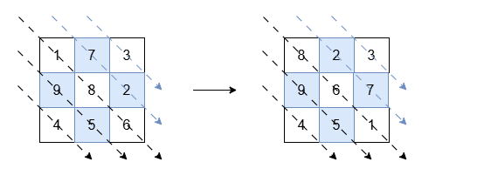
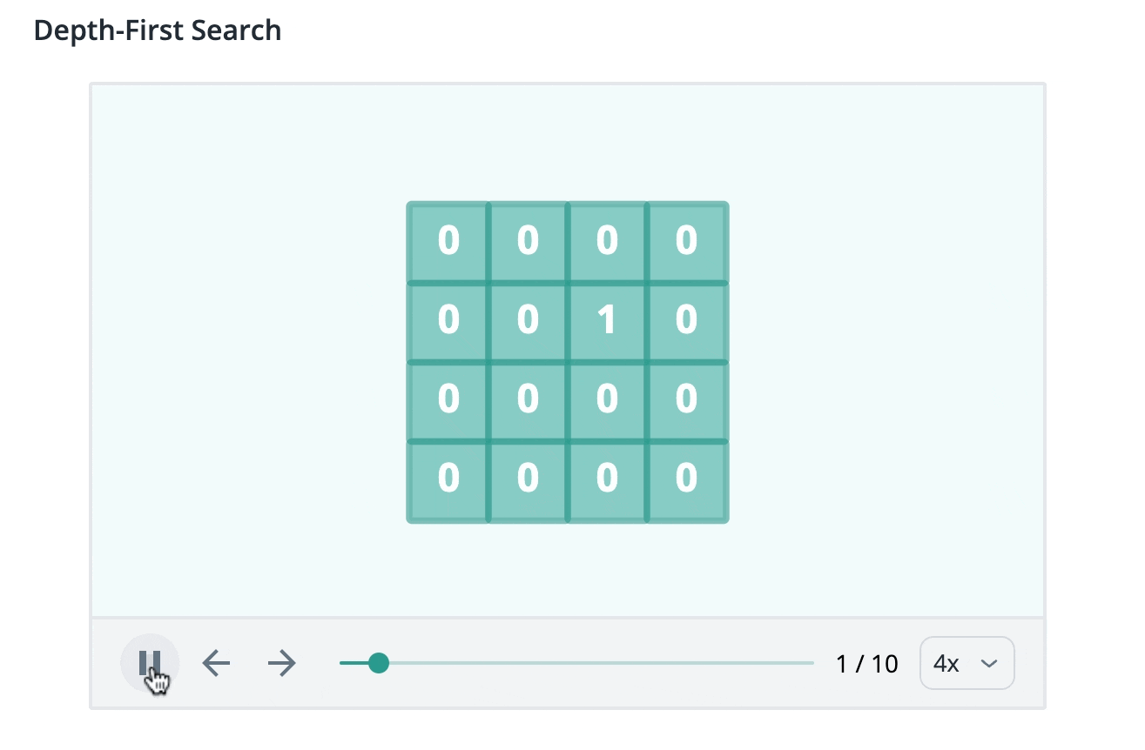
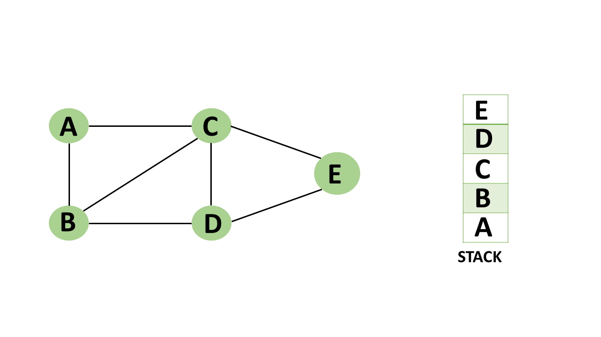
4
1) Definition
- Problems on a 2D grid (matrix)
- Each cell behaves like a graph node
- Move to neighboring cells (usually 4 directions, sometimes 8)
- Traversal using DFS or BFS

2) Typical Goals
- Visit all cells
- Find shortest path
- Compute distances
- Simulate spread
- Region filling

3) Common Applications
- Shortest path in grid
- Maze solving
- Distance to nearest target
- Multi source BFS problems
- Flood fill
- Path existence

4) Recognition Keywords
- Grid / Matrix input
- Shortest path
- Minimum steps / moves
- Nearest distance
- Reach destination
- Spread over time

5) Standard Approach
Scan + Traverse
- Iterate through grid
- Identify start cell(s)
- Apply DFS/BFS
- Process neighbors
- Maintain visited

6) BFS vs DFS Usage
Use BFS when:
- Shortest path needed
- Minimum steps
- Time based spread
Use DFS when:
- Explore all reachable cells
- Path existence
- Region filling

7) Example Problems
Easy
- 733 Flood Fill
Medium
- 1091 Shortest Path in Binary Matrix
- 542 01 Matrix
- 1926 Nearest Exit from Entrance in Maze
Hard
- 1293 Shortest Path in Grid with Obstacles Elimination

🏝️ Island Traversal (Connected Components in Grid)
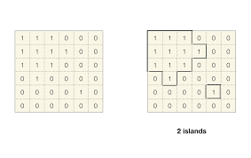
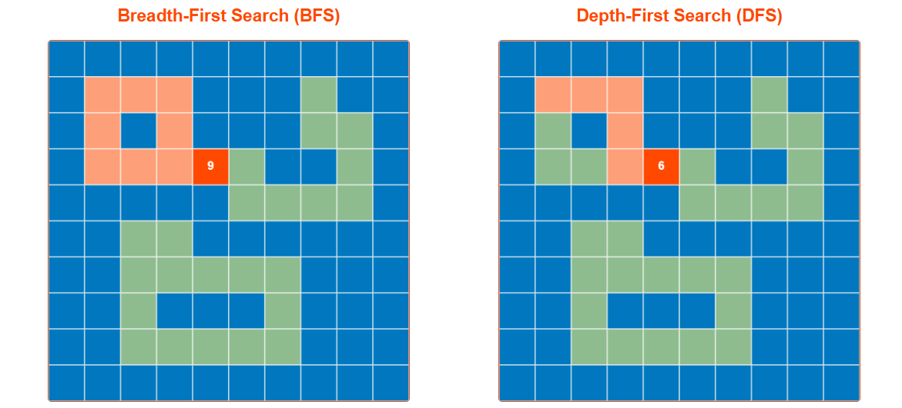
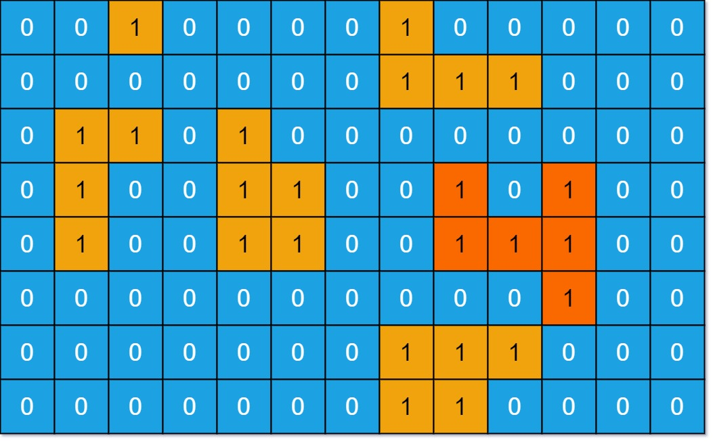
4
1) Definition
- Special type of matrix problem
- Grid contains land (1) and water (0)
- Adjacent land cells form an island
- Essentially finding connected components in a grid

2) Typical Goals
- Count islands
- Measure area
- Find perimeter
- Detect shapes
- Identify enclosed regions

3) Adjacency Rules
Usually 4 directions:
- Up, Down, Left, Right
Sometimes 8 directions (including diagonals)

4) Recognition Keywords
- Island
- Land / Water
- Region / Cluster
- Connected components
- Enclosed area
- Sub islands

5) Standard Approach (DFS)
- Scan grid
- When land found:
  - Run DFS/BFS
  - Mark all connected land
- Increase island count
- Continue scanning

6) Common Tasks
Counting
- Number of islands
- Distinct islands
- Closed islands
Measurement
- Max area of island
- Island perimeter
Advanced
- Merge islands
- Sub island detection
- Largest possible island after change

7) Example Problems
Easy
- 463 Island Perimeter
Medium
- 200 Number of Islands
- 695 Max Area of Island
- 1020 Number of Enclaves
- 130 Surrounded Regions
Hard
- 827 Making A Large Island
- 1905 Count Sub Islands
- 1254 Number of Closed Islands

🔑 Key Difference (Matrix vs Island)
Aspect | Matrix Traversal | Island Traversal
Grid type | Any values | Binary (land/water)
Goal | Path / distance / fill | Connected components
Typical algo | BFS or DFS | Mostly DFS
Start points | Given or multiple | Every land cell
Output | Path, distance, reachability | Count, area, perimeter

✅ Universal Java Templates for Grid / Matrix Problems

🔹 1) Direction Arrays (Use in Almost Every Problem)
// 4 directions (most common)
int[][] dirs4 = {{1,0}, {-1,0}, {0,1}, {0,-1}};
// 8 directions (including diagonals)
int[][] dirs8 = {
{1,0}, {-1,0}, {0,1}, {0,-1},
{1,1}, {1,-1}, {-1,1}, {-1,-1}
};

🔹 2) Boundary Check Function
boolean isValid(int r, int c, int m, int n) {
return r >= 0 && c >= 0 && r < m && c < n;
}

🔹 3) DFS Template (Recursive)
👉 Used for islands, regions, flood fill, area, perimeter
void dfs(int r, int c, int[][] grid, boolean[][] vis) {
int m = grid.length, n = grid[0].length;
if (r < 0 || c < 0 || r >= m || c >= n) return;
if (vis[r][c] || grid[r][c] == 0) return;
vis[r][c] = true;
for (int[] d : dirs4) {
dfs(r + d[0], c + d[1], grid, vis);
}
}

🔹 4) DFS Scan Pattern (Count Islands)
int countIslands(int[][] grid) {
int m = grid.length, n = grid[0].length;
boolean[][] vis = new boolean[m][n];
int count = 0;
for (int i = 0; i < m; i++) {
for (int j = 0; j < n; j++) {
if (grid[i][j] == 1 && !vis[i][j]) {
dfs(i, j, grid, vis);
count++;
}
}
}
return count;
}

🔹 5) BFS Template (Queue Based)
👉 Used for shortest path, spread, multi source BFS
void bfs(int sr, int sc, int[][] grid, boolean[][] vis) {
int m = grid.length, n = grid[0].length;
Queue<int[]> q = new LinkedList<>();
q.offer(new int[]{sr, sc});
vis[sr][sc] = true;
while (!q.isEmpty()) {
int[] cur = q.poll();
for (int[] d : dirs4) {
int nr = cur[0] + d[0];
int nc = cur[1] + d[1];
if (nr >= 0 && nc >= 0 && nr < m && nc < n
&& !vis[nr][nc] && grid[nr][nc] == 1) {
vis[nr][nc] = true;
q.offer(new int[]{nr, nc});
}
}
}
}

🔹 6) Multi Source BFS Template
👉 Used for Rotting Oranges, nearest distance problems
int multiSourceBFS(int[][] grid) {
int m = grid.length, n = grid[0].length;
Queue<int[]> q = new LinkedList<>();
// Add all sources
for (int i = 0; i < m; i++) {
for (int j = 0; j < n; j++) {
if (grid[i][j] == 2) { // example: rotten orange
q.offer(new int[]{i, j});
}
}
}
int time = 0;
while (!q.isEmpty()) {
int size = q.size();
while (size-- > 0) {
int[] cur = q.poll();
for (int[] d : dirs4) {
int nr = cur[0] + d[0];
int nc = cur[1] + d[1];
if (nr >= 0 && nc >= 0 && nr < m && nc < n
&& grid[nr][nc] == 1) {
grid[nr][nc] = 2; // mark infected
q.offer(new int[]{nr, nc});
}
}
}
time++;
}
return time;
}

🔹 7) Flood Fill Template
void floodFill(int r, int c, int oldColor, int newColor, int[][] image) {
int m = image.length, n = image[0].length;
if (r < 0 || c < 0 || r >= m || c >= n) return;
if (image[r][c] != oldColor) return;
image[r][c] = newColor;
for (int[] d : dirs4) {
floodFill(r + d[0], c + d[1], oldColor, newColor, image);
}
}

🔹 8) Shortest Path in Grid (BFS Level Based)
int shortestPath(int[][] grid, int sr, int sc, int tr, int tc) {
int m = grid.length, n = grid[0].length;
boolean[][] vis = new boolean[m][n];
Queue<int[]> q = new LinkedList<>();
q.offer(new int[]{sr, sc});
vis[sr][sc] = true;
int steps = 0;
while (!q.isEmpty()) {
int size = q.size();
while (size-- > 0) {
int[] cur = q.poll();
if (cur[0] == tr && cur[1] == tc)
return steps;
for (int[] d : dirs4) {
int nr = cur[0] + d[0];
int nc = cur[1] + d[1];
if (nr >= 0 && nc >= 0 && nr < m && nc < n
&& !vis[nr][nc] && grid[nr][nc] == 0) {
vis[nr][nc] = true;
q.offer(new int[]{nr, nc});
}
}
}
steps++;
}
return -1;
}

🔥 When to Use Which Template
Problem Type | Algorithm
Count islands | DFS
Max area / perimeter | DFS
Flood fill | DFS / BFS
Shortest path | BFS
Spread simulation | Multi source BFS
Distance to nearest | Multi source BFS
Maze problems | BFS

Complete Grid / Matrix Problems Pattern Sheet (Easy → Hard)

🟢 LEVEL 1: Basic Traversal & Simulation (Easy)
Goal: Just move through the grid
🔹 Pattern
- Scan every cell
- Apply simple logic
- No graph traversal needed
🔹 Typical Problems
- Count elements
- Modify grid values
- Row/column operations
- Matrix rotation
- Transpose
🔹 Key Idea
Two nested loops → process cell
🔹 Examples
- Matrix Transpose
- Rotate Image (easy version)
- Set Matrix Zeroes (basic approach)

🟡 LEVEL 2: Flood Fill / Region Fill (Easy → Medium)
🔹 Pattern
Start from a cell and fill the connected region
🔹 Algorithm
DFS or BFS
🔹 Recognition Keywords
- Fill region
- Replace color
- Connected same values
- Paint bucket
🔹 Steps
- Start from source cell
- Explore neighbors with same value
- Mark visited or change value
🔹 Classic Problems
- Flood Fill (LC 733)
- Surrounded Regions (LC 130)

🟠 LEVEL 3: Island Counting (Medium)
🔹 Pattern
Find number of connected components in grid
🔹 Algorithm
DFS preferred
🔹 Recognition Keywords
- Island
- Land / Water
- Region / Cluster
- Connected groups
🔹 Steps
- Scan grid
- When land found → DFS
- Mark entire island
- Increase count
🔹 Classic Problems
- Number of Islands (LC 200)
- Number of Enclaves (LC 1020)
- Closed Islands (LC 1254)

🔴 LEVEL 4: Area / Shape Measurement (Medium)
🔹 Pattern
Compute size, perimeter, or shape of islands
🔹 Algorithm
DFS
🔹 What to Track
- Area count
- Boundary edges
- Shape signature
🔹 Classic Problems
- Max Area of Island (LC 695)
- Island Perimeter (LC 463)
- Distinct Islands

🟣 LEVEL 5: Boundary & Enclosure Problems (Medium)
🔹 Pattern
Cells touching border behave differently
🔹 Key Idea
Start DFS/BFS from boundary cells
🔹 Recognition Keywords
- Surrounded
- Enclosed region
- Escape boundary
🔹 Classic Problems
- Surrounded Regions (LC 130)
- Number of Enclaves (LC 1020)

🔵 LEVEL 6: Shortest Path in Grid (Medium)
🔹 Pattern
Minimum steps to reach destination
🔹 Algorithm
BFS (level order)
🔹 Recognition Keywords
- Minimum moves
- Shortest path
- Distance
- Reach target
🔹 Classic Problems
- Shortest Path in Binary Matrix (LC 1091)
- Nearest Exit in Maze
- 01 Matrix (LC 542)

🟤 LEVEL 7: Multi Source BFS / Spread Problems (Medium)
🔹 Pattern
Multiple starting points spreading over time
🔹 Algorithm
Multi source BFS
🔹 Recognition Keywords
- Spread
- Infection
- Rotting
- Fire propagation
- Nearest distance from any source
🔹 Steps
- Push all sources into queue
- BFS level by level
- Each level = time unit
🔹 Classic Problems
- Rotting Oranges (LC 994)
- 01 Matrix (LC 542)
- Walls and Gates

⚫ LEVEL 8: Path With Constraints (Medium → Hard)
🔹 Pattern
Movement allowed but with rules
🔹 Examples of Constraints
- Obstacles
- Limited eliminations
- Height differences
- Cost restrictions
🔹 Algorithm
BFS or Dijkstra
🔹 Classic Problems
- Shortest Path with Obstacles Elimination (LC 1293)
- Path With Minimum Effort

⚪ LEVEL 9: Advanced Island Manipulation (Hard)
🔹 Pattern
Modify islands or analyze relationships
🔹 Tasks
- Merge islands
- Flip cells
- Compare islands
- Largest possible island
🔹 Classic Problems
- Making A Large Island (LC 827)
- Count Sub Islands (LC 1905)

🟫 LEVEL 10: Grid + DP / Graph Hybrid (Hard)
🔹 Pattern
Grid traversal with optimization
🔹 Algorithms
- DP on grid
- BFS + DP
- Bitmasking
- State search
🔹 Classic Problems
- Cherry Pickup
- Unique Paths variants
- Minimum Path Sum (advanced forms)

🧩 How to Identify the Correct Pattern (Interview Trick)
If question mentions | Use
Connected region | DFS
Count islands | DFS
Fill region | DFS/BFS
Minimum steps | BFS
Spread over time | Multi source BFS
Nearest distance | Multi source BFS
Costs or weights | Dijkstra
Optimization path | DP

🏆 Ultimate Interview Strategy
When you see a grid:
- Ask: Is this connected components?
- Ask: Is this shortest path?
- Ask: Is this spreading?
- Ask: Are there constraints or costs?
- Choose DFS, BFS, or DP accordingly

