HashMap

A hash map stores pairs of keys and values.
A hash function converts the key into an index, and that index tells where the data lives.
When two keys produce the same index, a collision occurs.
Common handling methods include chaining, where multiple items are kept in a list or tree at the same bucket.
Average performance for insert, delete, and search is constant.
If many collisions happen, operations can slow down.
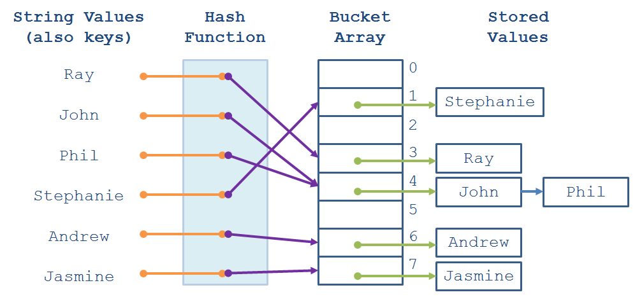

Core Ideas
Hashing
Transform the key into a number.
Bucket
Position in the internal array.
Collision
More than one key ends up in the same place.
Rehashing
Resize and redistribute when the table gets too full.

Where it shines
Fast lookups.
Counting frequency.
Remembering seen values.
Mapping relationships.
Memoization.

Common Interview Patterns
Frequency table.
Complement search such as two numbers forming a target.
First occurrence tracking.
Grouping by a computed signature.
Prefix sum with stored history.

Practical reminders
Keys should be stable.
Poor hash quality increases collisions.
Resizing is expensive but happens occasionally, not every operation.

1. Definition
A map stores data in key value form and uses hashing to compute the index of a bucket where the value will be placed. Duplicate keys are not allowed.

2. Working
A key is passed to the hash function which returns a bucket index.
If multiple keys land in the same bucket, collision handling such as chaining using a linked list or a tree is applied.
Average time for insert and search is constant, though heavy collision can degrade performance.

3. Applications
Fast lookup operations.
Counting frequencies.
Checking existence of an element.
Mapping an identifier to data.
Caching and memoization.

4. Common Problem Patterns
Frequency counting.
Pairs or complements.
Index lookup.
Group by logic, for example grouping anagrams or items with the same property.
Mapping one type to another such as character to number.

5. Advantages
Average constant time for get, put and remove.
Useful for generic key value storage.
Flexible and widely used in many algorithms.

6. Best Practices
Prefer methods like getOrDefault for counting.
Use putIfAbsent or computeIfAbsent to simplify initialization.
Be careful with mutable objects as keys since their hash can change.

7. Summary
Access is constant on average.
Stores key value pairs.
A new key replaces the old value if it already exists.
LinkedHashMap keeps insertion order.
Concurrent HashMap is used in multithreaded environments.

8. Practice Questions
LeetCode: 1, 49, 128, 146, 242, 290, 347, 383, 387, 409, 451, 560, 525, 763.
Easy
1. Two Sum
242. Valid Anagram
383. Ransom Note
387. First Unique Character in a String
409. Longest Palindrome

Medium
49. Group Anagrams
128. Longest Consecutive Sequence
290. Word Pattern
347. Top K Frequent Elements
451. Sort Characters By Frequency
560. Subarray Sum Equals K
525. Contiguous Array
763. Partition Labels

Hard
146. LRU Cache

9. Tips
Frequency map and index map patterns appear very often.
Grouping problems are special cases that rely on hashing.

