Stack

1) Definition
A stack is a linear data structure that follows LIFO (Last In, First Out).
Insertion and deletion happen only at one end called the top.

2) Core Operations
Operation | Description | Time
push(x) | Insert element on top | O(1)
pop() | Remove top element | O(1)
peek()/top() | View top element | O(1)
isEmpty() | Check if empty | O(1)

3) When to Use a Stack
Stacks are ideal when the process is naturally LIFO:
- Matching pairs (parentheses, brackets)
- Reversing order
- Backtracking (undo operations)
- Recursion simulation
- Maintaining previous state (browser history)
- Expression evaluation
- Depth First Search (DFS)

4) Key Advantages
- Simple and efficient
- Clean sequential processing
- Converts many O(n²) problems into O(n) using monotonic stacks
- Easy implementation (Array / LinkedList / Deque)

5) Important Stack Patterns
A) Simple Stack Usage
- Parentheses validation
- Expression evaluation
- Undo/Redo problems
B) Monotonic Stack
Maintains elements in sorted order (increasing or decreasing)
C) Two-Stack Problems
Used in expression evaluation or queue implementation

6) How to Approach Stack Problems
- Decide what to store (value or index)
- Decide push condition
- Decide pop condition
- Update answer while popping
- Process remaining stack at end

7) Recognize Stack Questions (Keywords)
Look for phrases like:
- Next greater/smaller
- Previous greater/smaller
- Valid parentheses
- Remove adjacent duplicates
- Backspace string
- Evaluate expression
- Largest rectangle in histogram
- Undo / history / recursion

Monotonic Stack

1) Definition
A monotonic stack keeps elements in sorted order inside the stack.
Two types:
Type | Order in Stack
Increasing stack | Top ≥ elements below
Decreasing stack | Top ≤ elements below
Used to find nearest greater/smaller elements in O(n).

2) Why It Works
Avoids repeated scanning.
Each element is pushed and popped at most once.
Time Complexity: O(n)
Space Complexity: O(n)

3) Major Applications
- Next greater/smaller element
- Previous greater/smaller element
- Stock span
- Daily temperatures
- Histogram problems
- Sliding window maximum (via monotonic deque)
- Range queries
- DP interval optimization

4) Recognition Clues
Look for problems that say:
- “Nearest element”
- “Next greater/smaller”
- “For each index…”
- “Span”
- “Histogram”
- Compare with future elements
- Need linear time instead of brute force

5) Standard Algorithm Template
1. Choose increasing or decreasing stack
2. Traverse array
3. While stack not empty AND condition breaks:
pop()
4. Use stack top to compute answer
5. Push current index/value
Direction matters:
- Left → Right → finds next elements
- Right → Left → finds previous elements

Essential Stack & Monotonic Stack Problems
(Easy → Hard)
Easy
- LC 20 — Valid Parentheses
- LC 155 — Min Stack
- LC 496 — Next Greater Element I
- LC 682 — Baseball Game
- LC 1047 — Remove All Adjacent Duplicates In String

Medium
- LC 150 — Evaluate Reverse Polish Notation
- LC 71 — Simplify Path
- LC 739 — Daily Temperatures
- LC 503 — Next Greater Element II
- LC 901 — Online Stock Span
- LC 84 — Largest Rectangle in Histogram
- LC 402 — Remove K Digits
- LC 316 — Remove Duplicate Letters
- LC 227 — Basic Calculator II
- LC 946 — Validate Stack Sequences

Hard
- LC 42 — Trapping Rain Water
- LC 85 — Maximal Rectangle
- LC 224 — Basic Calculator
- LC 907 — Sum of Subarray Minimums
- LC 1019 — Next Greater Node in Linked List
- LC 1944 — Number of Visible People in a Queue
- LC 1726 — Largest Submatrix With Rearrangements

Tips
- If brute force compares each element with many others → try monotonic stack
- Use indices instead of values when distances matter
- Many histogram and range problems reduce to next/previous smaller elements
- Sliding window maximum uses monotonic deque

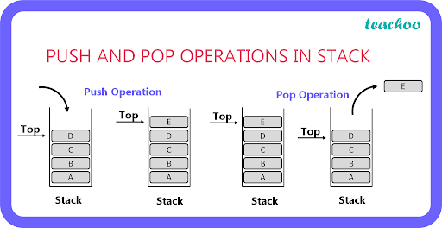
4
🔑 Key Idea: Last In, First Out
Think of a stack like a pile of plates.
- Insert only at the top → push
- Remove only from the top → pop
- Top element is accessed first
Push: 1 → 2 → 3
Top → [3]
2
1
Pop → removes 3 first
📌 Real-Life Examples
- Browser back history
- Undo operations
- Function call stack
- DFS traversal
- Parentheses matching

📈 Monotonic Stack
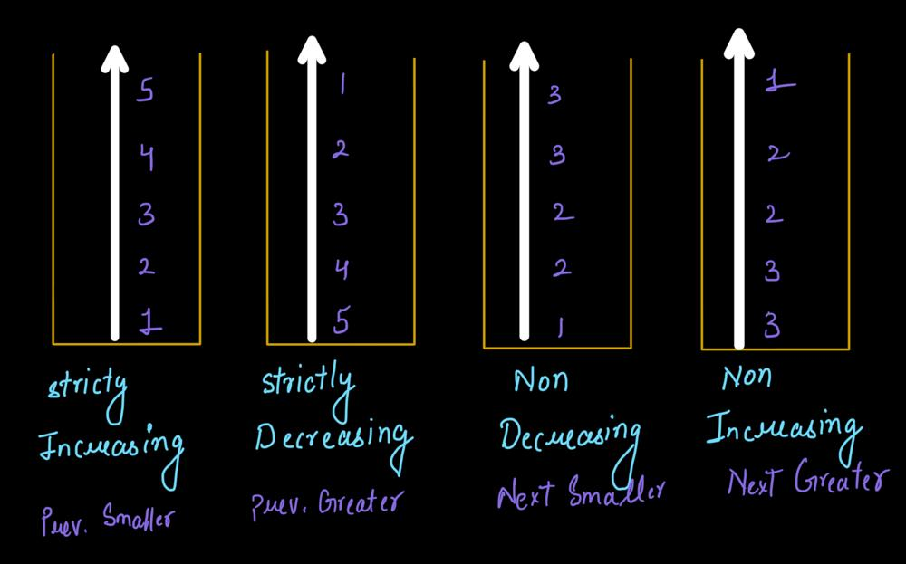

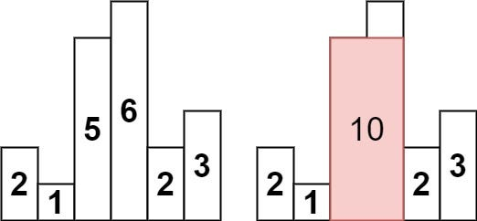
4
Key Idea: Stack Maintains Sorted Order
A monotonic stack keeps elements:
- Increasing stack → smallest at bottom, largest at top
- Decreasing stack → largest at bottom, smallest at top
Used to find nearest greater/smaller elements in O(n).

How It Works (Example: Next Greater Element)
Array: [2, 1, 5, 3, 6]
Process left → right using decreasing stack:
- Push 2
- Push 1
- 5 arrives → pop 1 and 2 (5 is greater)
- Push 5
- Push 3
- 6 arrives → pop 3 and 5
Each element is pushed and popped once → O(n)

Common Uses
- Next greater/smaller element
- Stock span
- Daily temperatures
- Largest rectangle in histogram
- Sliding window maximum (deque version)
- Range queries
Quick Difference
Feature | Simple Stack | Monotonic Stack
Purpose | LIFO storage | Maintain order + queries
Order inside stack | Any | Sorted (inc/dec)
Typical problems | Undo, DFS, parsing | NGE, histogram, spans
Time for nearest queries | O(n²) brute force | O(n)

