Backtracking

1) Definition
A systematic search technique that explores all possible solutions by building a solution step by step and undoing choices when they lead to a dead end. Conceptually similar to DFS on a decision tree.

2) When to Use / Advantages
- Need all valid solutions
- Combinatorial problems
- Natural recursive structure
- Can skip invalid paths early via pruning
- Handles complex constraints cleanly

3) Common Types
- Combinations → subsets, combinations
- Permutations → arrangements, word permutations
- Decision problems → Sudoku, N-Queens
- Construction problems → palindrome partitioning

4) Key Benefits
- Explores complete solution space
- Elegant recursive logic
- Early pruning saves time
- Works well with constraints

5) How to Recognize
Look for phrases like:
- Generate all…
- Find all combinations / permutations
- Count valid paths
- Try every possibility
- Check all configurations with constraints

6) Conceptual View
Backtracking = DFS on a decision tree
Each level = one choice
Each path = one candidate solution

7) Typical Steps (Template)
- State representation (path / partial solution)
- Choose an option
- Check validity
- Add result if complete
- Recurse to explore further
- Undo choice (backtrack)
- Apply pruning when possible

8) Complexity
- Time: Exponential (depends on branching factor)
- Space: O(depth) due to recursion stack

9) Classic LeetCode Problems
Easy
- 78 Subsets
- 77 Combinations
Medium
- 90 Subsets II
- 46 Permutations
- 47 Permutations II
- 39 Combination Sum
- 40 Combination Sum II
- 17 Letter Combinations of a Phone Number
- 22 Generate Parentheses
- 131 Palindrome Partitioning
- 79 Word Search
- 93 Restore IP Addresses
Hard
- 51 N Queens
- 37 Sudoku Solver
- 980 Unique Paths III

Subsets

1) Definition
Problems where you must generate or examine all possible selections of items from a set (power set), optionally under constraints.
Power set size for n elements = 2ⁿ

2) Methods to Generate Subsets
- Backtracking / DFS
- Bitmasking
Use binary representation to include/exclude elements

3) When to Use
- Need all subsets or combinations
- Include/exclude decisions per element
- Optimization over subsets
- Constraint filtering (sum, size, uniqueness)

4) Advantages
- Clean reusable framework
- Easy to adapt constraints (sum, length, uniqueness)
- Works well with pruning
- Makes exponential search manageable

5) Recognition Pattern
Keywords:
- Subsets / power set
- Combinations
- Partitioning a set
- Choose any number of elements
- Generate combinations of letters/numbers

6) Typical Backtracking Template for Subsets
For each element:
- Include it → recurse
- Exclude it → recurse

7) Complexity
- Time: O(n × 2ⁿ) (each subset takes up to n to build)
- Extra space (recursion): O(n)
- Output space: O(n × 2ⁿ)
Always think: Subsets ⇒ 2ⁿ

8) Important LeetCode Problems
Easy
- 78 — Subsets
- 401 — Binary Watch
Medium
- 90 — Subsets II
- 77 — Combinations
- 39 — Combination Sum
- 40 — Combination Sum II
- 216 — Combination Sum III
- 131 — Palindrome Partitioning
- 494 — Target Sum
- 1239 — Maximum Length of Concatenated String with Unique Characters
- 22 — Generate Parentheses
Hard
- 51 — N-Queens
- 37 — Sudoku Solver
- 980 — Unique Paths III

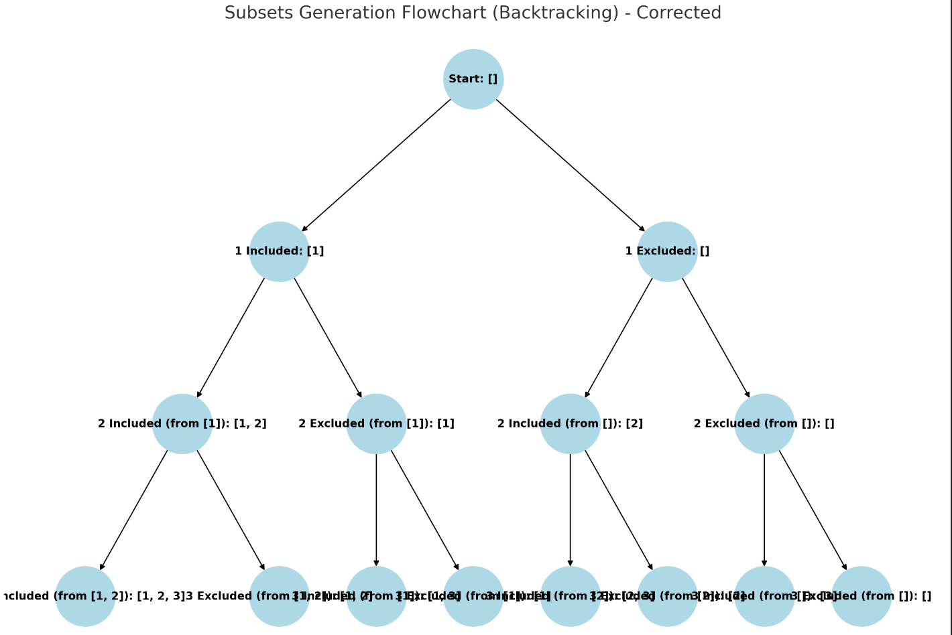
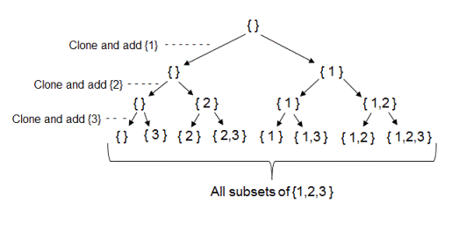
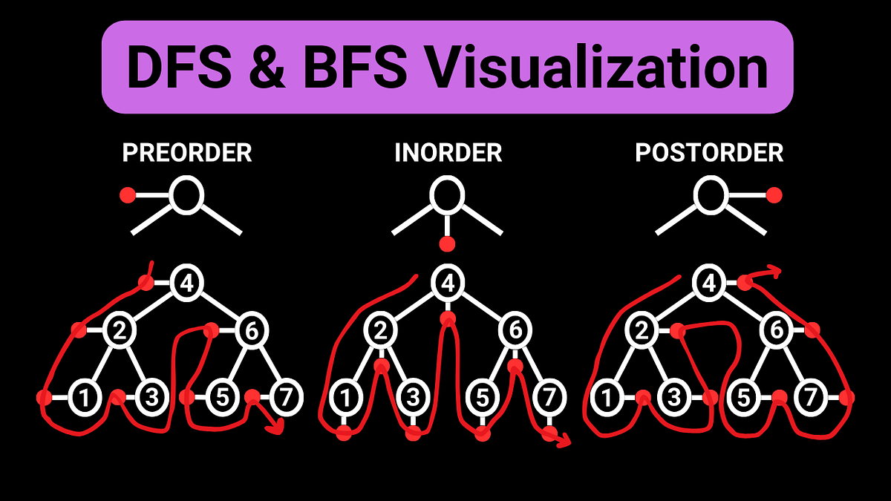
4
🔁 Backtracking & 🧩 Subsets — Quick Visual Guide
🔹 Core Idea
Backtracking explores a decision tree where each level represents a choice.
For subsets, each element has two options:
➡️ Include it
➡️ Exclude it
This naturally forms a binary tree, producing all 2ⁿ subsets.

🔹 Backtracking Flow
- Start with empty path
- Make a choice (include / exclude)
- Recurse to next element
- If solution complete → record it
- Undo choice (backtrack)
- Try next option

🔹 Why This Visual Matters
- Each root-to-leaf path = one solution
- DFS traversal generates all combinations
- Pruning skips invalid branches early
- Foundation for many problems:
  - Subsets
  - Combinations
  - Permutations
  - N-Queens
  - Sudoku
  - Partitioning problems

🔹 Key Complexity Insight
For n elements:
Number of subsets = 2ⁿ
Time ≈ O(n × 2ⁿ)
Recursion space = O(n)

