Stack & Queue

1) Fundamentals: Stack & Queue Basics
Concepts
- Stack (LIFO), Queue (FIFO)
- Array vs Linked List implementation
- Basic operations: push, pop, peek, enqueue, dequeue
Problems (Easy → Medium)
- LC 20 — Valid Parentheses
- LC 232 — Implement Queue using Stacks
- LC 225 — Implement Stack using Queues
- LC 155 — Min Stack
- LC 933 — Number of Recent Calls

2) Monotonic Stack
Maintains elements in increasing or decreasing order. Used for nearest greater/smaller problems.
Key Patterns
- Next Greater Element (NGE)
- Next Smaller Element (NSE)
- Previous Greater/Smaller
- Histogram problems
Problems (Easy → Hard)
- LC 496 — Next Greater Element I
- LC 503 — Next Greater Element II (circular)
- LC 739 — Daily Temperatures
- LC 901 — Online Stock Span
- LC 84 — Largest Rectangle in Histogram
- LC 85 — Maximal Rectangle

3) Monotonic Queue (Deque Based)
Used when order matters and window slides. Maintains candidates for min/max.
Key Patterns
- Sliding window maximum/minimum
- Range queries over moving window
Problems (Medium → Hard)
- LC 239 — Sliding Window Maximum
- LC 1438 — Longest Continuous Subarray With Absolute Diff ≤ Limit
- LC 862 — Shortest Subarray with Sum at Least K

4) Next Greater / Smaller Element Family
Core interview pattern derived from monotonic stack.
Variants
- Next Greater to Right
- Next Greater to Left
- Next Smaller to Right
- Circular arrays
- Distance instead of value
Problems
- LC 496 — Next Greater Element I
- LC 503 — Next Greater Element II
- LC 739 — Daily Temperatures
- LC 1475 — Final Prices With a Special Discount
- LC 1944 — Number of Visible People in a Queue

5) Stack Simulation Problems
Use stack to simulate processes, parsing, or undo operations.
Patterns
- Expression evaluation
- String reduction
- Collision simulation
- Recursive behavior emulation
Problems (Easy → Hard)
- LC 1047 — Remove All Adjacent Duplicates in String
- LC 682 — Baseball Game
- LC 150 — Evaluate Reverse Polish Notation
- LC 71 — Simplify Path
- LC 735 — Asteroid Collision
- LC 394 — Decode String

6) Sliding Window + Deque
Combines two powerful techniques for optimal O(n) solutions.
Use Cases
- Window max/min
- Longest/shortest valid subarray
- Constraint-based subarray problems
Problems (Medium → Hard)
- LC 239 — Sliding Window Maximum
- LC 1425 — Constrained Subsequence Sum
- LC 1696 — Jump Game VI
- LC 1438 — Longest Continuous Subarray With Limit

🧠 Recognition Guide (Quick Interview Clues)
Use Stack when:
- You need nearest greater/smaller
- Parentheses or nested structure
- Undo or reverse operations
- Histogram / skyline shapes
Use Monotonic Stack when:
- “Next/Previous greater/smaller”
- Need O(n) instead of O(n²)
Use Deque / Monotonic Queue when:
- Sliding window min/max
- Window moves one step at a time
- Need both ends operations

🌳 Trees & BST — Complete Placement Master Sheet (Easy → Hard)
🌱 1) Tree Traversals (DFS & BFS)
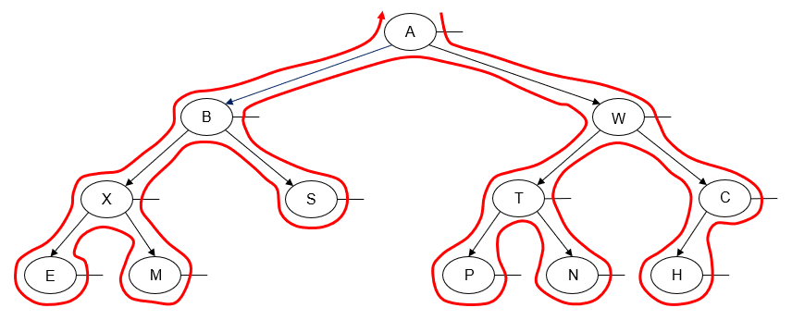
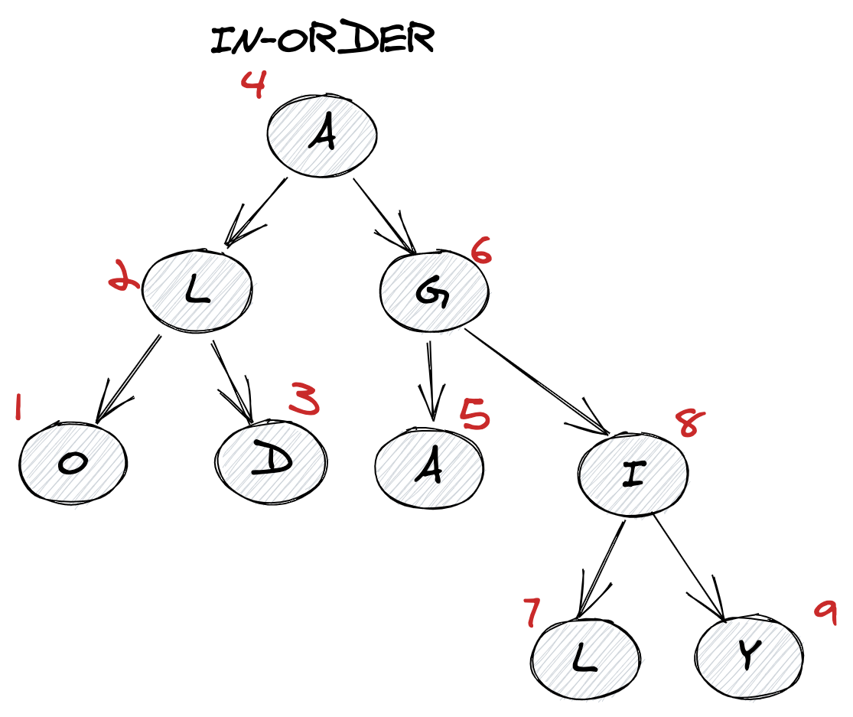
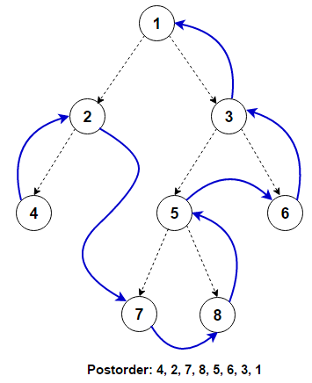
4
Concepts
- DFS: Preorder, Inorder, Postorder (Recursive + Iterative)
- BFS: Level Order using Queue
- Foundation for almost all tree problems
LeetCode Problems
- Easy: 144 (Preorder), 94 (Inorder), 145 (Postorder), 102 (Level Order)
- Medium: 103 (Zigzag Level Order), 199 (Right Side View)
- Hard: 987 (Vertical Order Traversal)
Java Pattern (DFS Recursive)
void inorder(TreeNode root){
if(root == null) return;
inorder(root.left);
System.out.print(root.val);
inorder(root.right);
}

🌿 2) Height, Depth & Balanced Tree
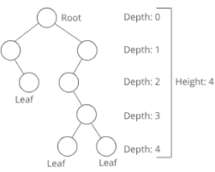
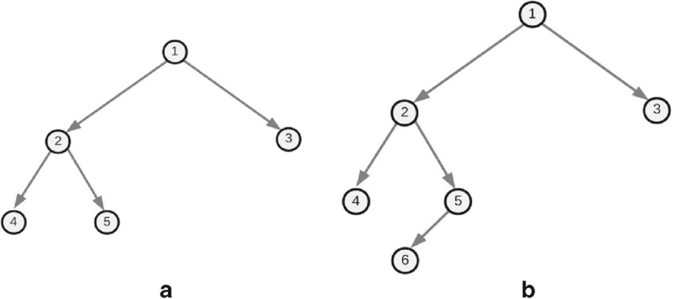
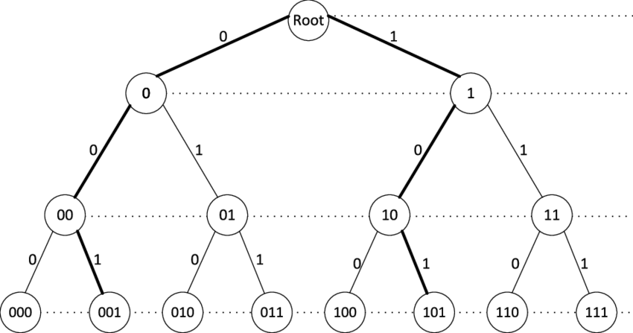
4
Concepts
- Height = longest path from node to leaf
- Depth = distance from root
- Balanced Tree: height difference ≤ 1
LeetCode Problems
- Easy: 104 (Max Depth), 111 (Min Depth)
- Easy: 110 (Balanced Binary Tree)
- Medium: 543 (Diameter of Binary Tree)
- Medium: 662 (Max Width of Binary Tree)
Java Pattern
int height(TreeNode root){
if(root == null) return 0;
return 1 + Math.max(height(root.left), height(root.right));
}

🍃 3) Path & Sum Problems
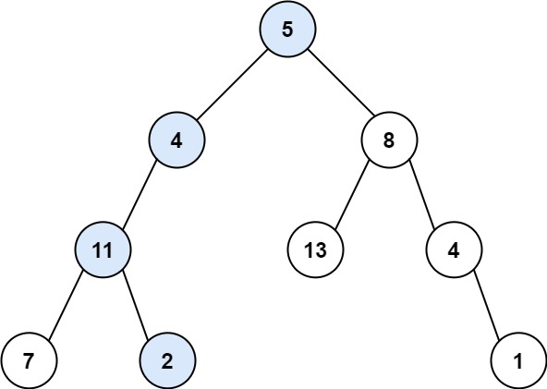
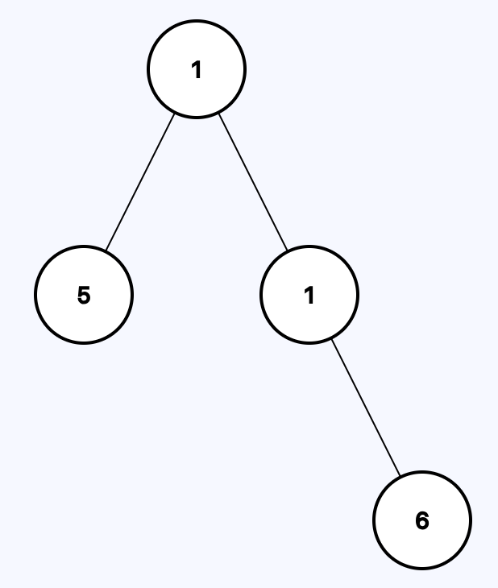

4
Concepts
- Root → Leaf paths
- Accumulated sum during traversal
- Backtracking
LeetCode Problems
- Easy: 112 (Path Sum)
- Medium: 113 (Path Sum II)
- Medium: 129 (Sum Root to Leaf Numbers)
- Hard: 124 (Binary Tree Maximum Path Sum)
Java Pattern
boolean hasPathSum(TreeNode root, int sum){
if(root == null) return false;
if(root.left == null && root.right == null)
return sum == root.val;
return hasPathSum(root.left, sum - root.val) ||
hasPathSum(root.right, sum - root.val);
}

🌲 4) Tree Construction
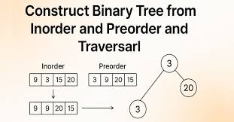

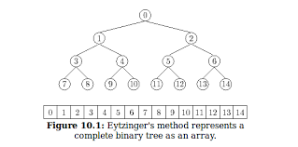
4
Concepts
- Build tree from traversal arrays
- Divide and conquer
LeetCode Problems
- Medium: 105 (Preorder + Inorder)
- Medium: 106 (Inorder + Postorder)
- Medium: 889 (Preorder + Postorder)

🌳 BST (Binary Search Tree) Section
🌿 5) BST Basics & Validation
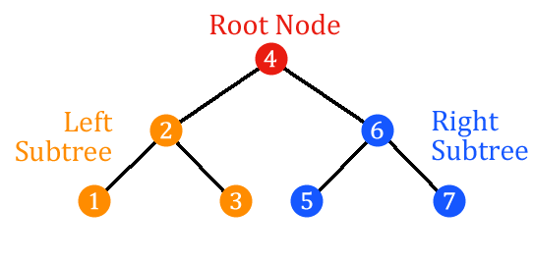
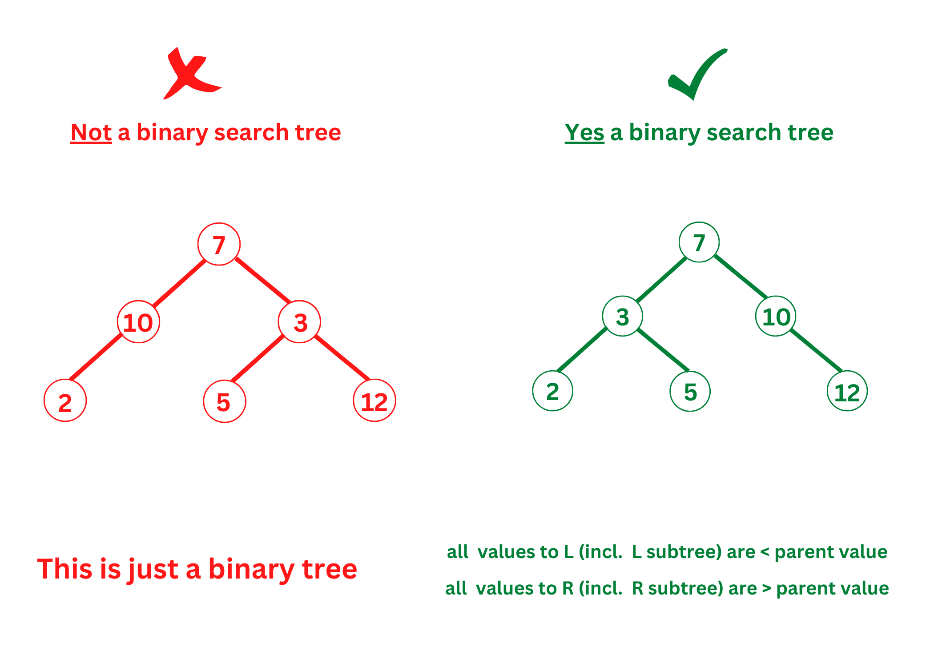
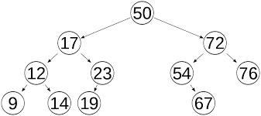
4
Concepts
- Left < Root < Right
- Inorder traversal gives sorted order
LeetCode Problems
- Easy: 700 (Search in BST)
- Medium: 98 (Validate BST)
- Medium: 530 (Min Absolute Difference)
- Medium: 230 (Kth Smallest Element)
Java Pattern (Validate BST)
boolean isValidBST(TreeNode root){
return validate(root, Long.MIN_VALUE, Long.MAX_VALUE);
}
boolean validate(TreeNode node, long min, long max){
if(node == null) return true;
if(node.val <= min || node.val >= max) return false;
return validate(node.left, min, node.val) &&
validate(node.right, node.val, max);
}

🍂 6) BST Operations (Insert, Delete, LCA)

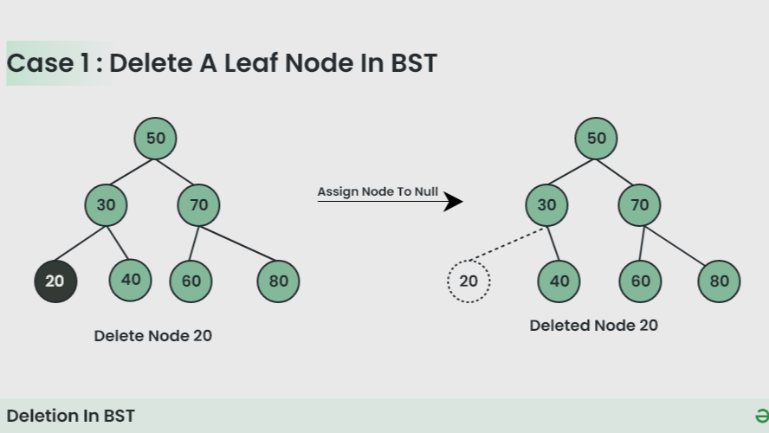
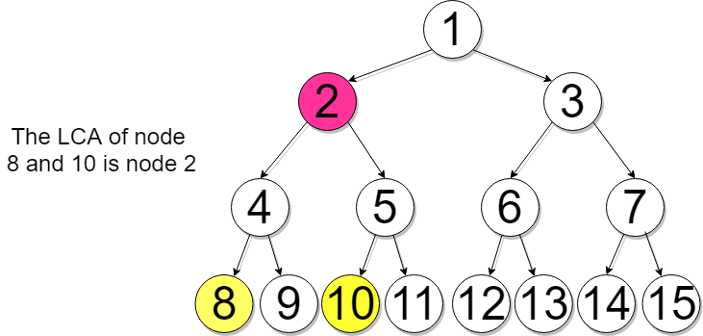
4
LeetCode Problems
- Easy: 701 (Insert into BST)
- Medium: 450 (Delete Node in BST)
- Easy: 235 (LCA in BST)

🌳 7) Advanced Tree Problems
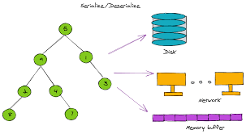

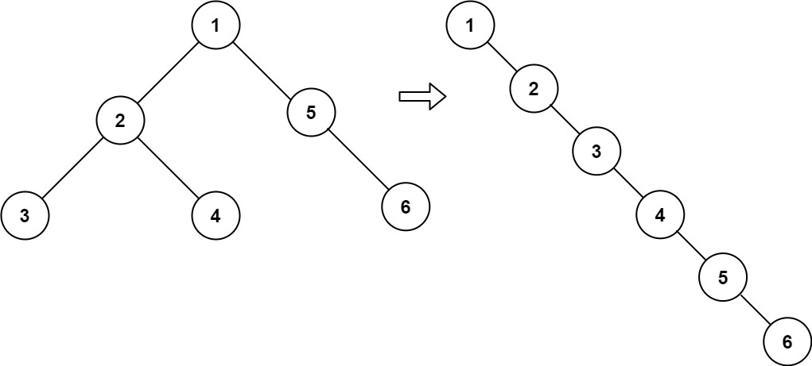
4
Key Interview Problems
- Medium: 236 (LCA in Binary Tree)
- Medium: 114 (Flatten Binary Tree to Linked List)
- Hard: 297 (Serialize & Deserialize)
- Hard: 968 (Binary Tree Cameras)
- Hard: 124 (Max Path Sum)

⭐ Must-Do Tree Problems for Product Companies
Top Priority List
94, 144, 145, 102, 104, 110,
112, 113, 543, 98, 230,
236, 114, 105, 106,
124, 297

