Graphs

1) Definition
A graph is a structured set of vertices (nodes) connected by edges.

Categories
- Directed / Undirected
- Weighted / Unweighted
- Cyclic / Acyclic
Traversal Methods
- BFS (Breadth First Search)
- DFS (Depth First Search)
Represents
- Networks, maps, dependencies, relationships, routes

2) Use Cases / Advantages
- Models many real world problems
- Finds shortest paths and connectivity
- Detects cycles
- Represents complex relationships clearly
- Foundation for algorithms like Dijkstra and Topological Sort

3) Common Problem Types
- Shortest path in unweighted graph
- Connectivity and components
- Cycle detection
- Effect of direction on reachability
- Tree and island problems
- Algorithms: BFS, DFS, Dijkstra, Bellman Ford

4) Benefits
- Solves complex relational problems
- BFS gives shortest path in unweighted graphs
- DFS explores structure deeply
- Essential for technical interviews

5) Pattern Recognition
Indicators
- Nodes and edges mentioned
- Connected or not connected
- Shortest path
- Detect cycle
- Components / islands
- Bipartite checking
Applications
- Social or computer networks
- Maps and GPS routing
- Course scheduling (dependencies)
- Recommendation systems

6) Important LeetCode Problems
547, 133, 261, 207, 210, 127, 743, 994, 417, 286, 787, 1971, 785, 684, 1091

7) General Steps to Solve Graph Problems
- Build graph (usually adjacency list)
- Choose BFS or DFS based on requirement
- Maintain visited set to avoid revisits
- If weighted → Dijkstra (or Bellman Ford)
- For cycles or components → DFS or BFS

8) Quick Technique Guide
Problem Type | Method
Unweighted shortest path | BFS
Cycle detection (undirected) | DFS
Cycle detection (directed) | DFS with recursion stack
Weighted shortest path | Dijkstra
Connectivity / components | BFS or DFS
DAG ordering | Topological Sort

21. DFS (Depth First Search)
1) Definition
Traversal technique that explores one branch completely before backtracking.
Implementation
- Recursion (implicit stack)
- Explicit stack
Used On
- Trees (no cycles)
- Graphs (cycle handling required)

2) Traversal Orders (Trees)
- Preorder: Root → Left → Right
- Inorder: Left → Root → Right
- Postorder: Left → Right → Root

3) Uses / Advantages
- Explores all possible paths
- Good for connected components
- Backtracking problems
- Cycle detection
- Topological sorting

4) Types of DFS
- Recursive DFS
- Iterative DFS (stack)
- DFS with coloring
- DFS with timestamps
- DFS with backtracking

5) Benefits
- Simple and intuitive
- Detects cycles and components
- Useful for bipartite check
- Ideal for maze and path problems

6) Recognition Patterns
Keywords
- All paths
- Connected components
- Islands
- Reachability
- Recursive exploration
- Traverse deeply
Common Domains
- Trees, graphs, grids
- Path enumeration
- Cycle detection
- Connectivity queries

7) Important LeetCode Problems
200, 695, 323, 733, 112, 113, 124, 543, 110, 257, 236, 797, 130, 261, 207

8) DFS Steps
- Initialize visited set
- For graphs, iterate all nodes
- Call DFS on unvisited node
- Mark visited
- Recursively explore neighbors
- Collect or count result

22. BFS (Breadth First Search)
1) Definition
Level order traversal using a queue. Explores neighbors first before going deeper.
Used On
- Trees
- Graphs
- Grids / matrices

2) Uses / Advantages
- Shortest path in unweighted graphs
- Level order traversal
- Connectivity detection
- Spread simulations (virus, rot, fire)
- Multi source scenarios

3) Variants
- Single source BFS
- Multi source BFS
- Bidirectional BFS
- BFS on grids

4) Benefits
- Guarantees minimum number of edges
- Ideal for shortest path problems
- No recursion depth issues
- Structured exploration

5) Recognition Patterns
Keywords
- Shortest path (unweighted)
- Minimum steps or moves
- Level by level
- Distances
- Neighbor expansion
- Spread from sources

6) Important LeetCode Problems
102, 200, 994, 127, 1091, 286, 417, 133, 110, 261, 752, 207, 210, 199, 785

7) BFS Steps
- Initialize queue
- Add starting node(s)
- Mark visited
- While queue not empty
  - Process current level
  - Explore neighbors
  - Update distance or count
- Stop when target reached or all visited

8) BFS vs DFS Comparison
Property | BFS | DFS
Traversal style | Level wise | Depth first
Shortest path (unweighted) | Yes | No
Cycle detection | Good | Good
Data structure | Queue | Stack / Recursion
Memory usage | Higher | Lower

If you want, I can also provide:
- Complete Graph Algorithms Master Sheet (Interview Ready)
- BFS + DFS Decision Flowchart
- Java template code for all graph patterns
- Must solve problem list from easy to hard
Just say what you need.

You said:
Complete Graph Algorithms Master Sheet

ChatGPT said:
🧠 Complete Graph Algorithms Master Sheet (Interview Ready)
1) Graph Fundamentals
Graph = (V, E)
- V → Vertices (nodes)
- E → Edges (connections)
Types of Graphs
- Directed / Undirected
- Weighted / Unweighted
- Cyclic / Acyclic
- Connected / Disconnected
- DAG (Directed Acyclic Graph)
Representations
Method | Space | Notes
Adjacency List | O(V + E) | Most common
Adjacency Matrix | O(V²) | Dense graphs
Edge List | O(E) | Used in Kruskal

2) Traversal Algorithms
BFS (Breadth First Search)
Use When
- Shortest path in unweighted graph
- Minimum moves / steps
- Level order traversal
- Multi source spread problems
Data Structure: Queue
Time: O(V + E)
Space: O(V)
Template Steps
- Push start node into queue
- Mark visited
- While queue not empty
  - Pop node
  - Explore neighbors
  - Add unvisited neighbors
Key Problems
127, 994, 1091, 286, 417, 752, 199

DFS (Depth First Search)
Use When
- Explore all paths
- Components / islands
- Cycle detection
- Backtracking
- Topological sort
Data Structure: Stack / Recursion
Time: O(V + E)
Space: O(V)
Template Steps
- Mark node visited
- Recurse on neighbors
- Backtrack if needed
Key Problems
200, 695, 323, 733, 130, 797, 261, 207

3) Shortest Path Algorithms
Unweighted Graph → BFS
- Minimum number of edges
- Works on grids and graphs

Dijkstra Algorithm
Use When
- Weighted graph
- All edge weights ≥ 0
- Need shortest path from single source
Data Structure: Min Heap (Priority Queue)
Time: O((V + E) log V)
Steps
- Distance array initialize ∞
- Source = 0
- Use min heap
- Relax edges
Key Problems
743, 1631, 1514, 778

Bellman Ford
Use When
- Negative weights allowed
- Need negative cycle detection
Time: O(V × E)
Core Idea
Relax all edges V−1 times

Floyd Warshall
Use When
- All pairs shortest path
- Small graphs
Time: O(V³)

4) Minimum Spanning Tree (MST)
Kruskal Algorithm
Idea: Pick smallest edges without forming cycle
Tools
- Edge list sorted by weight
- Disjoint Set (Union Find)
Time: O(E log E)
Key Problems
1584, 1135

Prim Algorithm
Idea: Grow MST from a node
Tools
- Min Heap
- Visited set
Time: O(E log V)

5) Topological Sorting (DAG Only)
Kahn Algorithm (BFS Based)
Use When
- Course scheduling
- Dependency resolution
Steps
- Compute indegree
- Push nodes with indegree 0
- Remove and reduce neighbors
Key Problems
207, 210, 1136

DFS Based Topological Sort
- Use postorder stack
- Reverse result

6) Cycle Detection
Undirected Graph
Method: DFS with parent tracking
Condition
Visited neighbor ≠ parent → cycle

Directed Graph
Method: DFS with recursion stack
Condition
Node visited again in recursion stack → cycle

7) Connected Components
Method: DFS or BFS
Applications
- Number of provinces
- Islands
- Network connectivity
Key Problems
547, 200, 323, 1319

8) Bipartite Graph Check
Method: BFS / DFS Coloring
Rule
Adjacent nodes must have opposite colors
Key Problems
785, 886

9) Union Find (Disjoint Set)
Operations
- Find (with path compression)
- Union (by rank/size)
Use When
- Dynamic connectivity
- Cycle detection in undirected graph
- MST (Kruskal)
Time: Almost O(1)
Key Problems
547, 684, 1319, 1584

10) Graph on Grid Patterns
Treat grid as graph where each cell = node
Common Moves
- 4 direction (up, down, left, right)
- 8 direction (including diagonals)
Used For
- Islands
- Shortest path in matrix
- Flood fill
- Spread simulation
Key Problems
200, 695, 1091, 733, 994, 417

11) Strongly Connected Components
Kosaraju Algorithm
Steps
- DFS order stack
- Reverse graph
- DFS in stack order

Tarjan Algorithm
- Single DFS
- Uses low link values
- More optimal

12) Decision Guide (Interview Shortcut)
Problem Clue | Algorithm
Shortest path (unweighted) | BFS
Shortest path (weighted ≥ 0) | Dijkstra
Negative weights present | Bellman Ford
All pairs shortest path | Floyd Warshall
Minimum spanning tree | Kruskal / Prim
Dependencies / ordering | Topological Sort
Cycle detection | DFS / Union Find
Connectivity | BFS / DFS
Dynamic connectivity | Union Find
Grid islands | DFS / BFS
All paths | DFS

13) Must Solve LeetCode Set (High Yield)
Easy
1971, 733, 997
Medium
200, 547, 207, 210, 133, 785, 684, 743, 1091, 417
Hard / Important
127, 778, 1631, 1514, 269, 882

If you want, I can also provide one of these powerful resources:
- 🏆 Ultimate Graph Problems List (Easy → Hard Roadmap)
- 📅 30 Day Graph Mastery Plan
- 💻 Java Graph Templates for Every Algorithm
- 🧩 Pattern Based Graph Interview Cheatsheet (Top FAANG Picks)
Just tell me which one you want next.

You said:
Visualization

ChatGPT said:
🧠 Graph Algorithms Visualization Guide (Intuition First)
1) Graph Representation (Adjacency List)
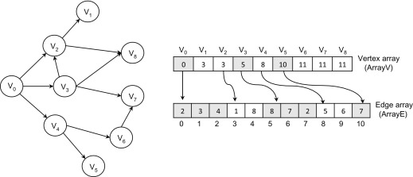

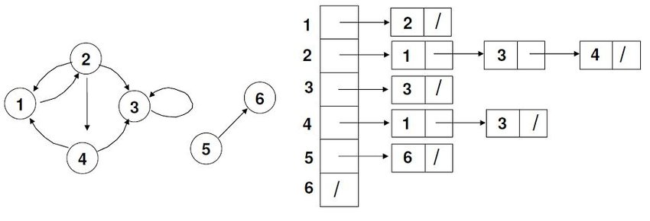
4
How to See It Mentally
- Nodes → points
- Edges → connections
- Adjacency list → “neighbors of each node”
Example
A → B, C
B → A, D
C → A, D
D → B, C

2) BFS (Breadth First Search) — Level by Level
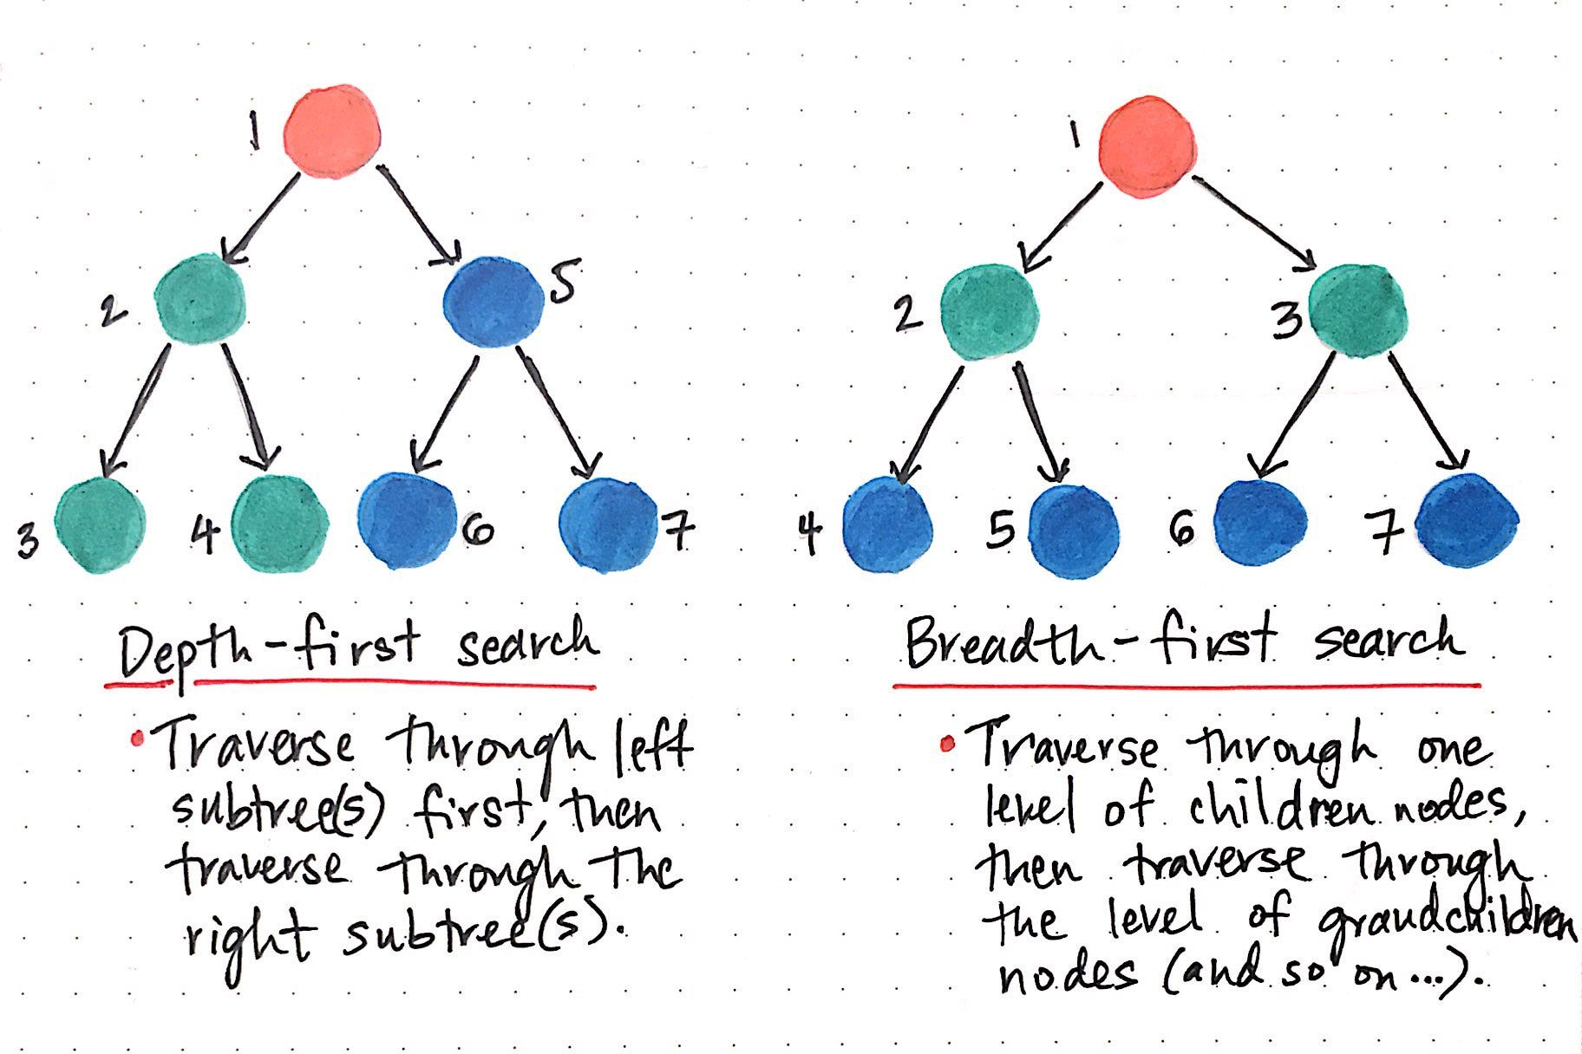
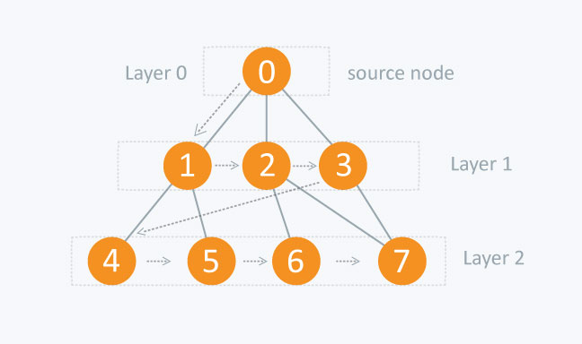

4
Visual Idea
BFS spreads like a wave 🌊
Level 0 → Start node
Level 1 → All neighbors
Level 2 → Neighbors of neighbors
Queue behavior
➡️ First in → First out
Key Insight
First time you reach a node = shortest path (unweighted)

3) DFS (Depth First Search) — Go Deep First
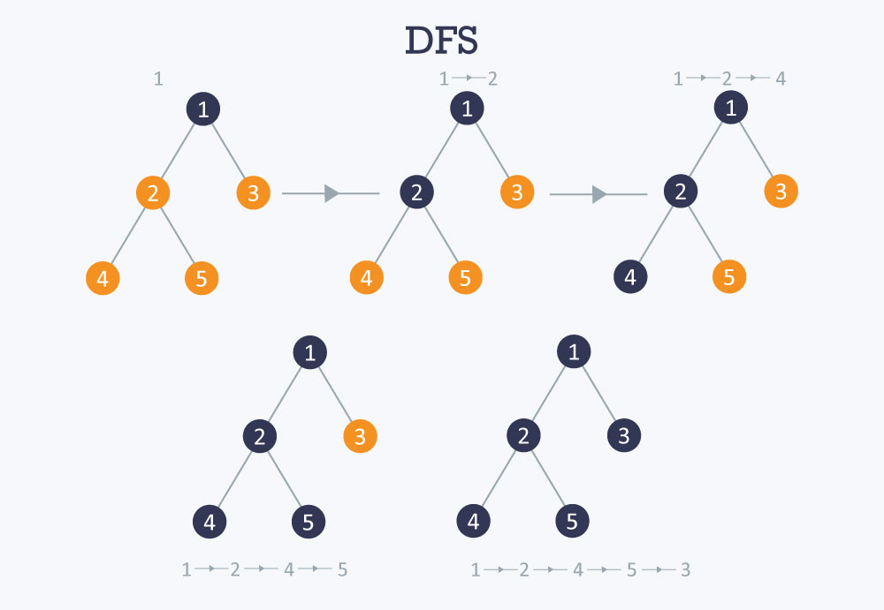
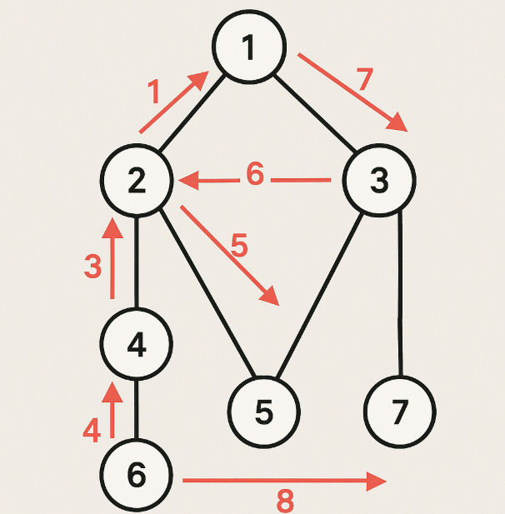
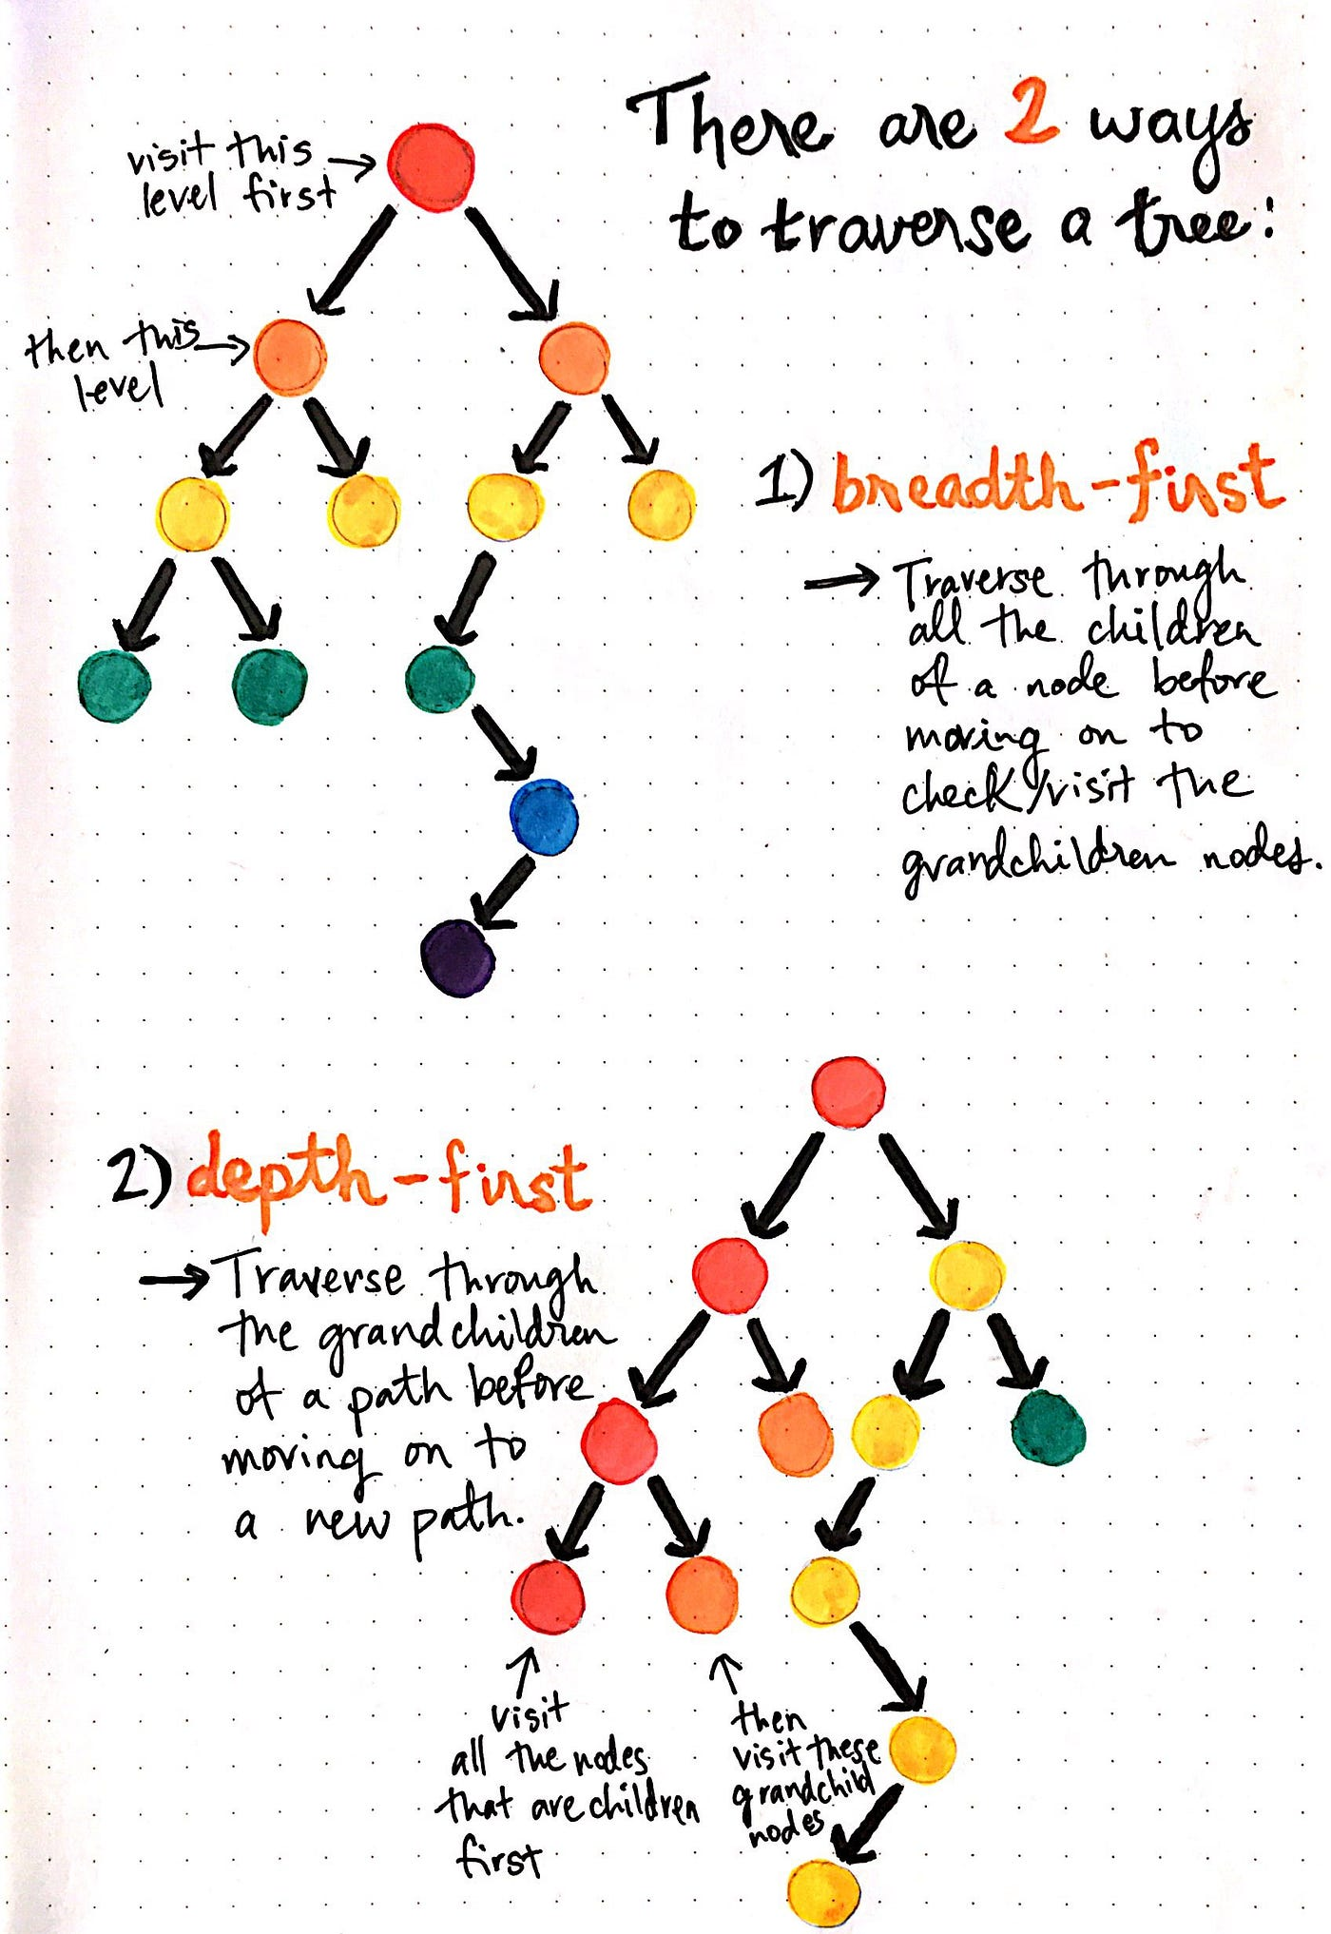
4
Visual Idea
DFS behaves like exploring a maze 🧭
Go as deep as possible
Dead end → backtrack
Stack behavior
➡️ Last in → First out
Key Insight
Great for exploring structure and all paths

4) Dijkstra — Weighted Shortest Path
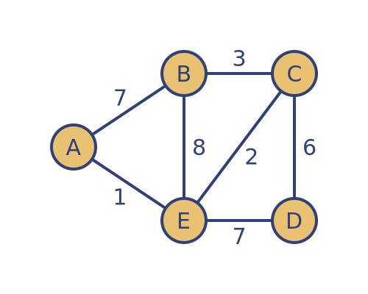
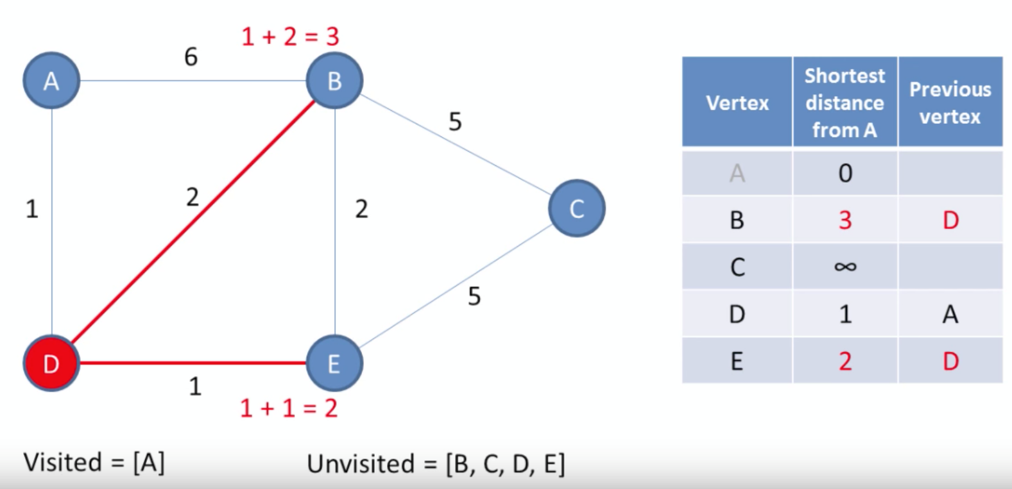
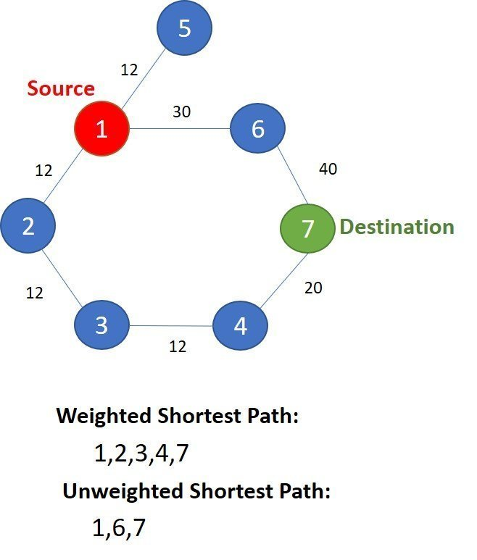
4
Visual Idea
Expands outward by minimum distance, not by edges
Always pick node with smallest current distance
Think
➡️ GPS choosing cheapest route

5) Minimum Spanning Tree (MST)
Kruskal + Prim
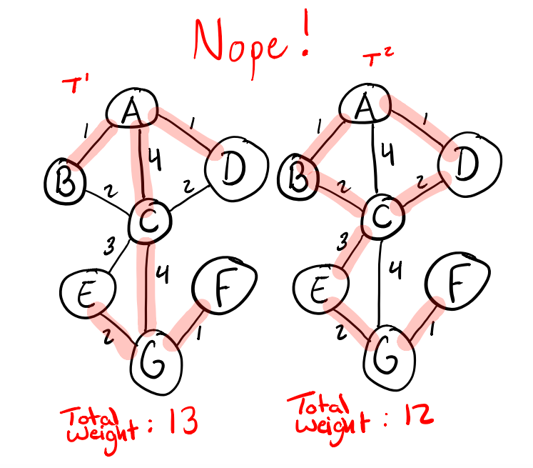
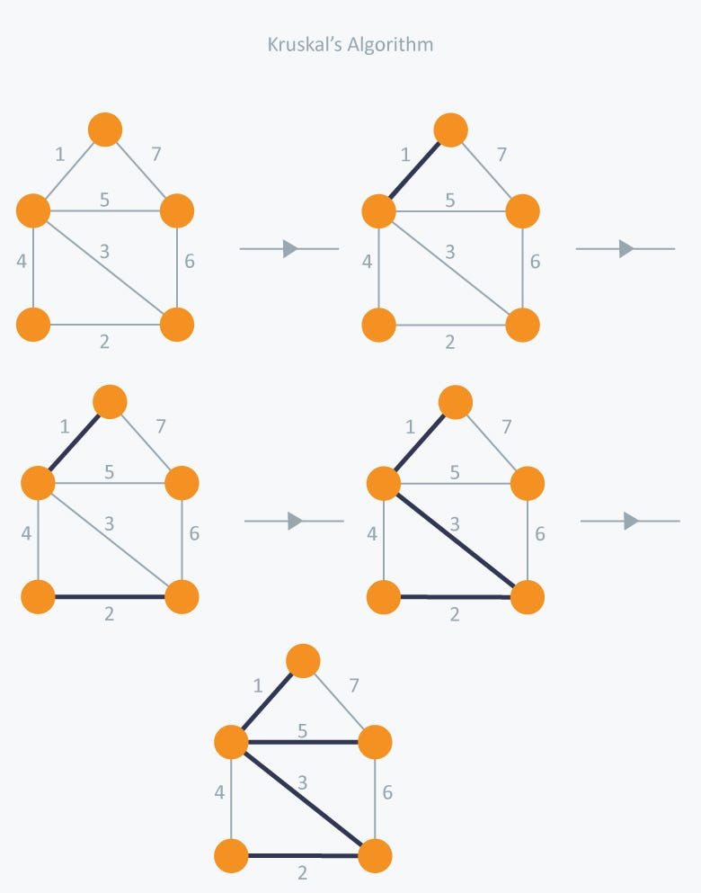
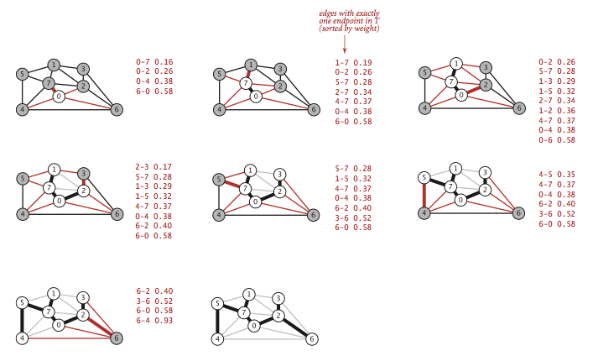
4
Goal
Connect all nodes with minimum total weight
No cycles allowed
- Kruskal → pick smallest edges globally
- Prim → grow tree from a starting node

6) Topological Sort (DAG Ordering)
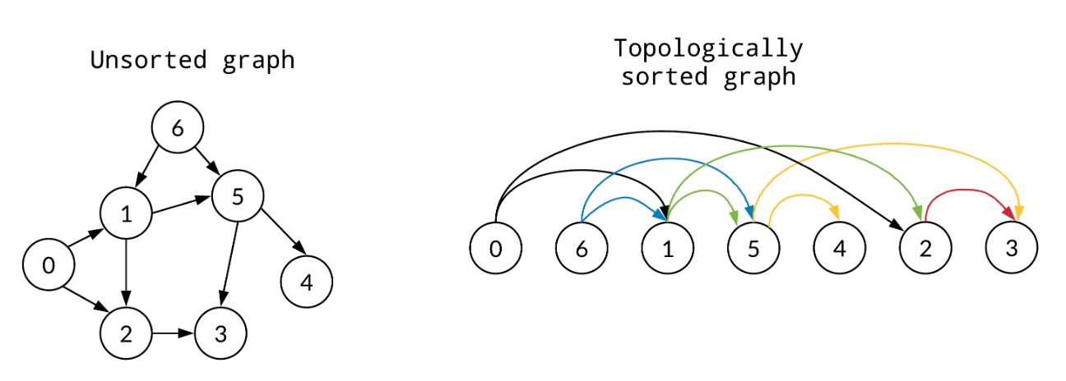
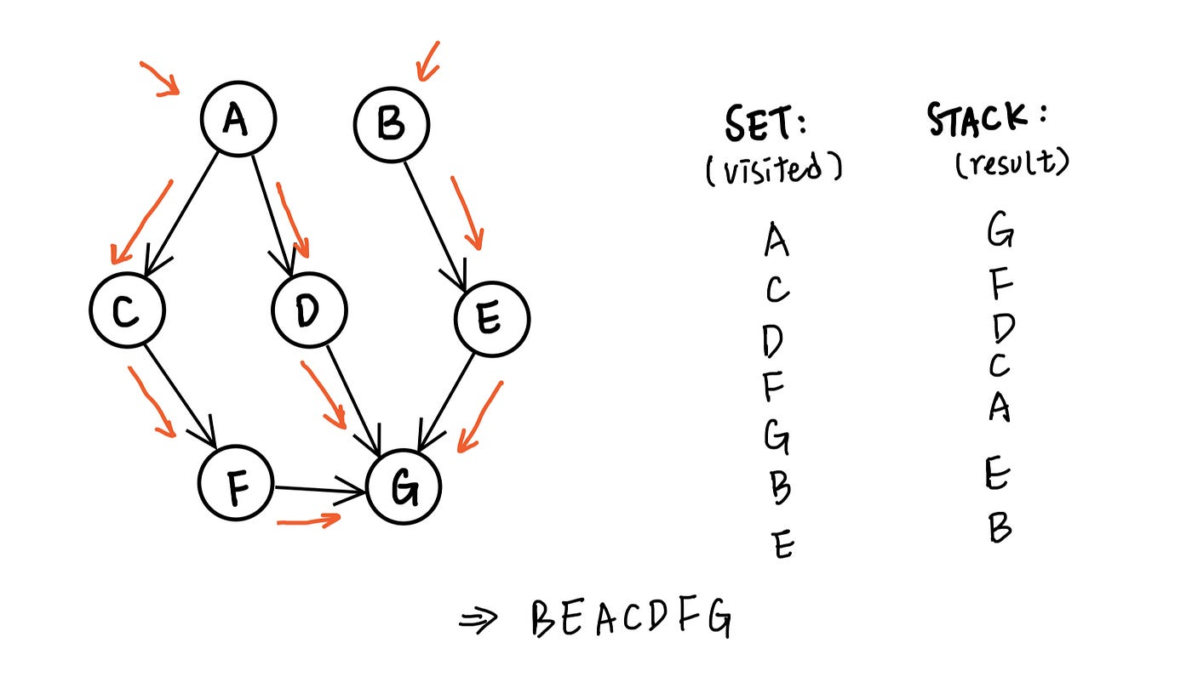
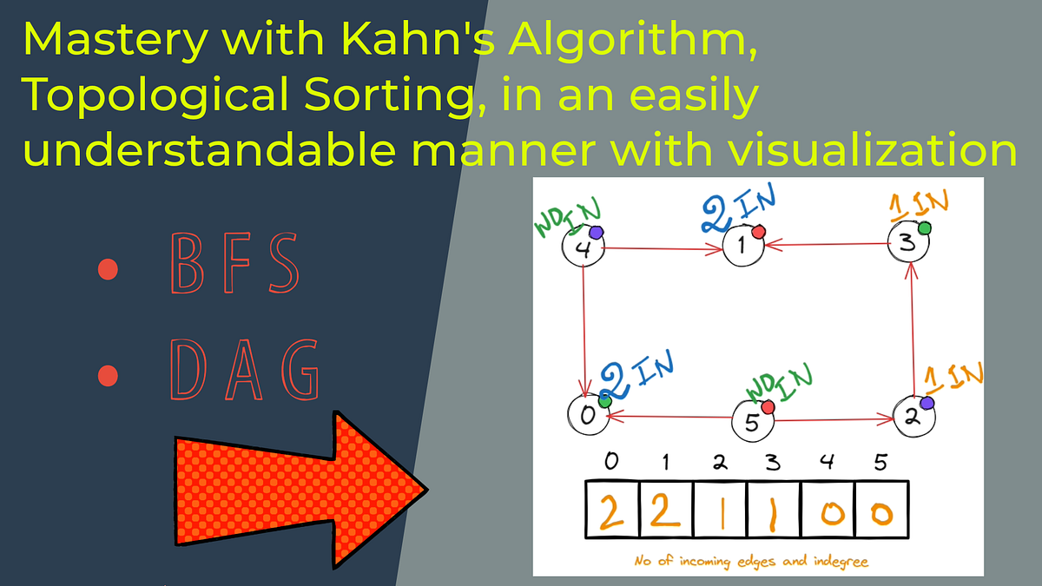
4
Visual Idea
Arrange tasks so all dependencies come first
Example
Study basics → Practice → Mock test → Interview
Only works for DAG (no cycles)

🏆 Quick Mental Model Cheat Sheet
Pattern Seen | Picture in Mind | Algorithm
Minimum steps | Expanding circles | BFS
Explore everything | Deep tunnel | DFS
Weighted shortest path | Cheapest expansion | Dijkstra
Connect all cheaply | Minimal wiring | MST
Dependencies | Task ordering | Topological Sort
Group islands | Flood fill | DFS / BFS

Tree Data Structures — Visualization Guide (Interview Ready)
1) Basic Tree Structure
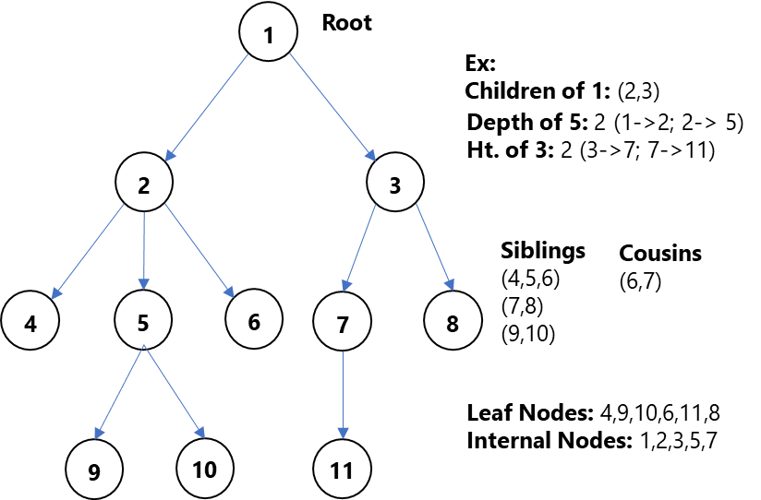
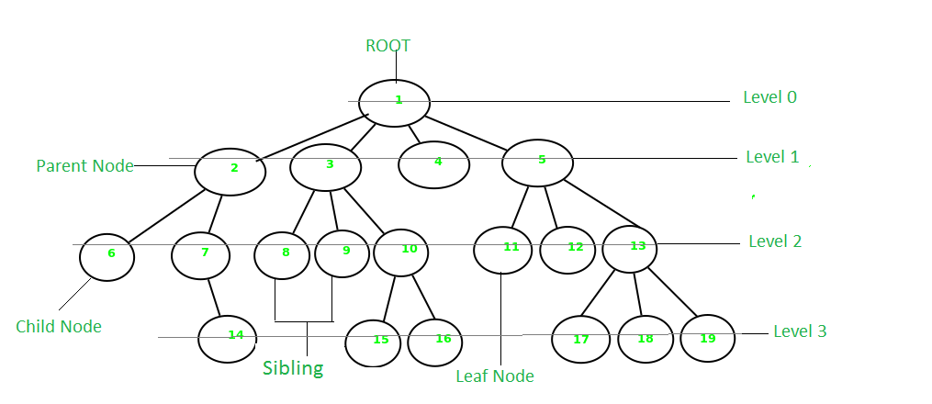
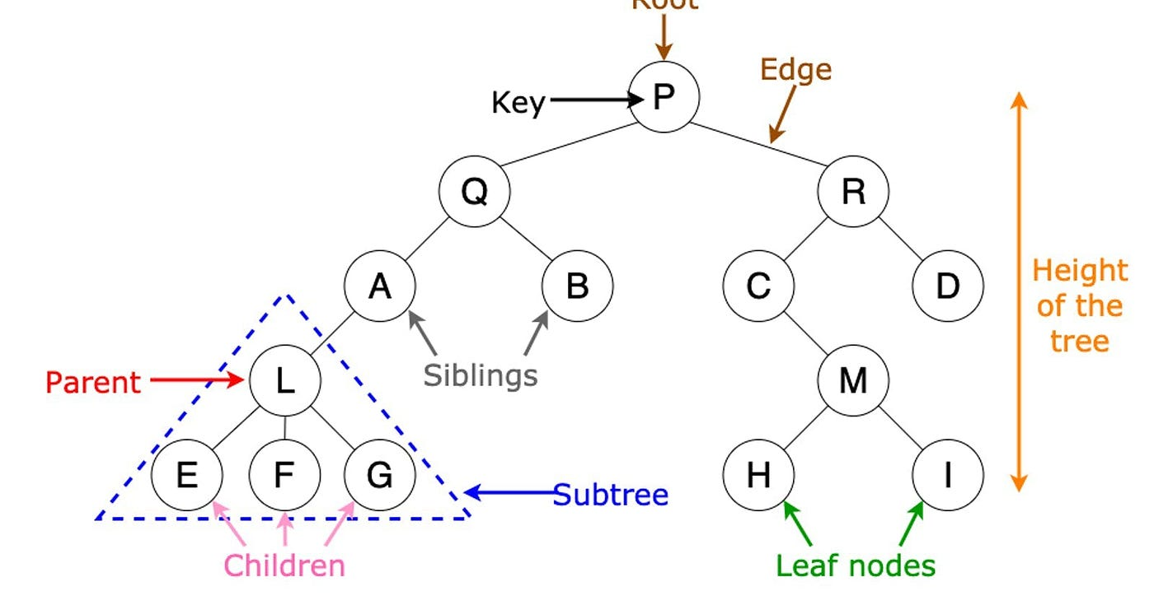
Key Components
- Root → Top node
- Parent / Child → Hierarchical relation
- Siblings → Same parent
- Leaf → No children
- Depth → Distance from root
- Height → Longest path to leaf
Mental Picture
Upside down tree 🌳

2) Binary Tree

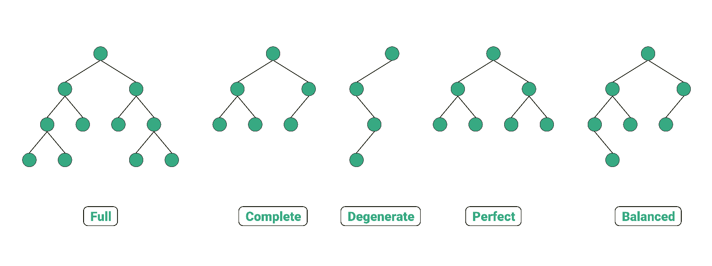
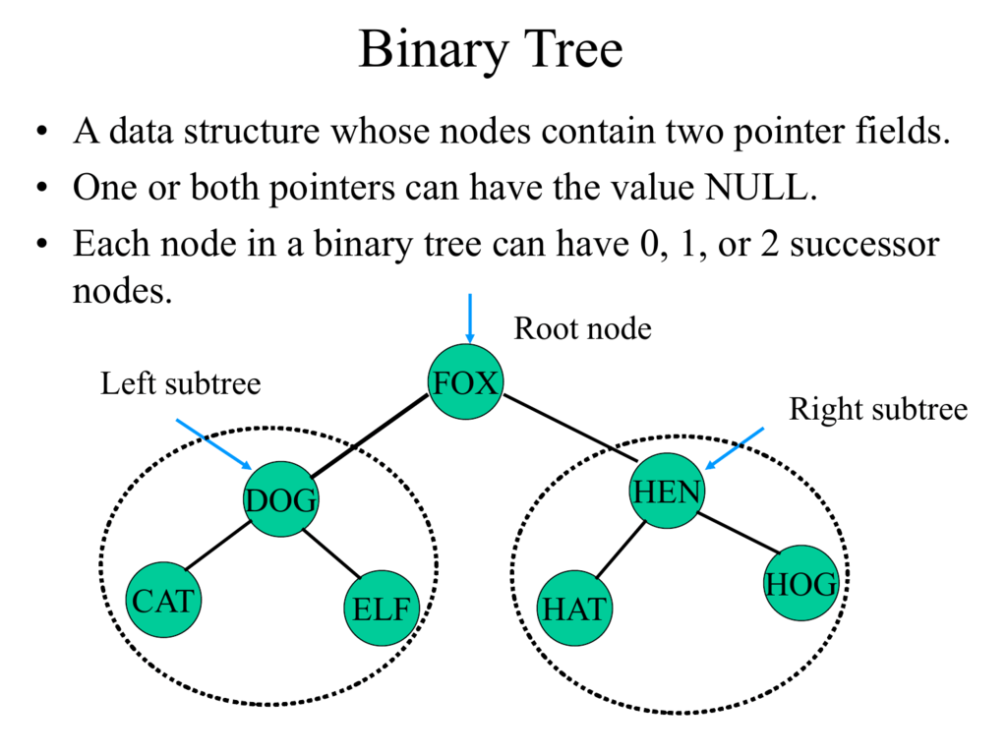
4
Each node has at most 2 children
- Left child
- Right child
Types
- Full → 0 or 2 children
- Complete → Filled level by level
- Perfect → All levels full

3) Binary Search Tree (BST)
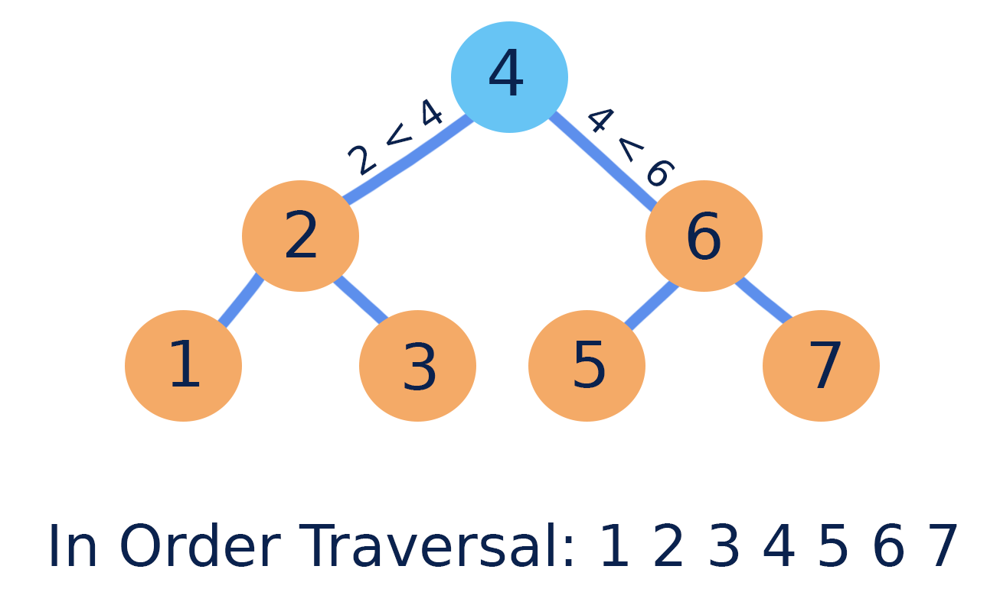
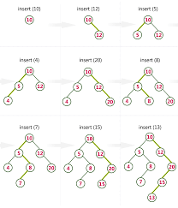
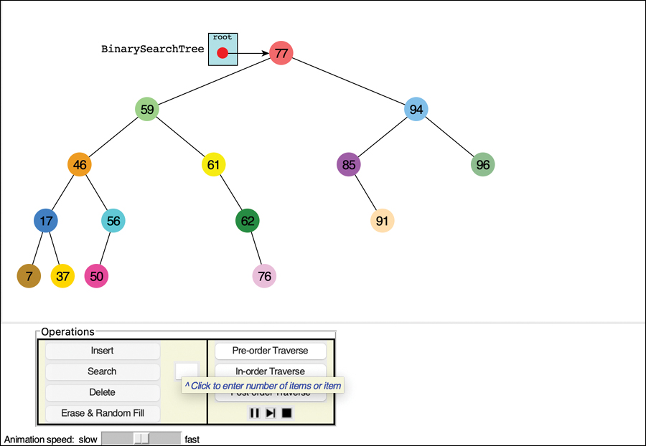
4
BST Property
Left subtree < Root < Right subtree
Why Important
- Enables fast search
- Inorder traversal gives sorted order
Operations
- Search
- Insert
- Delete
Time
O(log n) average, O(n) worst

4) Tree Traversals
DFS Traversals

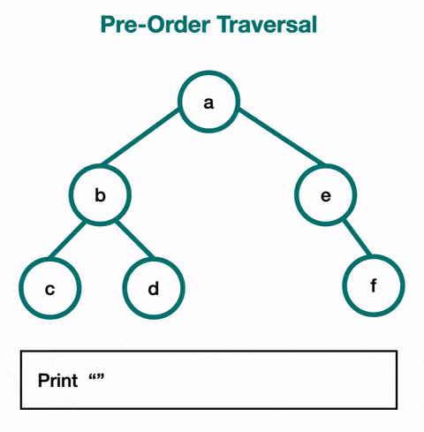
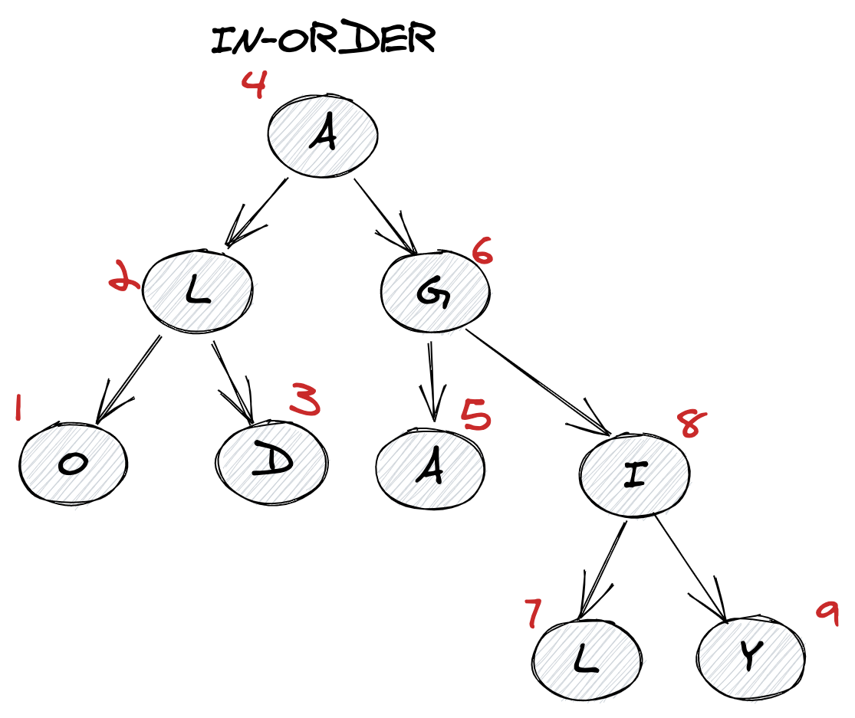
4
Preorder (Root Left Right)
Used for copying tree, prefix expression
Inorder (Left Root Right)
Sorted order in BST
Postorder (Left Right Root)
Used for deletion, evaluation

BFS Traversal (Level Order)
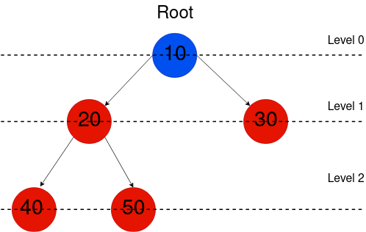
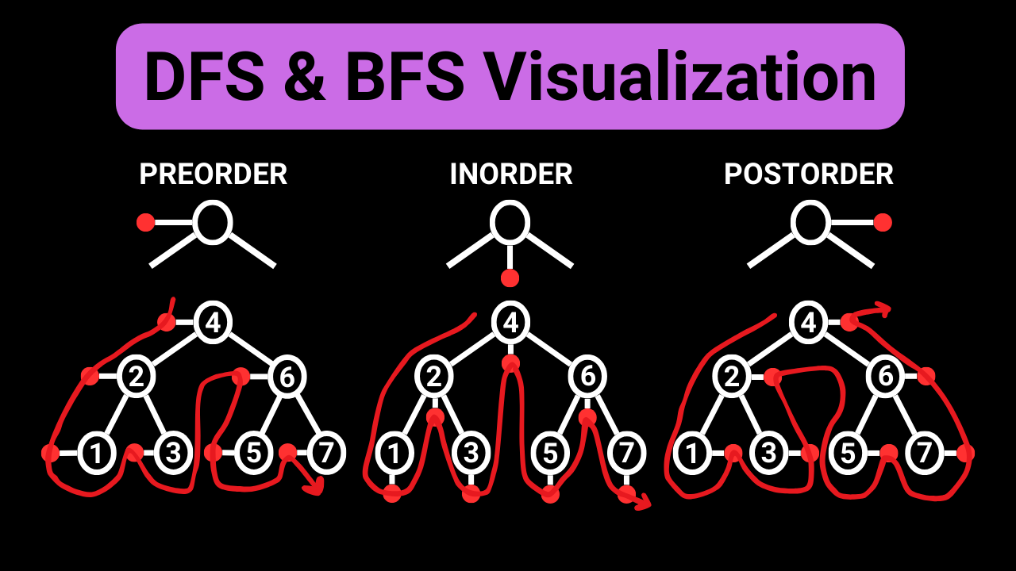
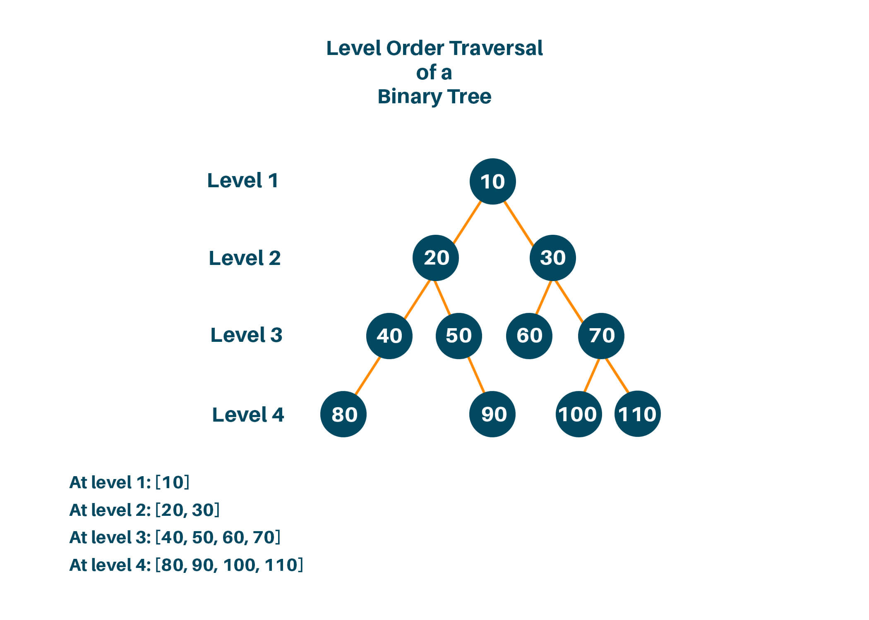
4
Visits nodes level by level
Uses queue
Common Uses
- Minimum depth
- Right or left view
- Zigzag traversal

5) Balanced Trees
AVL Tree / Red Black Tree
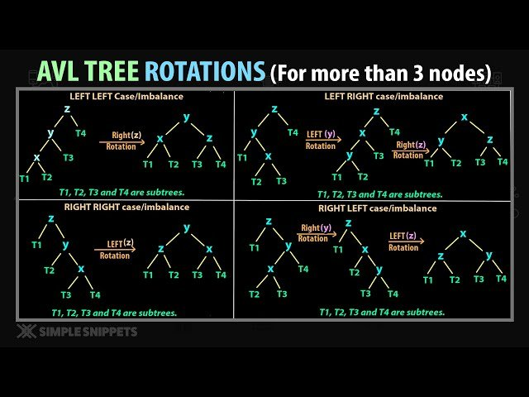
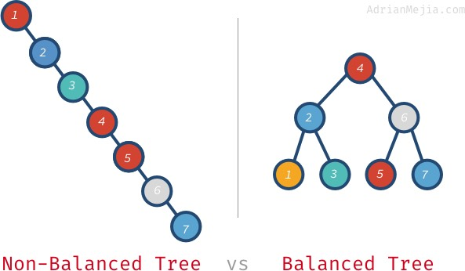

4
Keep height ≈ log n
Use rotations to maintain balance
Why Needed
Prevents worst case O(n) of BST
Used in databases and libraries

6) Heap (Priority Queue)
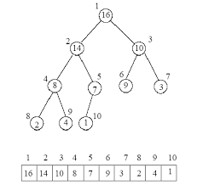
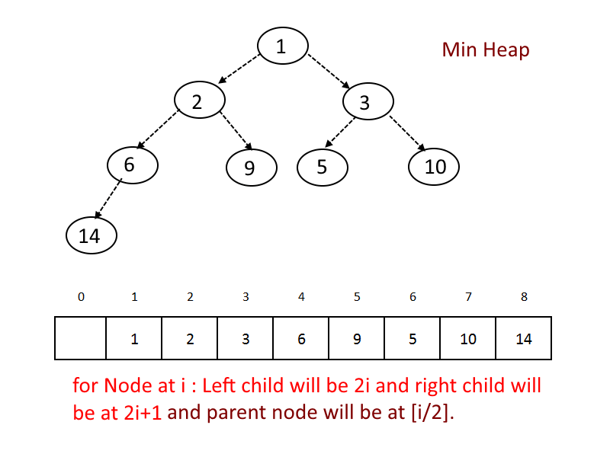
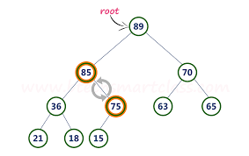
4
Complete binary tree with ordering property
Min Heap
Parent ≤ Children
Max Heap
Parent ≥ Children
Stored as array
Applications
- Priority queue
- Dijkstra
- Top K problems
- Scheduling

7) Trie (Prefix Tree)
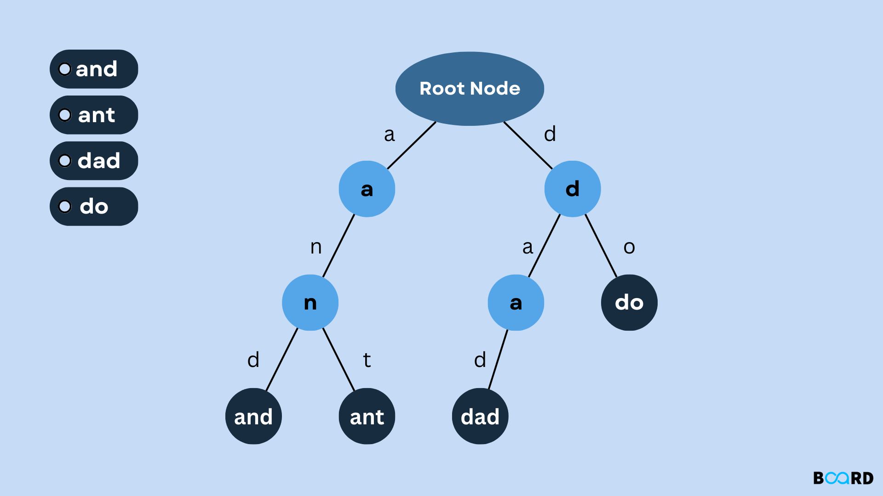
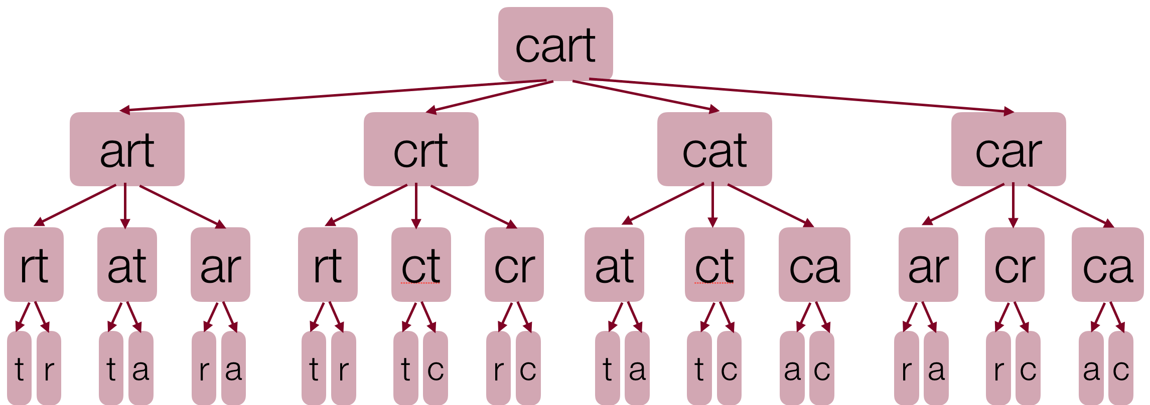
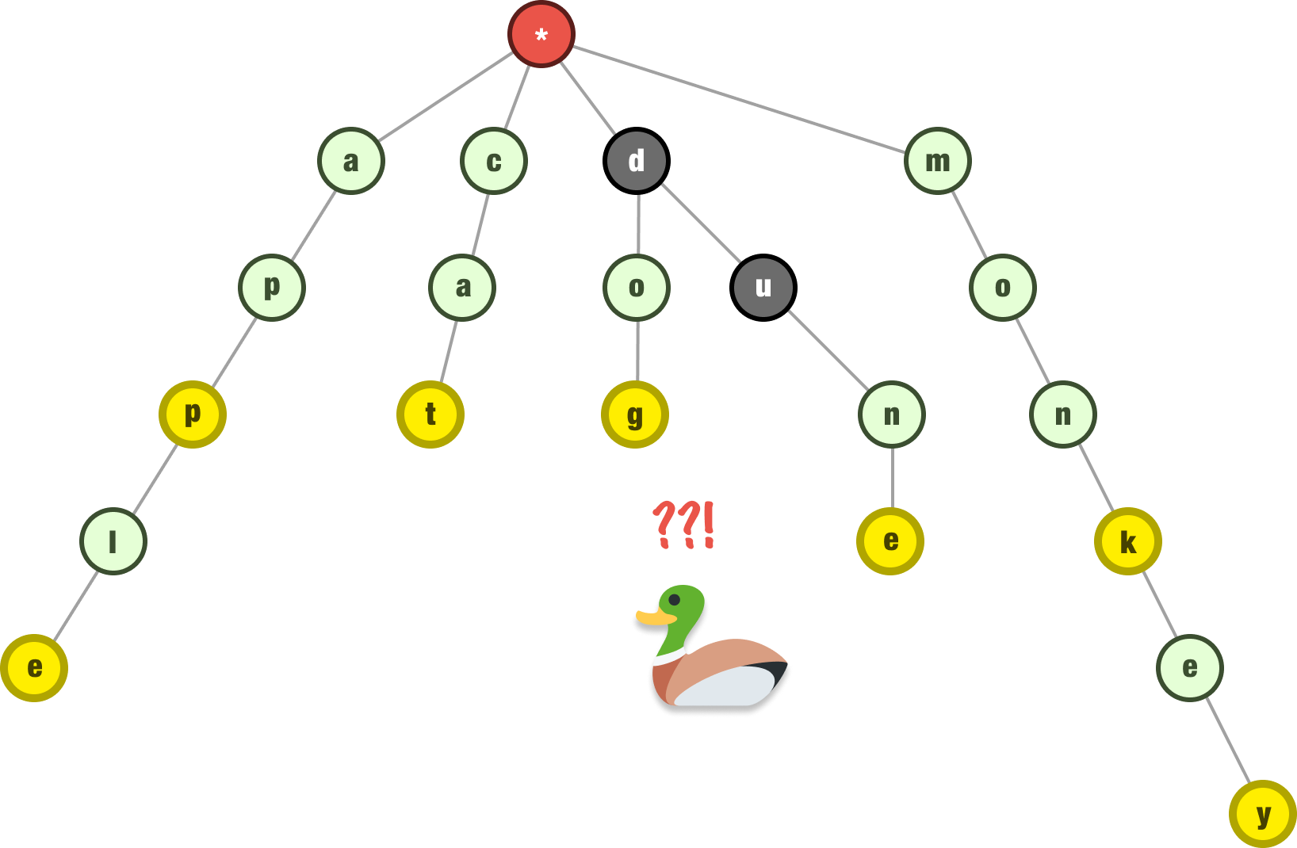
4
Tree for strings
Each edge = character
Best For
- Prefix search
- Autocomplete
- Dictionary problems

🏆 Tree Pattern Recognition Cheat Sheet
Problem Clue | Visualization | Approach
Hierarchy | Family tree | Basic tree
Sorted structure | Ordered tree | BST
Levels / distance | Layered tree | BFS
All paths | Deep exploration | DFS
Balance needed | Short height | AVL / RB
Priority | Root most important | Heap
Prefix words | Letter branches | Trie

🎯 Must Know Tree Problems (High Yield)
Easy
104, 100, 226, 101
Medium
102, 199, 236, 98, 230, 114
Hard / Important
124, 297, 968, 272

Complete Tree Algorithms Master Sheet (Interview Ready)
1) Tree Fundamentals
Tree = Hierarchical data structure (no cycles)
Special case of graph
Key Terms
- Root → Top node
- Parent / Child
- Siblings
- Leaf → No children
- Height → Longest path root → leaf
- Depth → Distance from root
- Subtree → Tree inside a tree
Types of Trees
- Binary Tree
- Binary Search Tree (BST)
- Balanced Trees (AVL, Red Black)
- Heap
- Trie
- N ary Tree

2) Binary Tree Basics
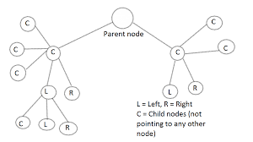
4
Each node has at most two children
Important Properties
Property | Formula
Max nodes at level L | 2^L
Max nodes in height h | 2^(h+1) − 1
Min height for n nodes | ⌈log2(n+1)⌉ − 1

3) Tree Traversals
DFS Traversals
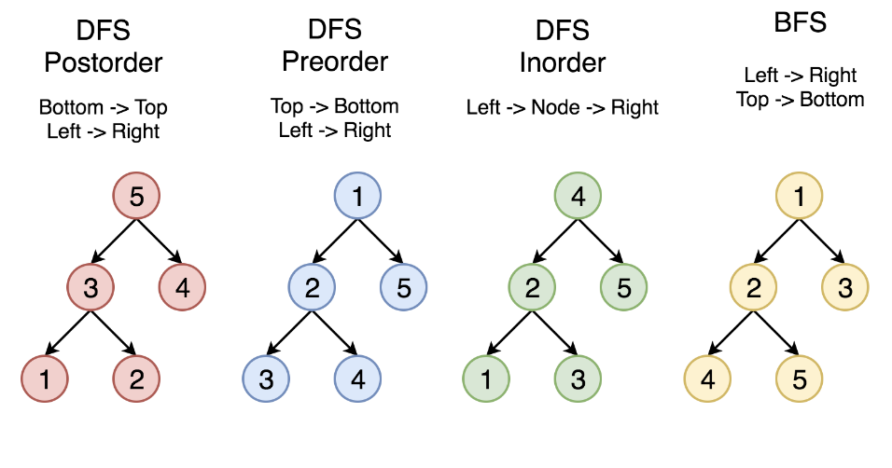

4
Traversal | Order | Use Cases
Preorder | Root Left Right | Copy tree, serialization
Inorder | Left Root Right | Sorted order in BST
Postorder | Left Right Root | Delete tree, DP on trees
Time: O(n)

BFS Traversal (Level Order)
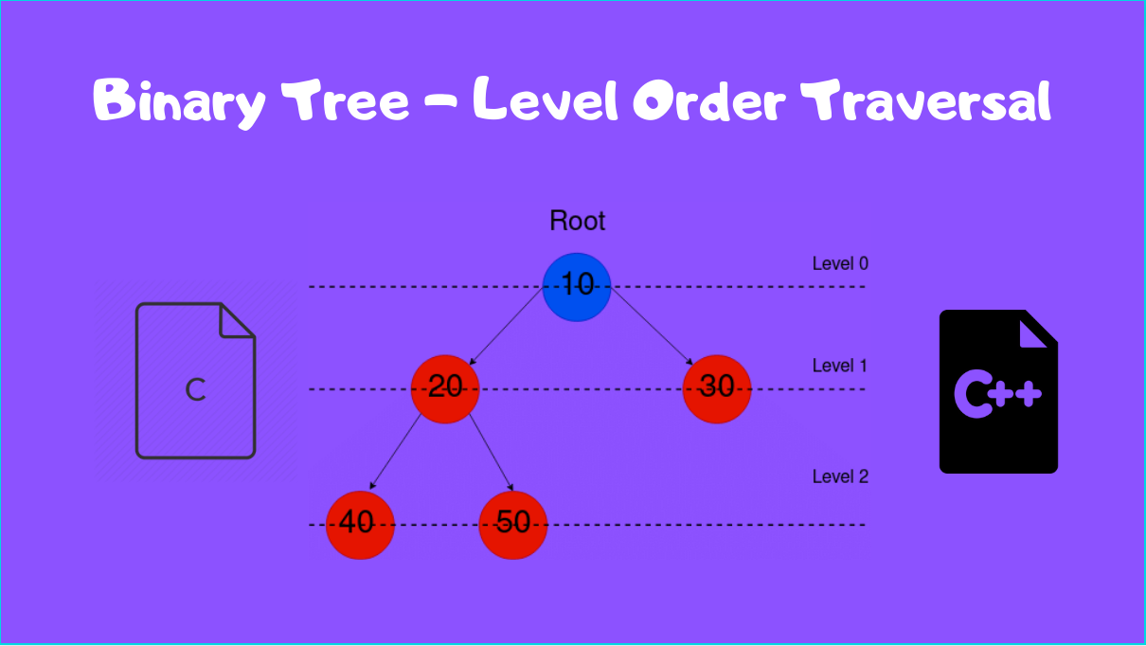
4
Visits nodes level by level using queue
Common Uses
- Minimum depth
- Level wise output
- Right/left view
- Zigzag traversal

4) Binary Search Tree (BST)
4
BST Property
Left subtree < Root < Right subtree
Operations
Operation | Time (Avg) | Time (Worst)
Search | O(log n) | O(n)
Insert | O(log n) | O(n)
Delete | O(log n) | O(n)
Key Techniques
- Inorder successor / predecessor
- Range queries
- Kth smallest element

5) Balanced BST
AVL & Red Black Trees

4
Maintain height ≈ log n using rotations
Why Important
Prevents degeneration into linked list
AVL
- Strictly balanced
- Faster lookups
Red Black
- Looser balance
- Faster insert/delete
- Used in libraries

6) Lowest Common Ancestor (LCA)
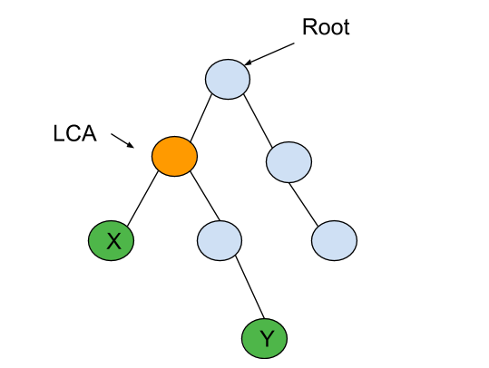
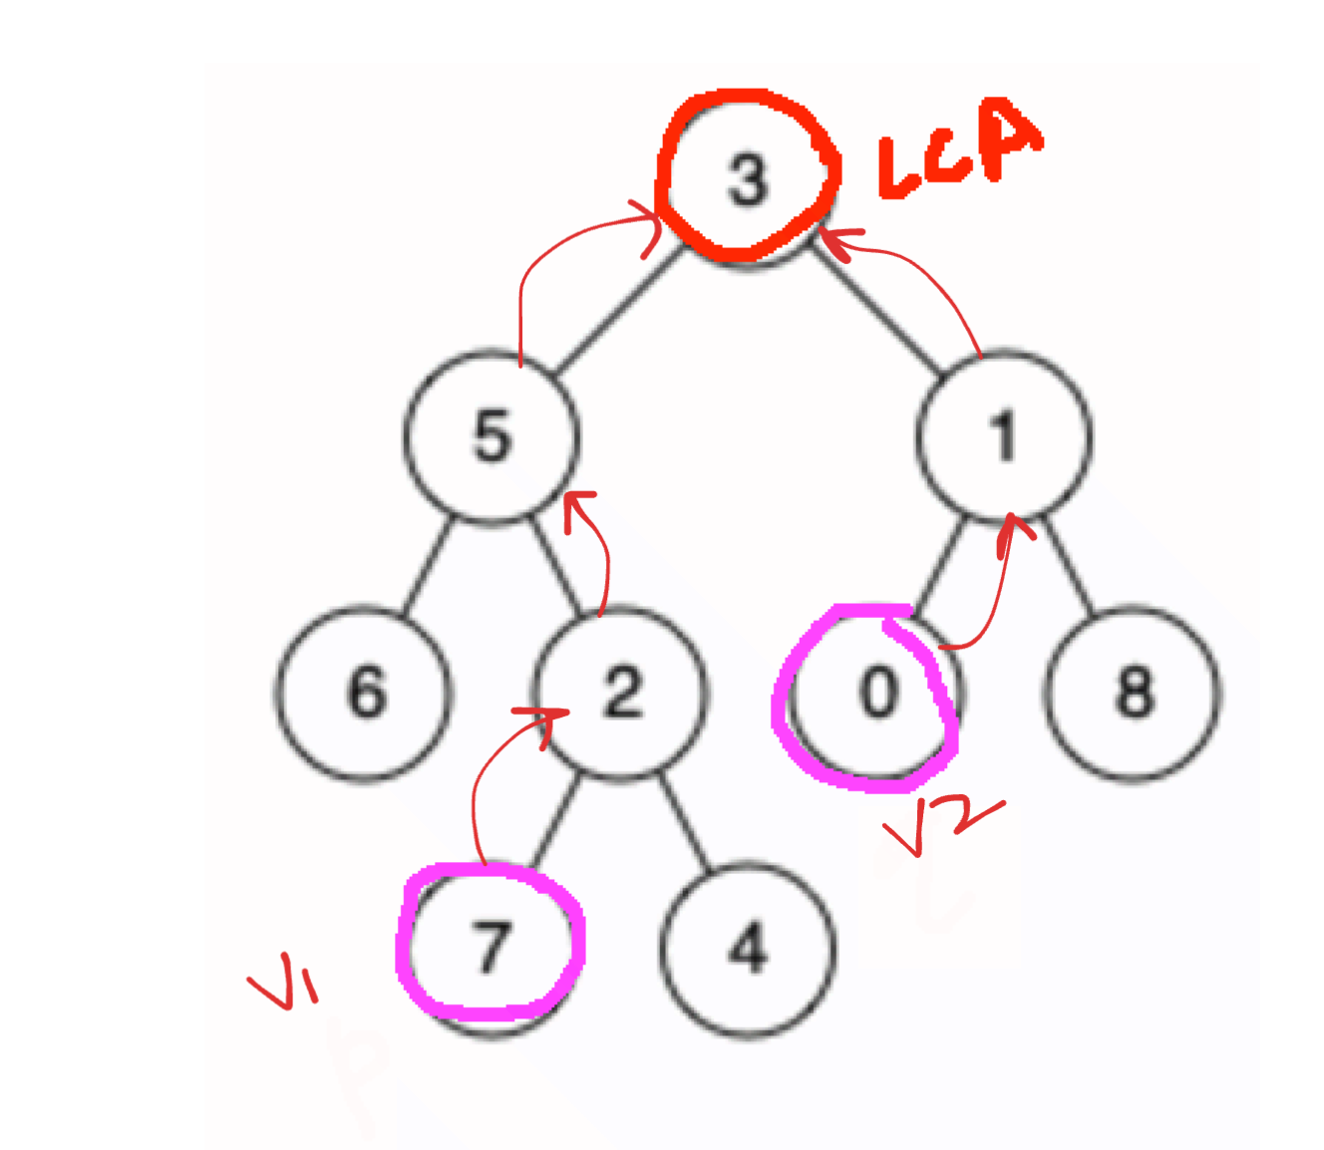
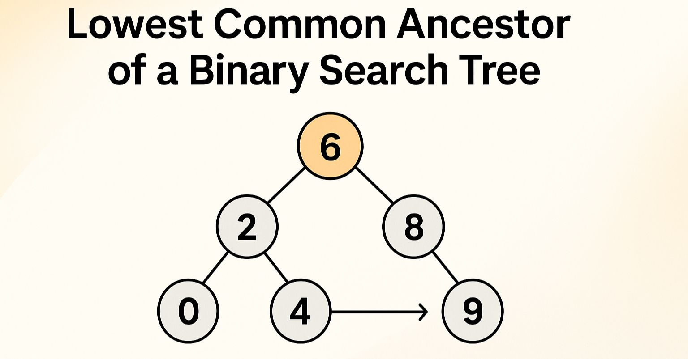
4
Node farthest from root that is ancestor of both nodes
Methods
- DFS recursion
- Parent pointers
- Binary lifting (advanced)
BST Shortcut
Use BST property to move left or right

7) Path Based Problems
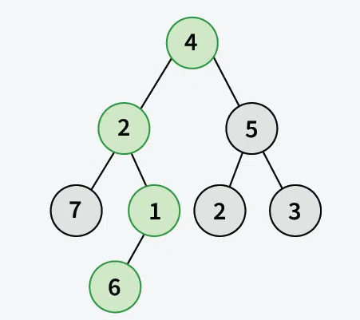
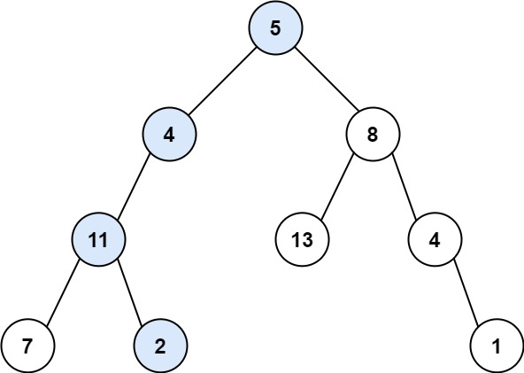
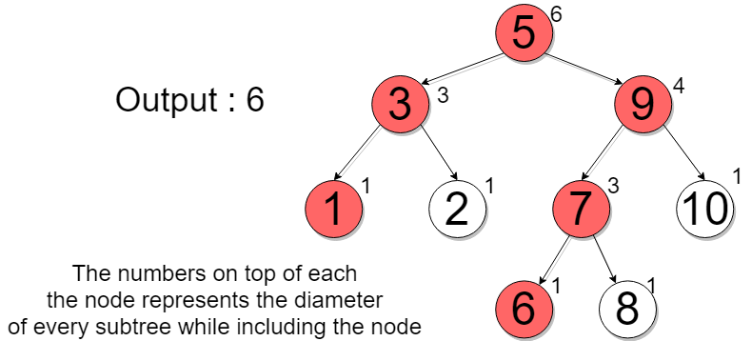
4
Common questions involve:
- Root to leaf paths
- Path sum
- Diameter (longest path)
- Maximum path sum
- Count paths
Typically solved using DFS + recursion

8) Tree Construction

4
Build tree from traversal arrays
Common Combinations
Given | Can Build?
Preorder + Inorder | Yes
Postorder + Inorder | Yes
Preorder + Postorder | Only if full tree

9) Heap (Priority Queue)
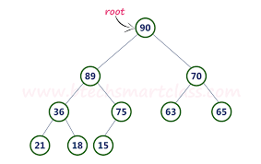
4
Complete binary tree with heap property
Min Heap
Parent ≤ children
Max Heap
Parent ≥ children
Operations
- Insert → Heapify up
- Remove root → Heapify down
Time
Insert / Delete → O(log n)

10) Trie (Prefix Tree)
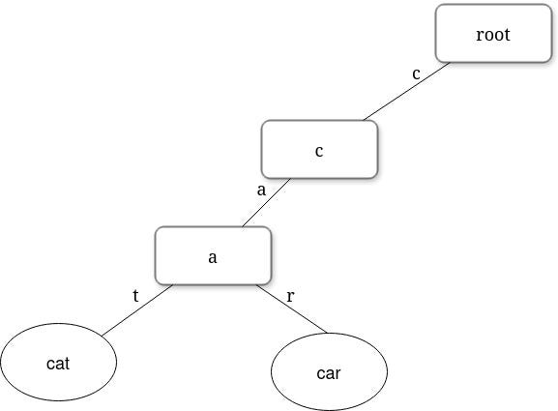
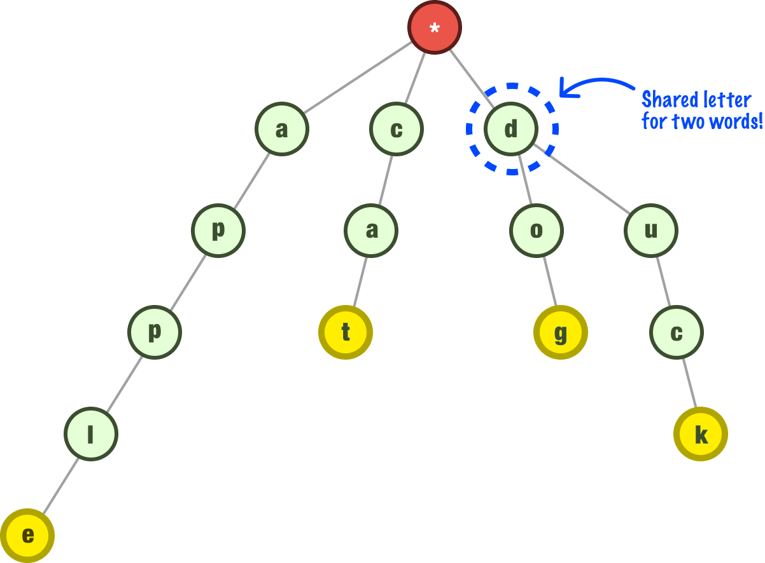
4
Tree specialized for strings
Applications
- Prefix search
- Autocomplete
- Word dictionary
- Spell checking

11) Tree DP (Advanced but Important)
Solve problems using information from children
Examples
- Diameter
- Maximum path sum
- Robber on tree
- Subtree calculations
Pattern
Postorder traversal + return values upward

12) N ary Trees
Each node can have many children
Used in:
- File systems
- DOM trees
- Organization structures
Traversal similar to binary tree (DFS/BFS)

🏆 Interview Decision Guide
Problem Clue | Approach
Levels / distance | BFS
All paths / recursion | DFS
Sorted property | BST
Kth smallest in BST | Inorder traversal
Ancestor queries | LCA
Longest path | Diameter
Prefix words | Trie
Priority removal | Heap
Balanced requirement | AVL / Red Black
Build tree from arrays | Recursion

🎯 High Yield LeetCode Problems
Easy
100, 101, 104, 226, 543
Medium
102, 199, 236, 98, 230, 114, 113
Hard / Must Know
124, 297, 968, 272, 337

